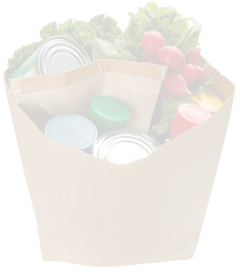
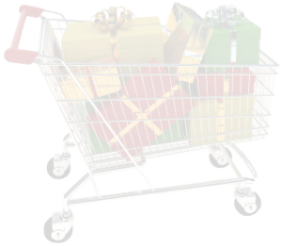

Home Grocery List
Important Notes: ________________________________________ _____________________________________________________________________________________________________________________________________________________________________
Misc.
Item Name | Quantity

Snacks
Item Name | Quantity

Vegetables
Item Name | Quantity

Produce
Item Name | Quantity

Cleaning Products
Item Name | Quantity

Meats
Item Name | Quantity

Canned/Dry
Item Name | Quantity

Frozen Food Items
Item Name | Quantity

Dairy
Item Name | Quantity

