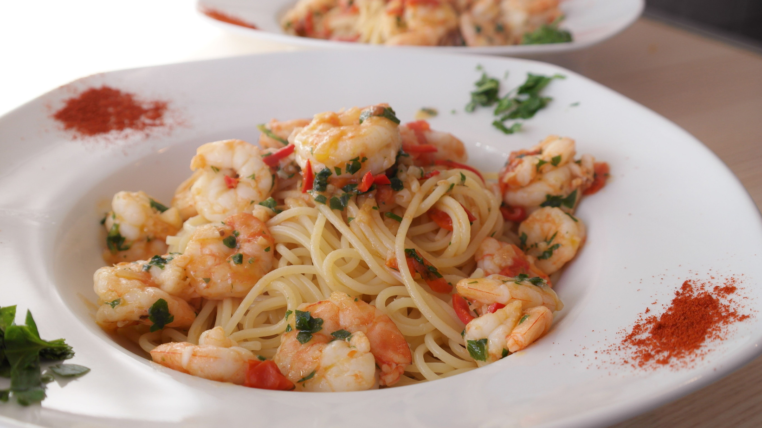
- Cook the pasta: Bring a large pot of salted water to a boil. Add the linguine and cook until al dente, according to the package instructions. Drain and set aside.
- Prepare the shrimp: Meanwhile, heat the olive oil in a large skillet over medium-high heat. Add the shrimp, season with salt and pepper, and sauté until they turn pink, about 2-3 minutes per side. Remove the shrimp from the skillet and set aside.
- Make the sauce: In the same skillet, add the minced garlic and red pepper flakes. Cook until the garlic is fragrant, about 1 minute. Stir in the chicken broth, lemon juice, and lemon zest. Bring the mixture to a simmer and cook for about 5 minutes, or until the sauce has reduced by half.
- Combine the pasta and shrimp with the sauce: Return the shrimp to the skillet. Add the cooked pasta and toss to combine, making sure the pasta is well-coated with the sauce.
- Serve: Remove the skillet from the heat. Sprinkle with the chopped fresh parsley and grated Parmesan cheese. Serve immediately.
8 oz linguine pasta
2 tbsp olive oil
1 lb large shrimp, peeled and deveined
Salt to taste
Black pepper to taste
1 tbsp minced garlic
1 tsp red pepper flakes
1/2 cup chicken broth
1 cup fresh lemon juice
Zest of 1 lemon
1/2 cup finely chopped fresh parsley
Grated Parmesan cheese for serving
Ingredients
Instructions
Zesty Lemon Garlic Shrimp Pasta
SERVINGS: 4
PREPPING TIME: 15 MIN
COOKING TIME: 20 MIN
For an extra punch of flavor, add a splash of white wine to the sauce.
Feel free to add more vegetables like cherry tomatoes or spinach for added nutrition.
Use whole grain pasta for a healthier twist.
Tips and Variations

