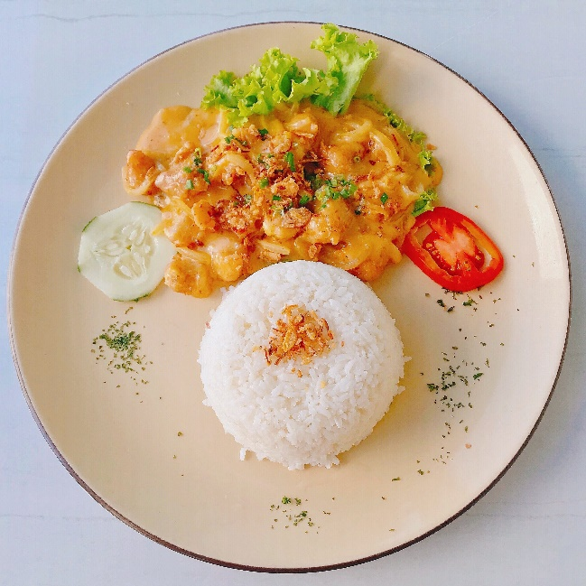
Starters / Dish #23
I get a lot of orders at Two Fingers from sportsman who need to eat a lot of very healthful food, and this recipe has been a favourite of my menu planning clients to make themselves. This is such a favourite because it easy, delicious and well rounded.
Spaghetti Aglio
Delle Olio
- Cook pasta according to package directions. Drain and set aside.

- In a small saucepan or deep frying pan, melt butter. Add onion, mushrooms, and flour.

- While onions and mushrooms are browning, chop bacon to slices. Add to pan and mix five more minutes.

- Lorem ipsum dolor sit amet, consectetuer adipiscing elit. Maecenas porttitor congue massa.

- Fusce posuere, magna sed pulvinar ultricies, purus lectus malesuada libero, sit amet commodo magna eros quis urna.
PREPARATION STEPS
INGREDIENTS
1 pound whole wheat angel hair pasta, 1/2 pound mushrooms, 1 small onion, diced 3-4 cloves garlic, 2 tablespoons butter or Earth Balance, 1 cup 0.1%, 2 tablespoons white whole wheat flour, 2 tablespoons fresh dill or parsley, 2 tablespoons red onion, diced or thinly sliced, 1/2 cup plus 2 tablespoons grated parmesan, Sea salt and black pepper.

