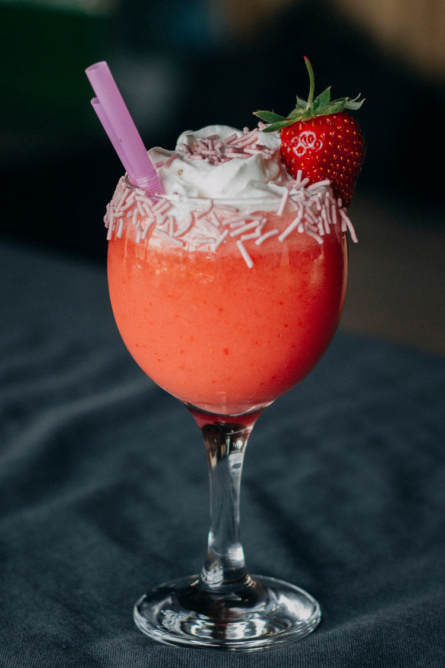




Strawberry Smoothie
A quick, healthy delight with ripe strawberries, creamy banana, and yogurt. Perfect for an invigorating start to your day or a refreshing midday treat.
2 cups fresh strawberries
1 banana
1 cup yogurt
1/2 cup milk
1-2 tablespoons honey or sugar
Ingredients :
Serves: 2
Preparation Time: 5 Minutes
Total Time: 5 Minutes
Clean the strawberries and remove the stems. Peel the banana.
Put the strawberries, banana, yogurt, milk, and sweetener if using, into a blender. Blend until smooth.
Pour into glasses and serve immediately.
1.

2.

3.
Procedure :
Use frozen strawberries or add a few ice cubes for a colder smoothie.
Substitute the strawberries with other fruits for different flavors.
Tips:

