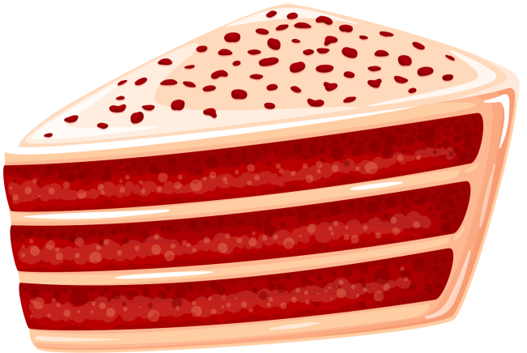
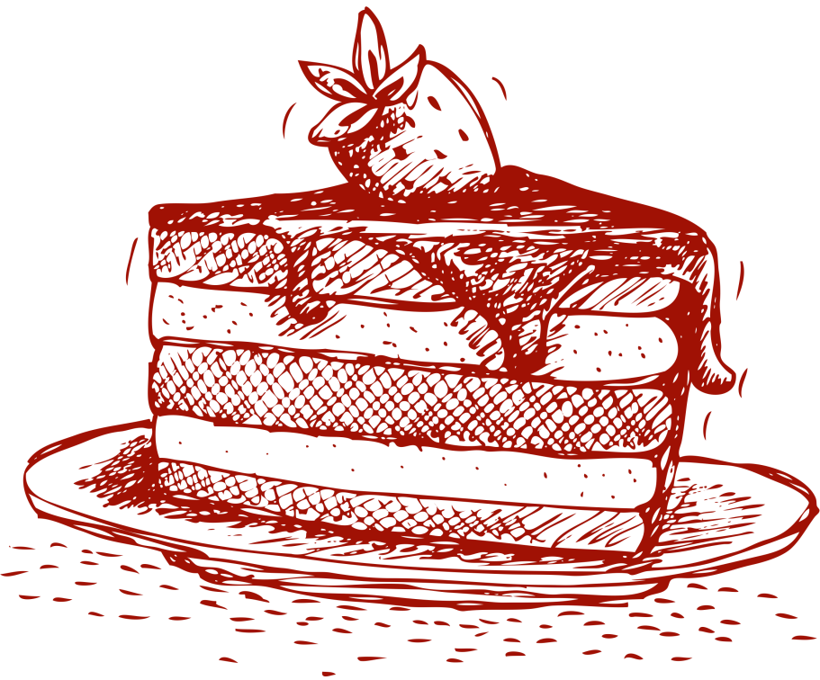
Ingredients
Directions
Red Velvet Cake
2 1/2 cups all-purpose flour
2 tablespoons unsweetened cocoa powder
1 teaspoon baking soda
1/2 teaspoon salt
1 cup unsalted butter, softened
2 cups granulated sugar
4 large eggs
1 cup buttermilk
2 teaspoons vanilla extract
2 tablespoons red food coloring
8 ounces cream cheese, softened
1/2 cup unsalted butter, softened
4 cups powdered sugar
1 teaspoon vanilla extract
- Preheat oven to 350°F (175°C). Grease and flour two 9-inch round cake pans.
- Whisk flour, cocoa powder, baking soda, and salt in a medium bowl.
- Cream butter and sugar in a large mixing bowl until light and fluffy.
- Add eggs one at a time, beating well after each addition. Mix in buttermilk, vanilla extract, and red food coloring.
- Gradually add dry ingredients, mixing until just combined.
- Divide batter between cake pans and smooth tops.
- Bake for 25-30 minutes or until a toothpick inserted into the center comes out clean.
- Cool cakes in pans for 10 minutes, then transfer to a wire rack to cool completely.
- Prepare cream cheese frosting by beating cream cheese and butter until smooth. Gradually add powdered sugar and vanilla extract, beating until creamy.
- Once cakes are cool, frost with cream cheese frosting.
- Enjoy your homemade Red Velvet Cake!
For the Cake:
For the Cream Cheese Frosting:

