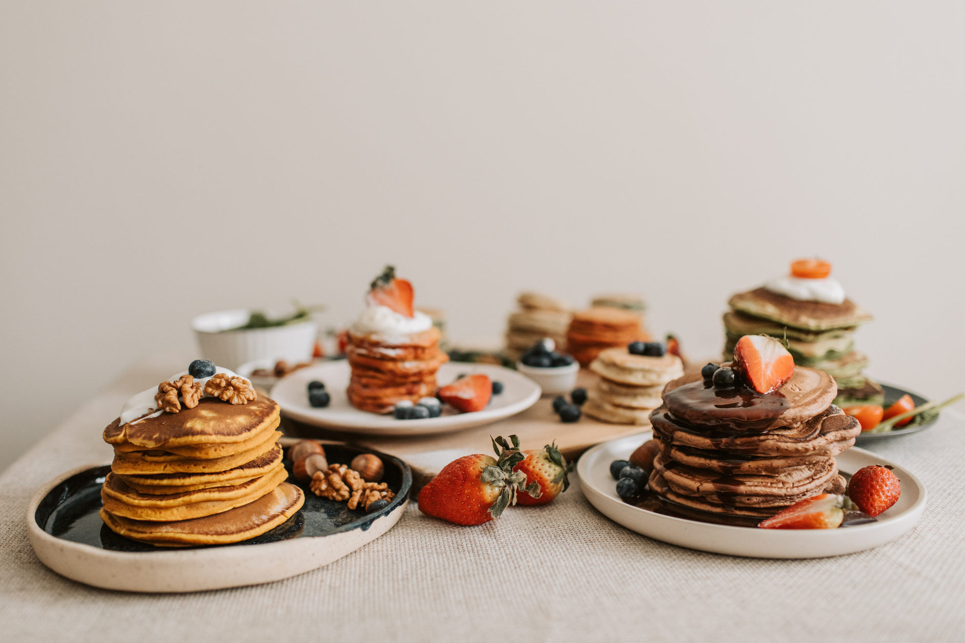


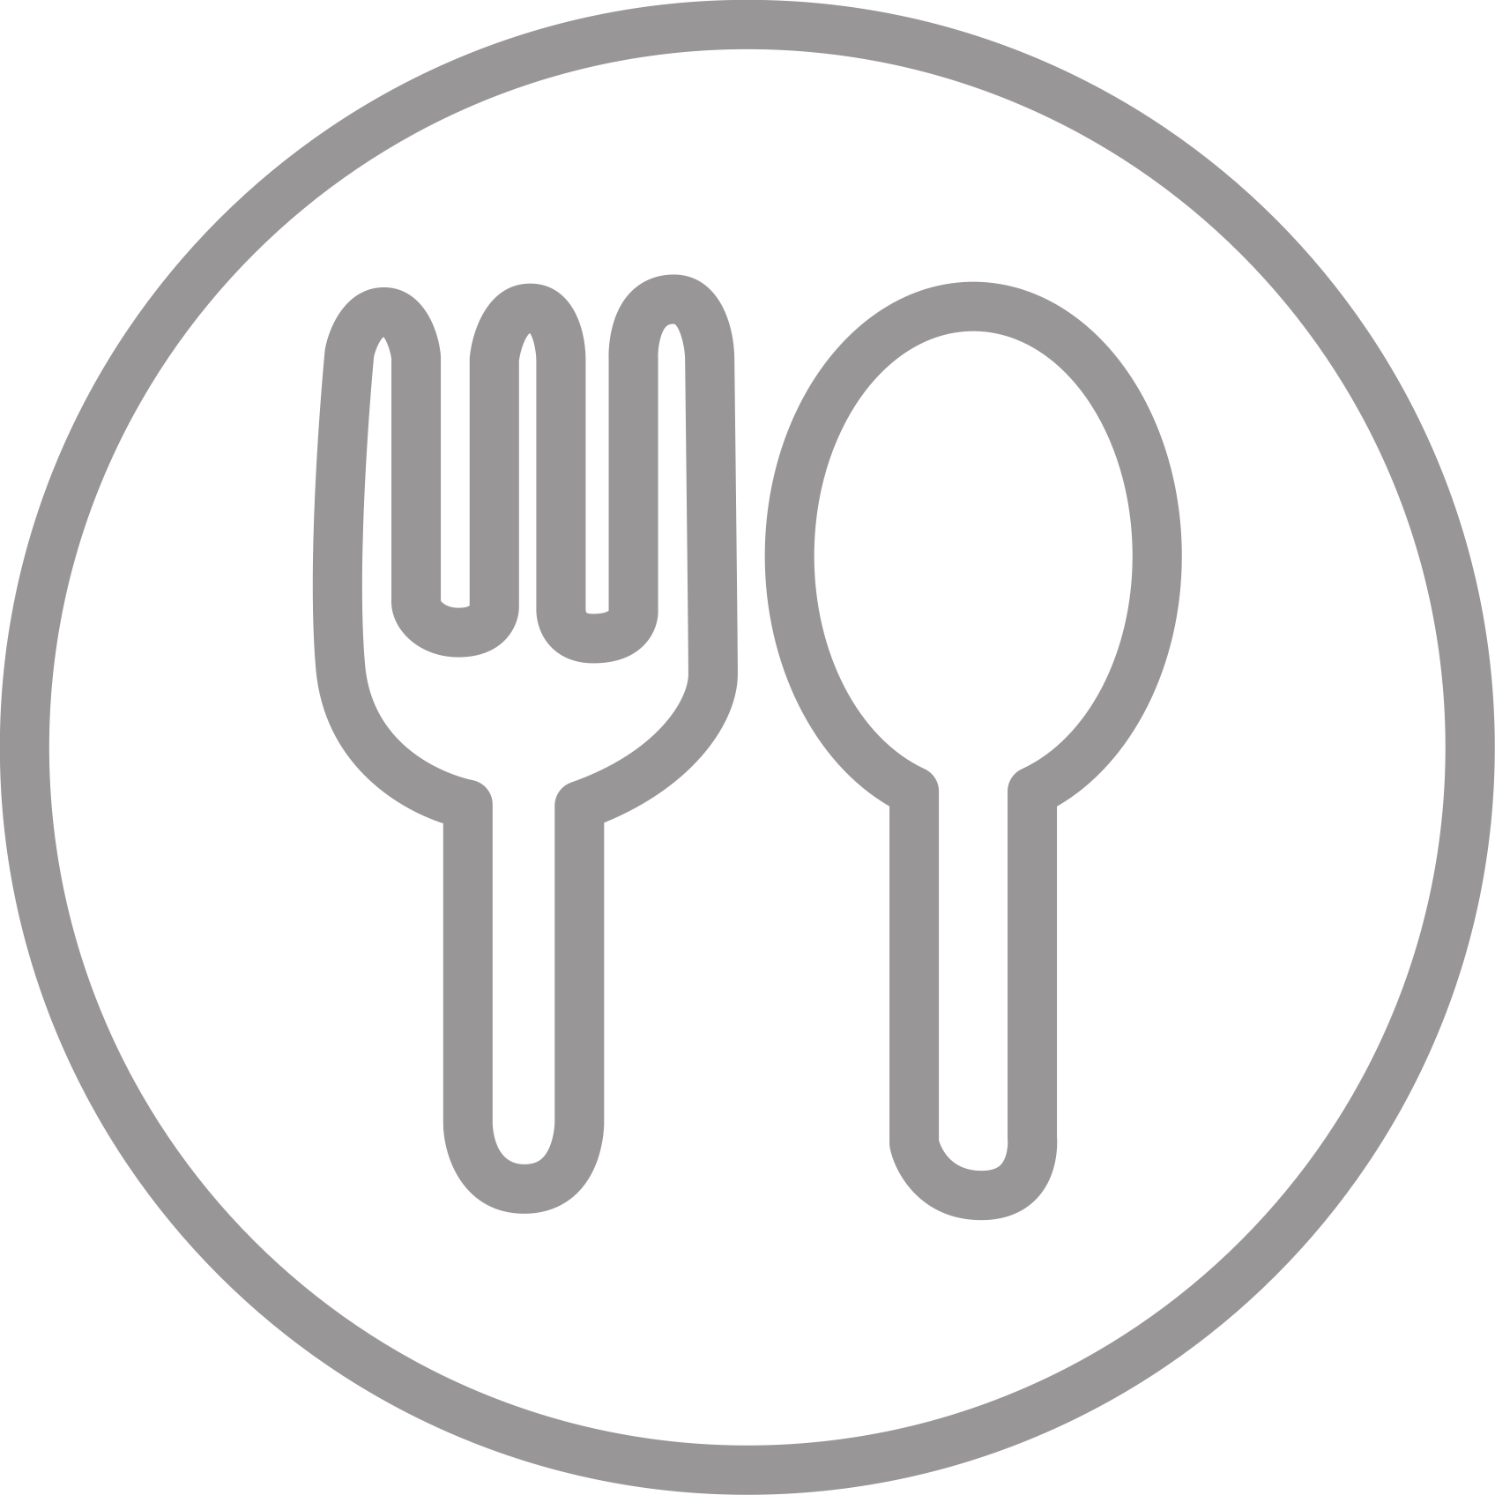
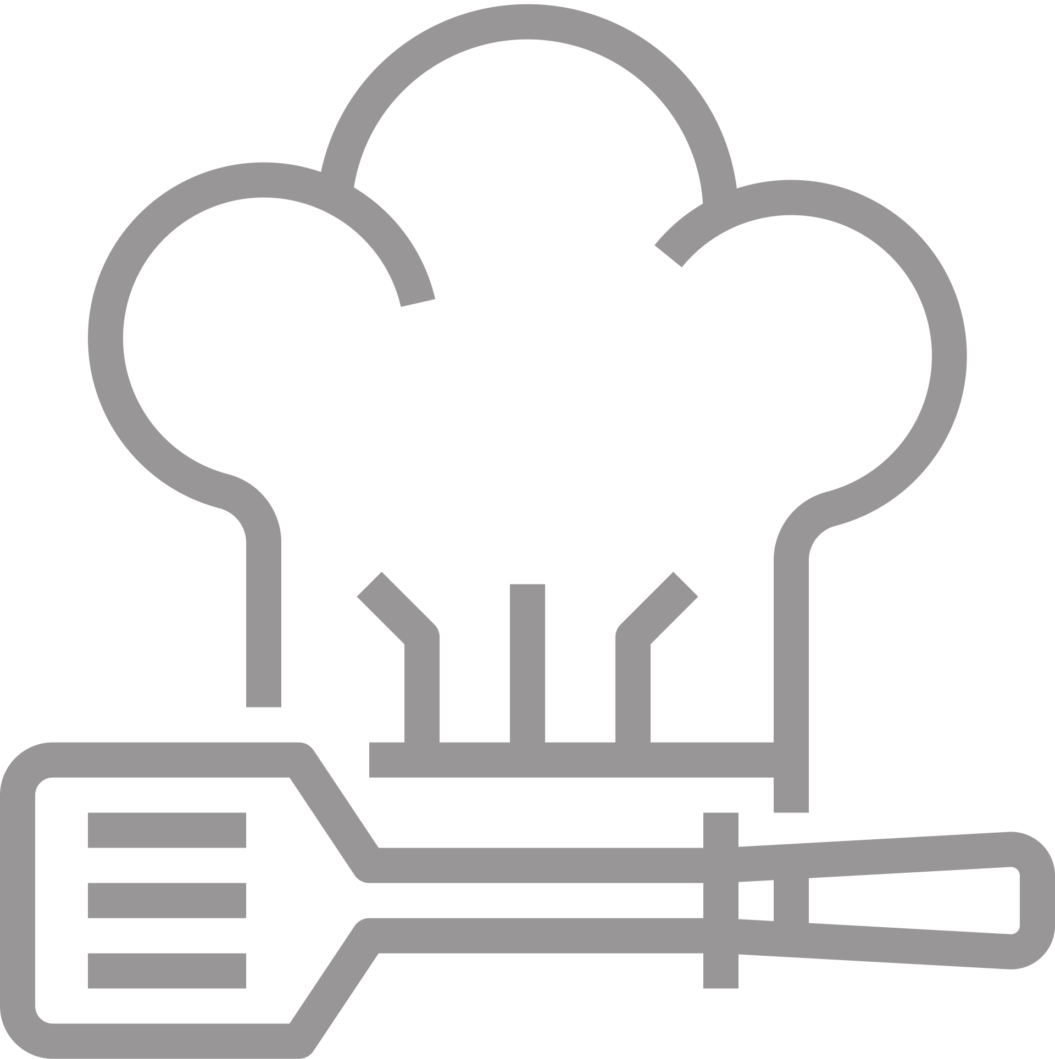
Recipes
PANCAKE
3
Ingredients
1 1/2 cups all-purpose flour
3 1/2 teaspoons baking powder
1/2 teaspoon salt
2 tablespoons granulated sugar
1 1/4 cups milk
1 large egg
3 tablespoons unsalted butter, melted
Cooking spray or additional butter for greasing the pan
Directions
- In a bowl, whisk together flour, baking powder, salt, and sugar.
- In a separate bowl, whisk together milk, egg, and melted butter.
- Combine the wet and dry ingredients, stirring until just combined. A few lumps are okay.
- Preheat a non-stick skillet or griddle over medium heat. Grease the cooking surface with cooking spray or a small amount of butter.
- Pour 1/4 cup of batter onto the skillet for each pancake. Cook until bubbles form on the surface, then flip and cook the other side until golden brown.
- Repeat with the remaining batter, adding more cooking spray or butter as needed to prevent sticking.
- Serve the Pancakes warm with your favorite toppings such as maple syrup, fresh fruits, or whipped cream.
SERVINGS
TIME
CALORIES
DIFFICULTY
2
30 min
Easy
1231 kcal
Tips:
For extra flavor, you can add a teaspoon of vanilla extract or a sprinkle of ground cinnamon to the batter.
If you prefer thinner pancakes, you can add a little more milk to the batter to achieve the desired consistency.

