Patient Progress Note
Please fill out form at each visit and return to the front desk assistant when finished. Thank you for your assistance.
Patient Name Date

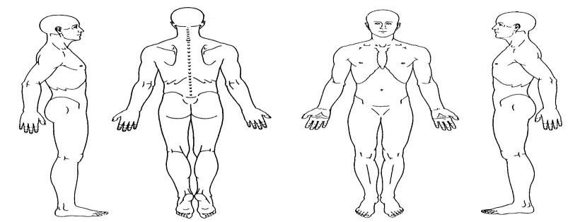
Please mark the area where there is pain. X=Sharp Pain
O=Dull Pain

Please mark the level of intensity of your symptoms using the following scale.
(0 equals no symptom at all, 100 equals maximum possible intensity of the symptom.)

Symptom | 0 | 10 | 20 | 30 | 40 | 50 | 60 | 70 | 80 | 90 | 100
Symptom | 0 | 10 | 20 | 30 | 40 | 50 | 60 | 70 | 80 | 90 | 100
Symptom | 0 | 10 | 20 | 30 | 40 | 50 | 60 | 70 | 80 | 90 | 100
Symptom | 0 | 10 | 20 | 30 | 40 | 50 | 60 | 70 | 80 | 90 | 100

Please rate by circling your overall state of wellness since your last treatment
Significantly Improved Improved Unchanged Worsened Significantly Worsened
(Office Use Only) PATIENT’S NOTES
Units: | Set: 1 2 3 4
Needle #
LV
GB
HT
SI
PC
SJ
SP
ST
LU
LI
KD
UB
REN
DU
EXTRA
ASHI
SCALP
EAR
MOXA/TDP
TUINA/CUP

What has changed?

_

Do you have any health concerns that you would like to communicate to the doctor other than those for which you are currently being treated for? If yes, please describe:

o (Check here if documenting any physician notes on reverse) Physician’s Signature:

