DESIGN AND ACCESS AND AGRICULTURAL NEED STATEMENT
PHASE 1 OF A 4 PHASE PLAN

Proposal: Planning Application for new agricultural storage building (woodchip for biomass boiler (existing on site)

Site Address: Rabys Farm, Bilsborrow Lane, Preston, Lancashire, PR3 0RP

Applicant: J & M Stuart & Son

1 Site Description

2 Proposed Development and agricultural need

4 Policy Assessments

5 Amount

6 Layout

7 Scale

8 Landscaping

9 Appearance

10 Access

11 Conclusion

- Site Description

1.1 The site is located south a Bilsborrow lane, approximately 1 kilometre east of the village of Bilsborrow and the A6 Preston/Lancaster Trunk Road.

1.2 There are 4 full time staff in association with agricultural activities on site. There is provision for 5 no. onsite parking spaces on the farm.

1.3 The site comprises the applicant’s residential property and various agricultural buildings for a range of livestock rearing including beef and dairy cattle, sheep and poultry.

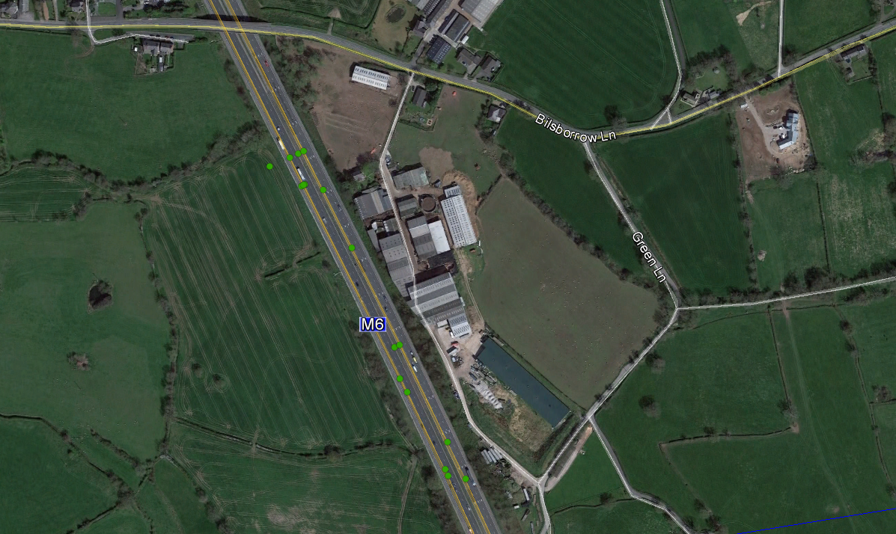

Google image of the site

Agricultural Background

Raby’s Farm comprises of the following stock number and land holdings, which forms the bulk of the agricultural business.

Current Herd, replacements and beef

Milk cows including dry cows 233 cubicle housed
In calf heifers 76 (cubicle housed)
Bulling heifers 75 (part turned out)
Fattening Bulls 35 (35 sold over winter)
Young stirks 72 (part turned out)
Calves mixed 30 (variable to time of year)

Sheep

Sheep 3500
50 Sheep Stores
150 Milk
120 Followers

Poultry

Stock chickens 55,000

Land

Owned 180 acres grass and short term leys
Rented grass and short term leys
40 acres long term agreement
70 acres short term grazing
Total grass 290 acres
Arable cropped/rented
60 acres maize
90 acres winter wheat
Total arable 150 acres
Total Farmed 440 acres

2 Proposed Development and agricultural need

2.1Phase One of a four phase plan is applied for. This will be in the form of a new portal framed storage building. A previous extant approval exists or a second poultry unit on the farm, in the precise location as these four phased buildings are proposed.

2.2 The building will be used to store and dry woodchip used in association with the poultry, pig, beef and dairy enterprises at the farm. The applicant installed a 200kw biomass boiler last year which provides essential heat for this type of poultry fattening. The boiler uses 2.5T of woodchip per week, and the applicant intends buying in the wood and chipping it on site, and storing it in the proposed building in order to maintain a continuous supply of fuel for the boiler and hence heat for the poultry building, and the other agricultural enterprises on the farm, which all require heat, such as grain drying for the feed mill, heat in the dairy and pig buildings.

The current supply of wood is not enough to be used to maximum potential and problems are arising due to not having sufficient supply of fuel. This proposal will remedy this problem, providing a continuous supply for the boiler, in bulk storage on the farm ,which is readily available.

4 Policy Assessments

4.1 The following policies are detailed as relevant to the application. In principle the proposal is acceptable in that it can clearly be shown to be reasonably necessary for the purposes of agriculture, as supported by the former PPS7 and other Planning Guidance notes, as well as double fold will preserve and enhance the environment.

National Planning Policy

The National Planning Policy Framework (NPPF) was published on 27 March 2012. The NPPF replaces various national planning documents including Planning Policy Statement 7: Sustainable Development in Rural Areas (published August 2004).

The NPPF is therefore a material consideration in the determination of applications for planning permission. A presumption in favour of sustainable development is at the heart of the NPPF.

The definition of sustainable development is outlined in the NPPF as ‘meeting the needs of the present without compromising the ability of future generations to meet their own needs’.
One of the Core Planning Principles (paragraph 17) is to contribute to conserving and enhancing the natural environment and reducing pollution.

Paragraph 28 of the NPPF states that planning policies should support economic growth in rural areas in order to create jobs and prosperity by taking a positive approach to sustainable new development, it states that there should be support for sustainable growth and expansion of all types of business and enterprise in rural areas including well designed new buildings.

Planning policies should also promote the development and diversification of agricultural and other land-based rural businesses. The NPPF also places great emphasis on good design as it is a key aspect of sustainable development.

5 Amount

5.1 Phase 1 of a four-phase plan is applied for; it measures 23 mtrs in length and 22.7 mtrs in width. At its highest point, it will be 12m, having an eaves height of 9.1metres. The total area of the proposed building 522.1 square mtrs.

6 Layout

6.1 The proposed building will be open plan for the storage of the wood. The height proposed is required to accommodate the machinery and equipment required to tip and manoeuvre the wood.

7 Scale

7.1 The proposed building is of an appropriate scale taking into account the stocking rates of the farm, layout of the farm buildings and position of other adjacent buildings

8 Landscaping

8.1 No landscaping scheme are required or proposed as part of this development. No works or alterations to the site levels are required.

9 Appearance

9.1 The proposed appearance of the building will confirm with the character and appearance of the adjacent agricultural building.

9.2 Materials to be used for the roof include box profile tin sheets in juniper green. The roof is to incorporate barge boards with 160mm half round P.V.C. gutters and fall pipes.
The walls will be clad in box profile tin in Juniper Green down to the floor

10 Access

10.1 Access will be gained through the farm yard, which serves adequately for the agricultural vehicles that use the site currently.

11 Conclusion

11.1 This Design and Access Statement demonstrates that the proposed development promotes sustainable farming methods.
11.2 This meets the objectives of National and local planning policies which support development that delivers sustainable farming methods.

