

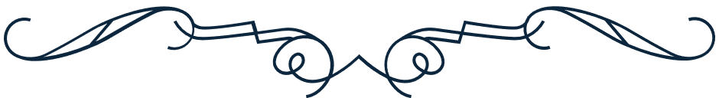
Francisco Andrade
THIS IS TO CERTIFY THAT, ON 15 JULY 2028,
THE INDIVIDUAL KNOWN AS
is the rightful owner of 3,000 stocks at ABC company.
Kyrie Petrakis
President
Frank Marcel
CEO
Corporate stock certificate

