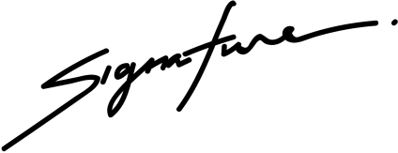

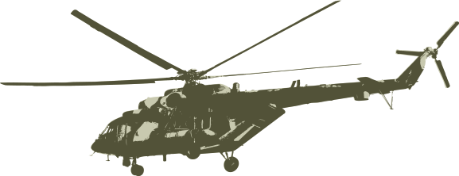
21.07.2027
DATE
SIGNATURE
DEPARTMENT OF THE ARMY
CERTIFICATE OF APPRECIATION
AWARDED TO
Sacha Dubois
for your outstanding support of the US Army Ordnance School at Fort Lee, Virginia. We greatly appreciate your excepotional service and product quality.

