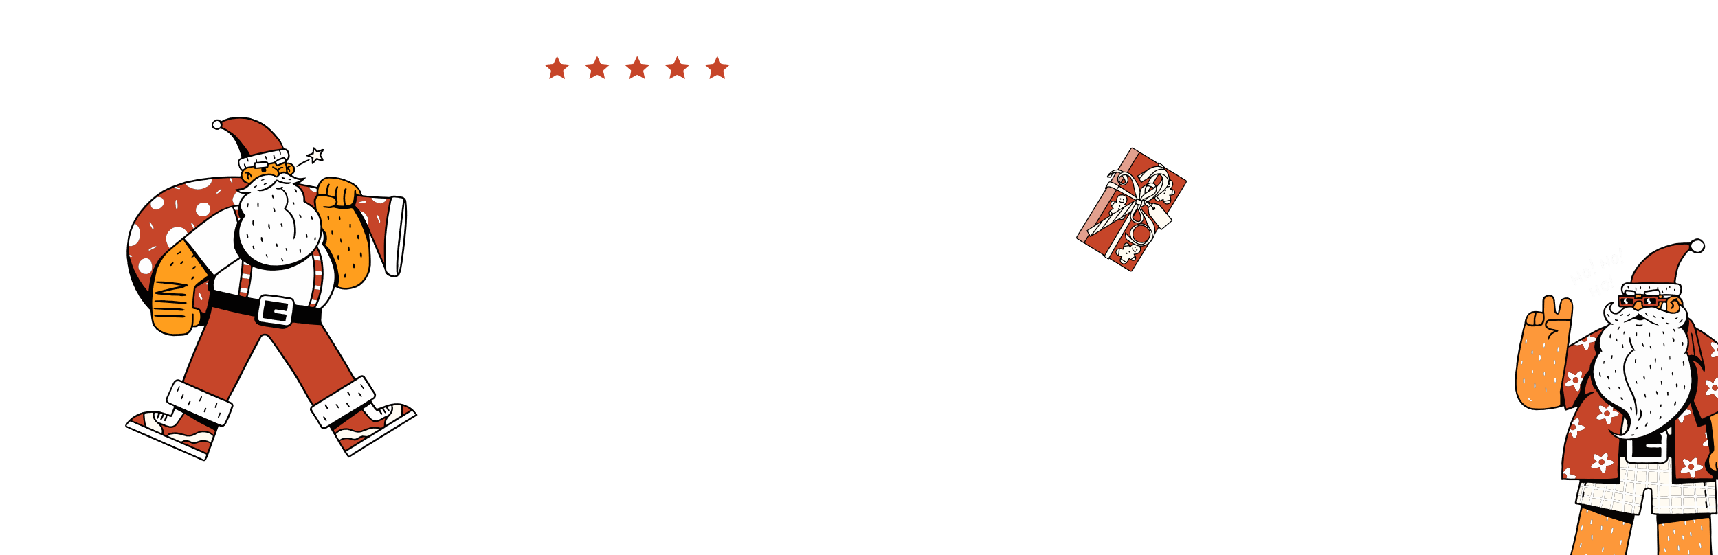
A SPECIAL GIFT FOR YOU!
GIFT
CERTIFICATE
AMOUNT :
TO:
MERRY
CHRISTMAS!

NO. 12345678
ENJOY YOUR PRESENT
Valid throughout
the holidays!
YOU CAN ADD MORE DETAILS ABOUT YOUR MESSAGE IN THIS SPACE. IF YOU NEED MORE SPACE FOR TEXT, YOU CAN REDUCE THE SIZE OF THE YOUR MESSAGE HERE TEXT BY SELECTING IT AND CHANGING THE FONT SIZE.

