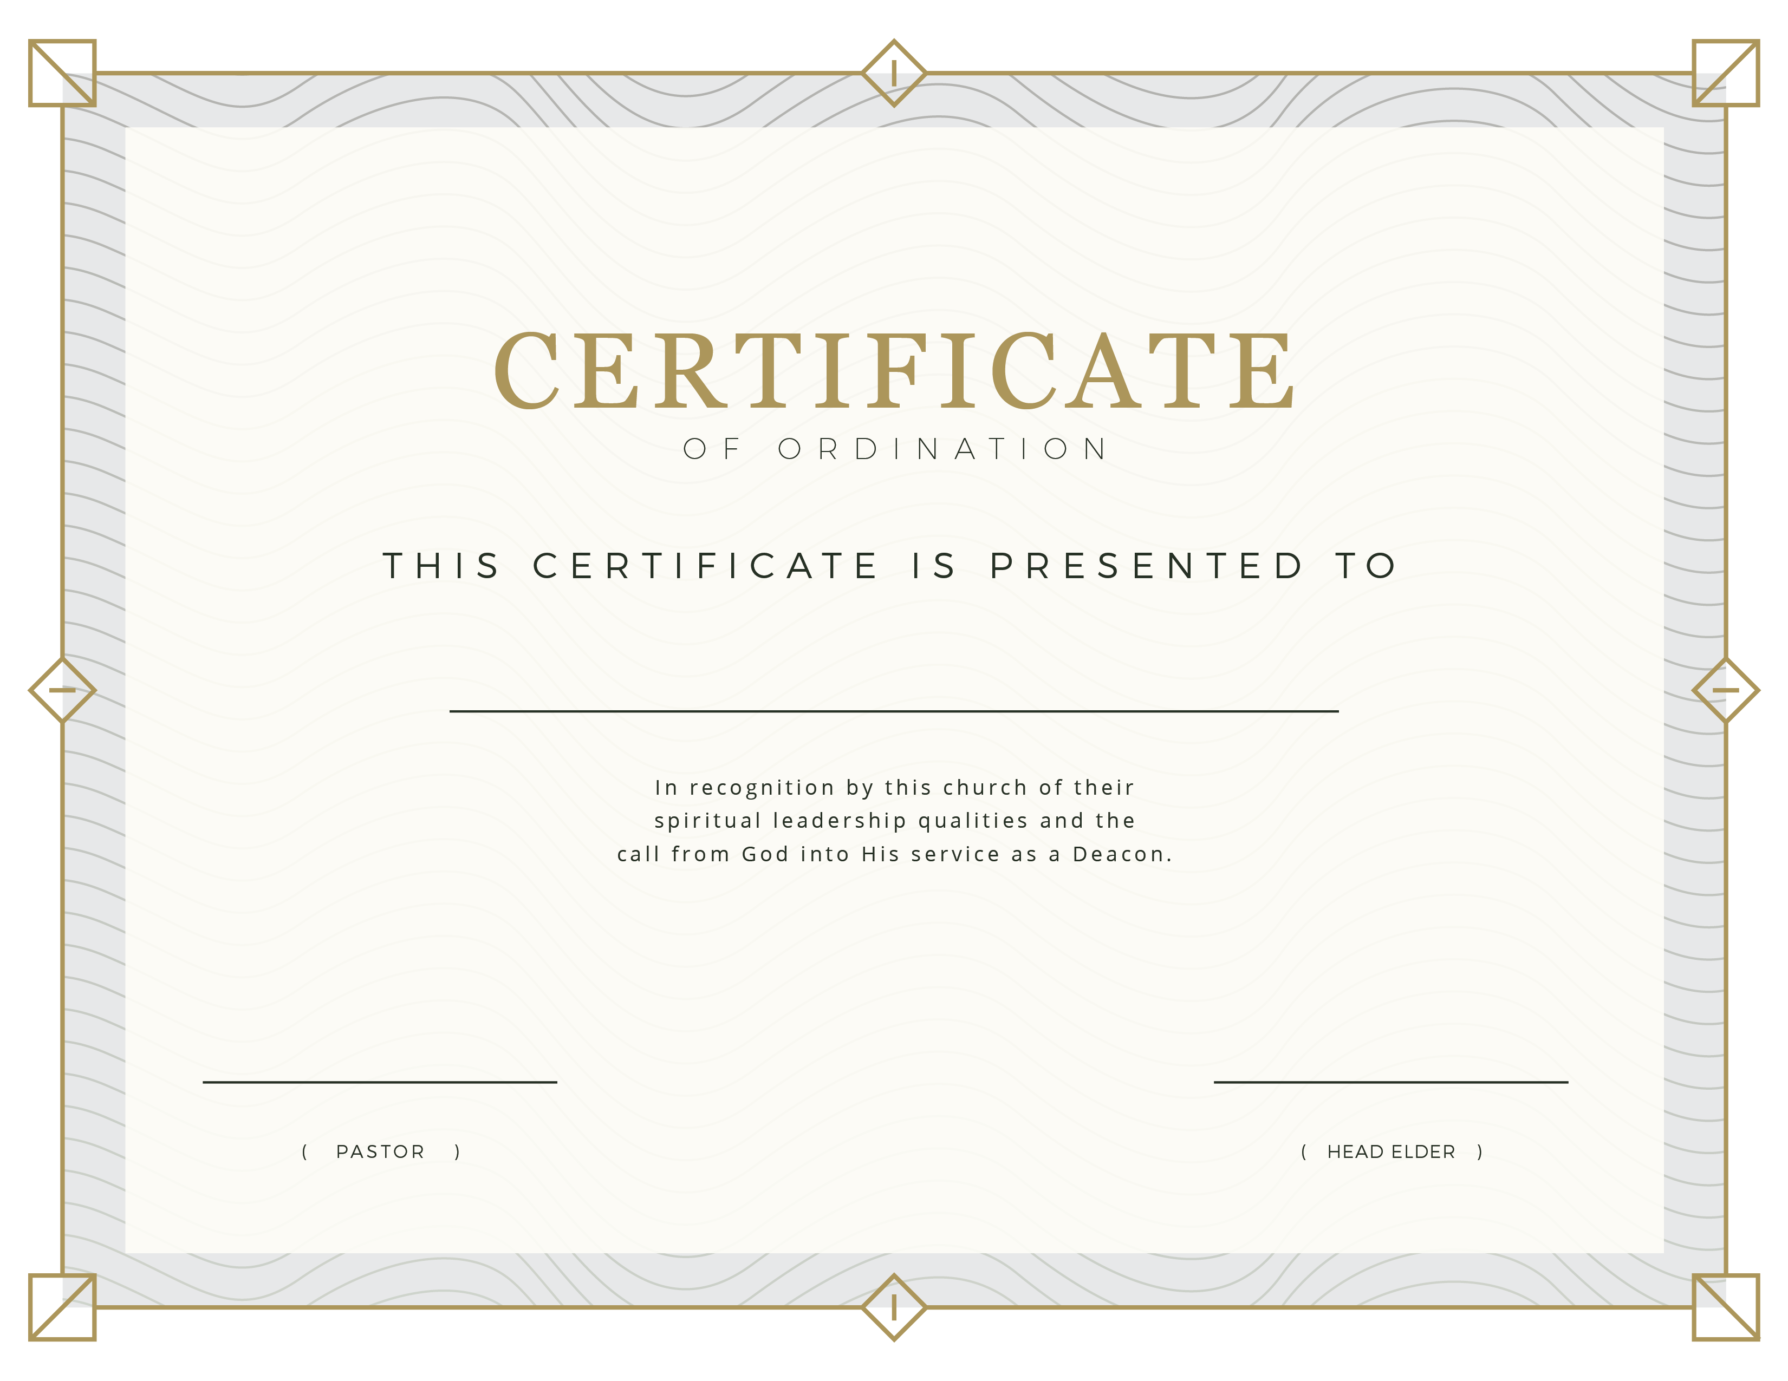
Local Seventh-day
Adventist Church
FEBRUARY, 25 I 2018
BOB SMITH
FRED SOMEBODY
John Smith

