
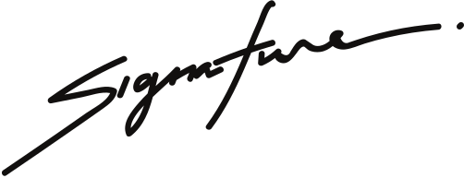
SCHOLARSHIP AWARD
Mariel Arevalo
JAMIE CHASTAIN
Company President
TAYLOR ALONSO
Vice President
in recognition of her excellence in academic endeavors & community involvement.
THIS IS AWARDED TO

