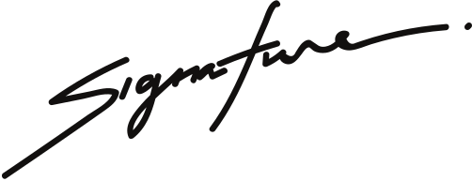
SCHOLARSHIP PROGRAM NAME
Certificate of Scholarship
This is to certify that
YEAL AMARI
for outstanding performance in ABC Program,
on 3rd December 2029.
Sigature name
Sigature name

