


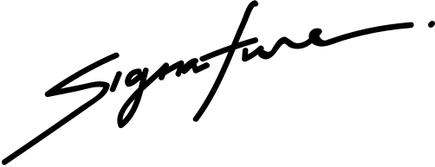


NOAH SCHUMACHER
CERTIFICATE OF SCHOLARSHIP
THIS IS TO CERTIFY THAT
Marceline Anderson
in honor of your outstanding performance in the ABC Program.
The Chariman
10 DECEMBER 2029
Date

