
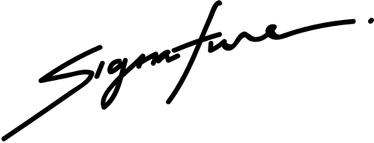
Certificate of
Scholarship
Curriculum Dean
CHRISTINA SHERLY
School Director
CLAIRE A. MAURA
in honor of your outstanding performance
in the ABC Program.
Isabel Mercado
This certifies that

