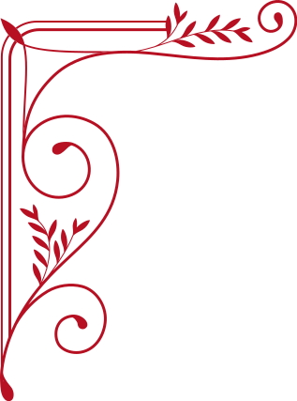

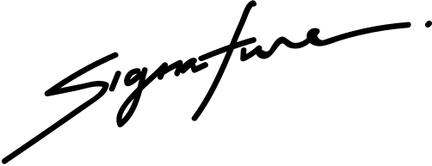
Lorem donec massa sapien faucibus et molestie ac feugiat sed lectus vestibulum mattis ullamcorper velit sed ullamcorper morbi tincidunt rnare massa eget egestas purus viverra accumsan in nisl nisi scelerisque eu ultrices.
CERTIFICATE
OF SCHOLARSHIP
This is to certify that
Connor Hamilton
Curriculum Dean
School Director

