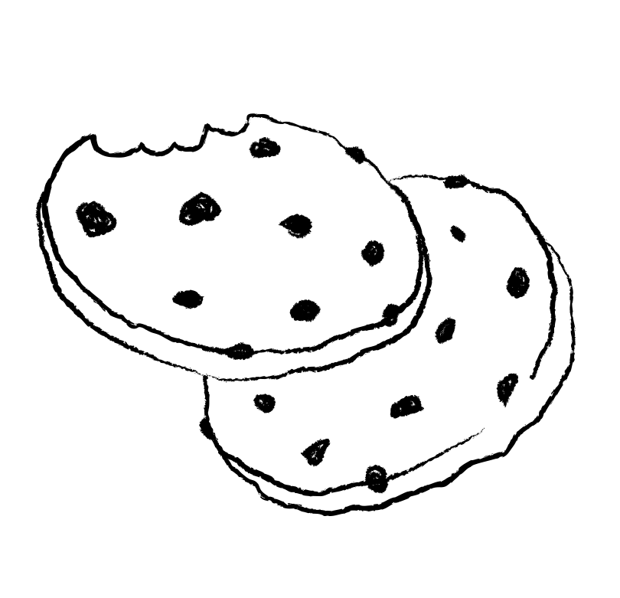
Start!
Great job
Keep going
Awesome
GREAT
ALMOST THERE
GOAL!
SALES GOAL
Girl Scout Cookies

