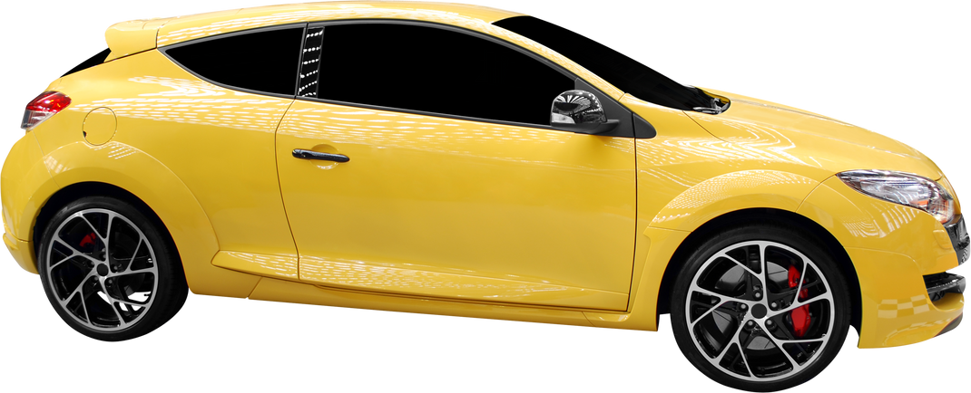
AUTO DETAILING
$129
LIMITED PACKAGE
  - Complete Meticulous Hand Wash
  - Chamois Dry
  - Interior Vacuum
  - Clean All Flat Interior Surfaces
  - Wash Floor Mats
  - Clean & Dress All Tires
  - Clean Door Jams / Interior Windows
PRICE LIST
$219
PLATINUM PACKAGE
  - Clean Wheel Wells & Rims
  - Spray Wax
  - Full Engine Shampoo
Includes All From Limited Package Plus:
$69
SALT WASH PACKAGE
  - Clean Mats (Wash & Vacuum)
  - Remove Salt Stains
  - Exterior Wash
123-456-789
123 Anywhere St., Any City

