

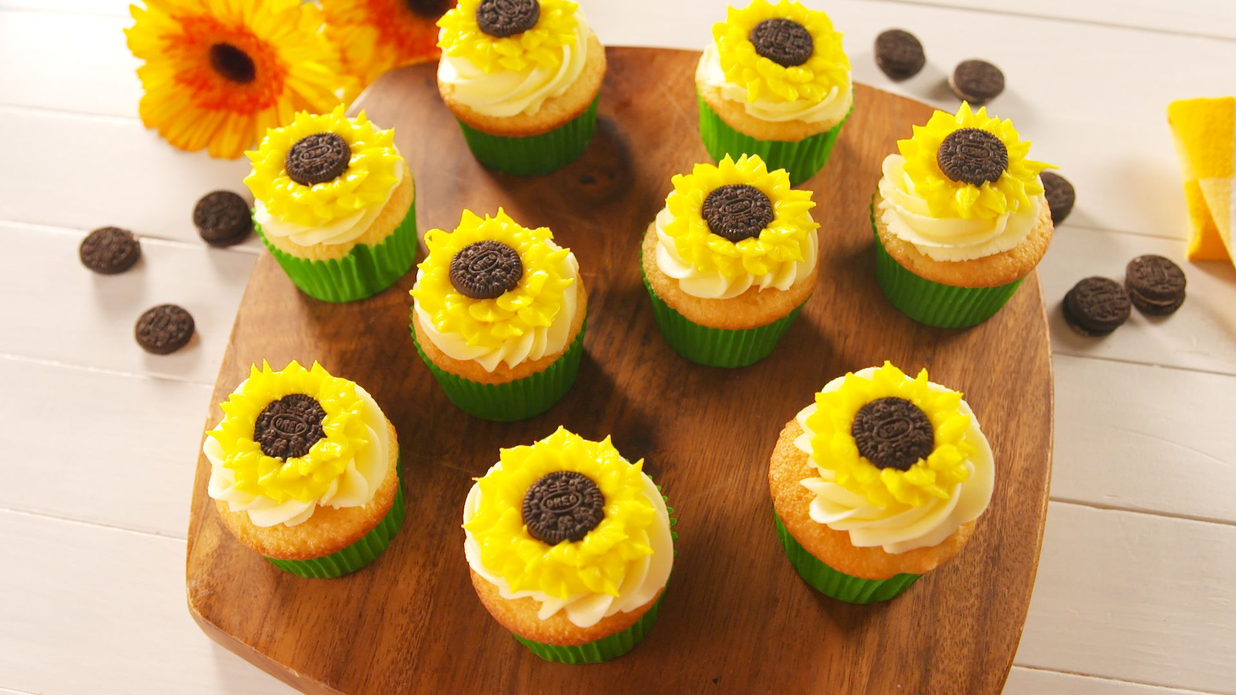
926 Baker Street, Sylvania, Ohio • 585 125 5689
WWW.BAKESALECOMPANY.COM
BAKE SALE
COOKIES $2
BROWNIES $3
MUFFINS $3
CUPCAKES $4
CAKE SLICE $5
WHOLE CAKES $5
PIES $4
ICE CREAM $6
DONUTS $3
LOREM IPSUM $8
LOREM IPSUM $7

OPEN
DAILY
07-19

