
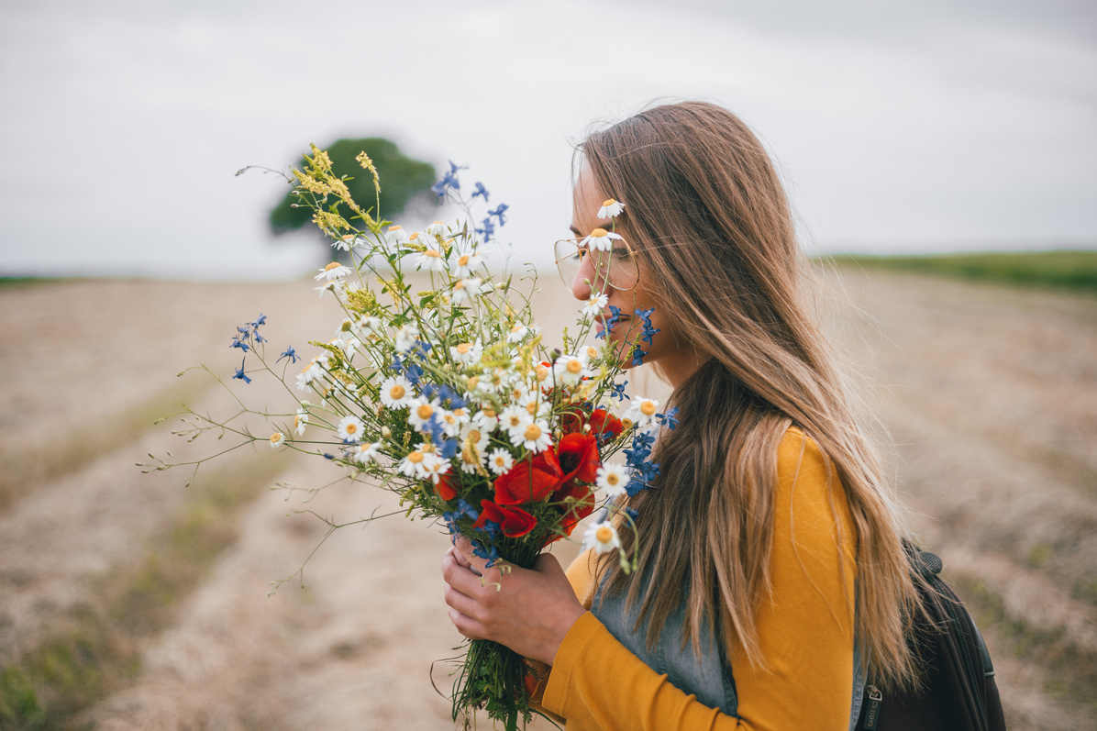
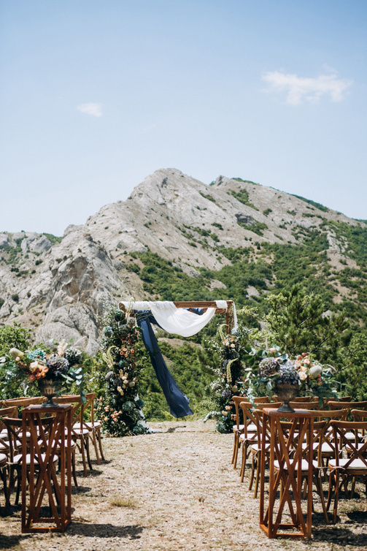
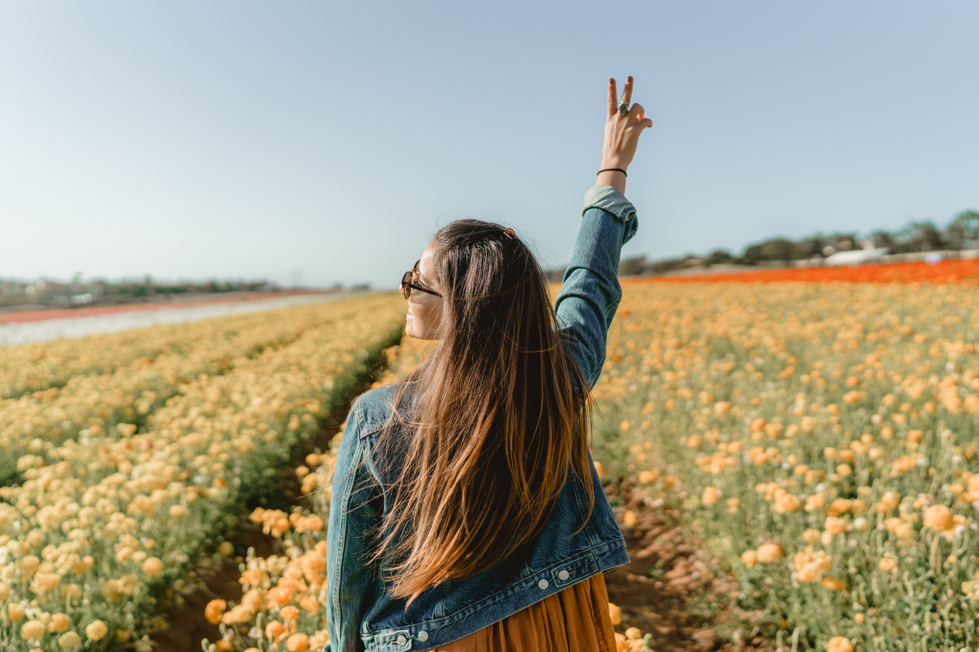
beginner photography
PRICE LIST
8 hour seasons
250 edited pictures
Two locations
Photo album
Canvas prints
Online access
2 hour seasons
50 edited pictures
Two locations
Photo album
Three 5x7 prints
Online access
1 hour season
25 edited pictures
One location
Photo album
One 5x7 print
Online access
Package three
Package two
Package One
$750
$450
$275
CANVAS
5x7
8x10
8x20
20x30
30x50
$35
$74
$125
$250
$375
PRINTS
4x6
5x7
6x8
6x10
11x14
13x19
$12
$24
$45
$50
$57
$64
ALBUMS
10x10
12x12
14x11
$275
$300
$450

