

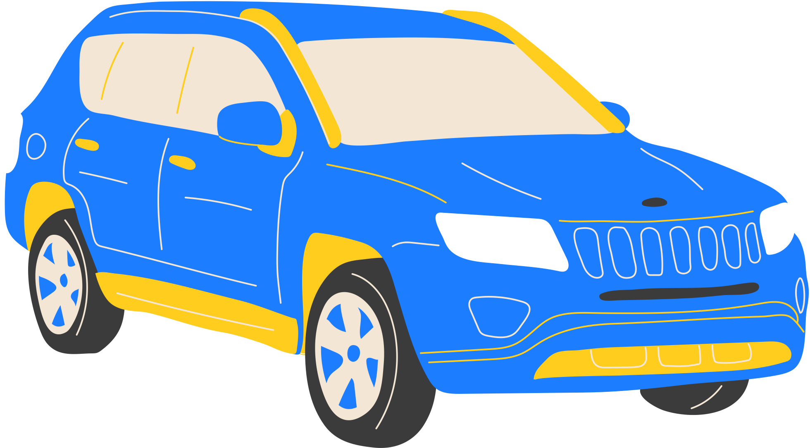





CAR WASH
$8
PACKAGE 1
PRE WASH
WASH & WAX
LEATHER DRY
TYRE SHINE
PRICE LIST
WASH NOW
123 Anywhere St., Any City
+123-456-7890
$12
PACKAGE 2
PRE WASH
WASH & WAX
LEATHER DRY
TYRE SHINE
WHEELS CLEANED
$20
PACKAGE 3
PRE WASH
WASH & WAX
LEATHER DRY
TYRE SHINE
$30
PACKAGE 2
PRE WASH
WASH & WAX
LEATHER DRY
TYRE SHINE
WHEELS CLEANED
WHEELS CLEANED
DOOR SHUTS CLEANED
INTERIOR HOOVER
RUBBISH REMOVED
INTERIOR DUST

