
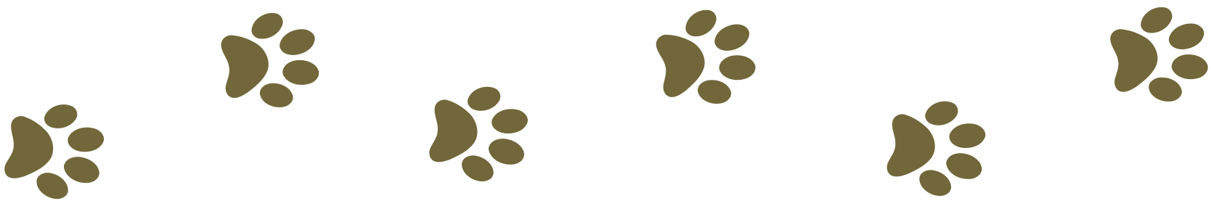
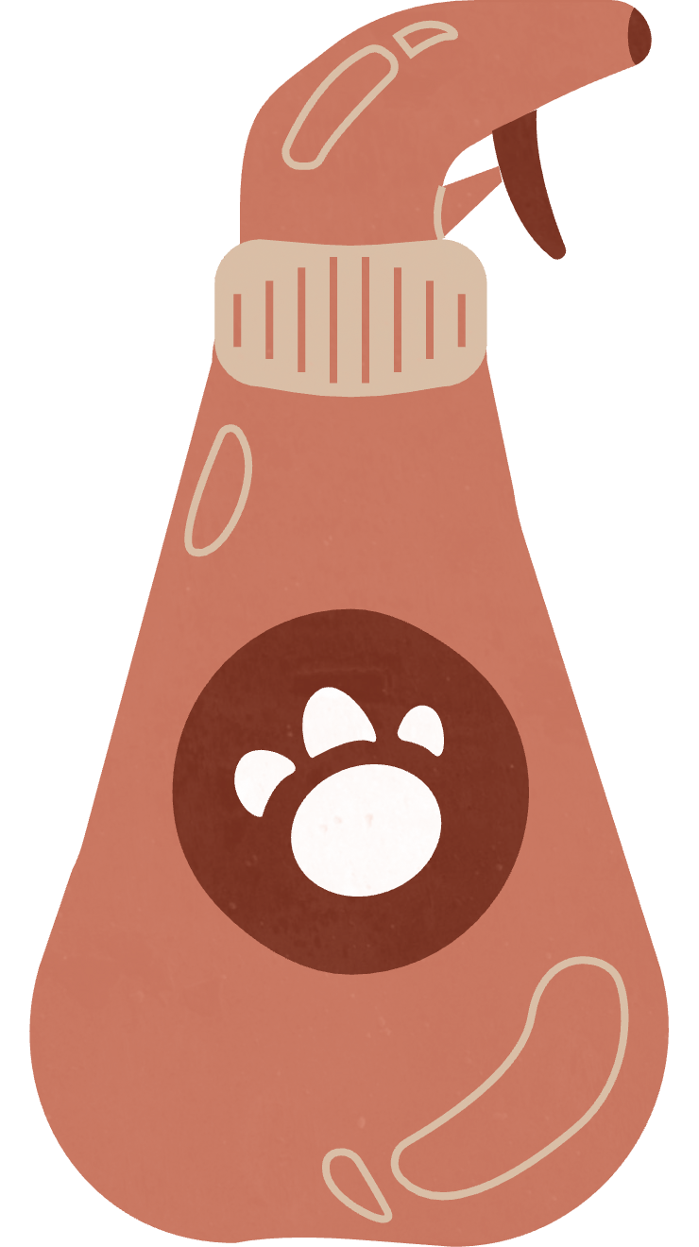
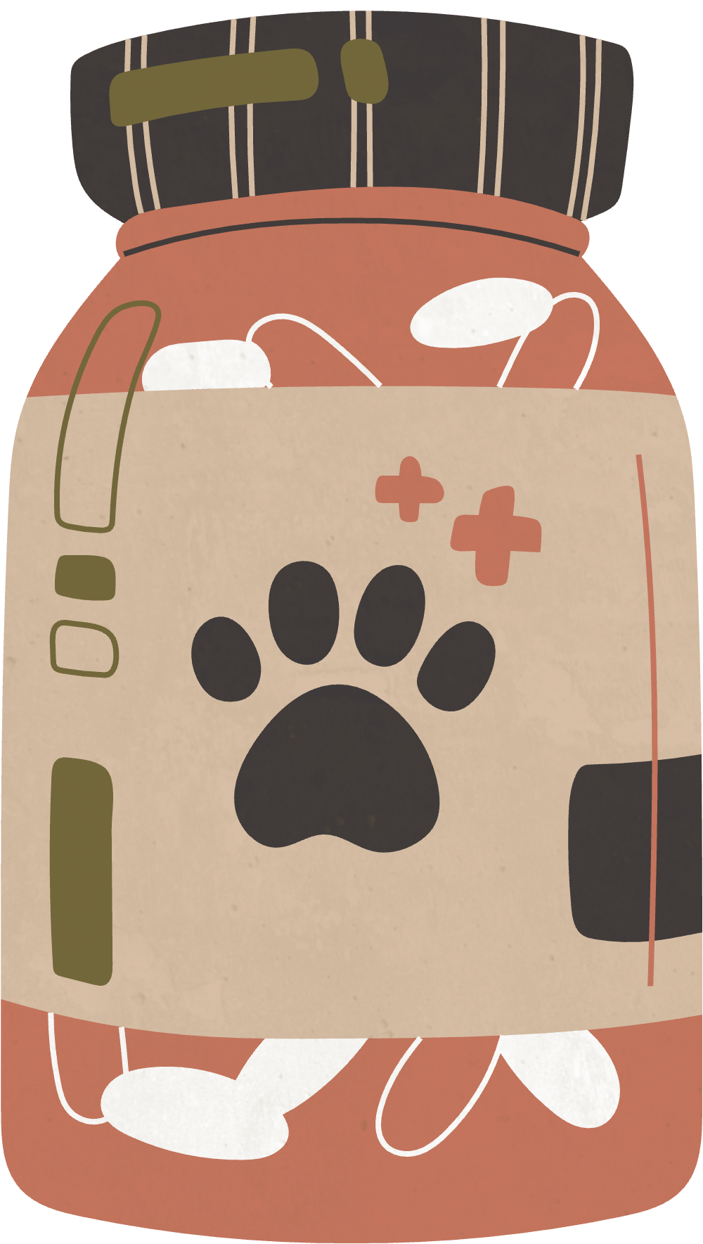
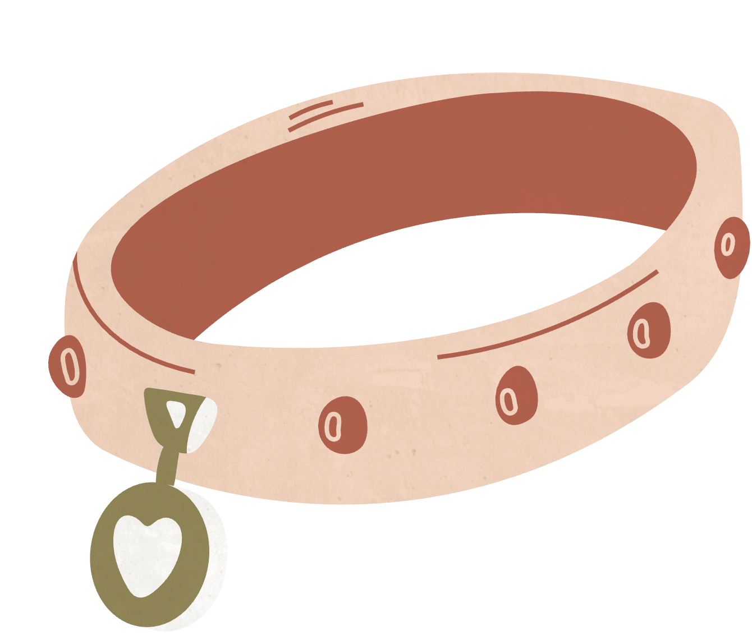
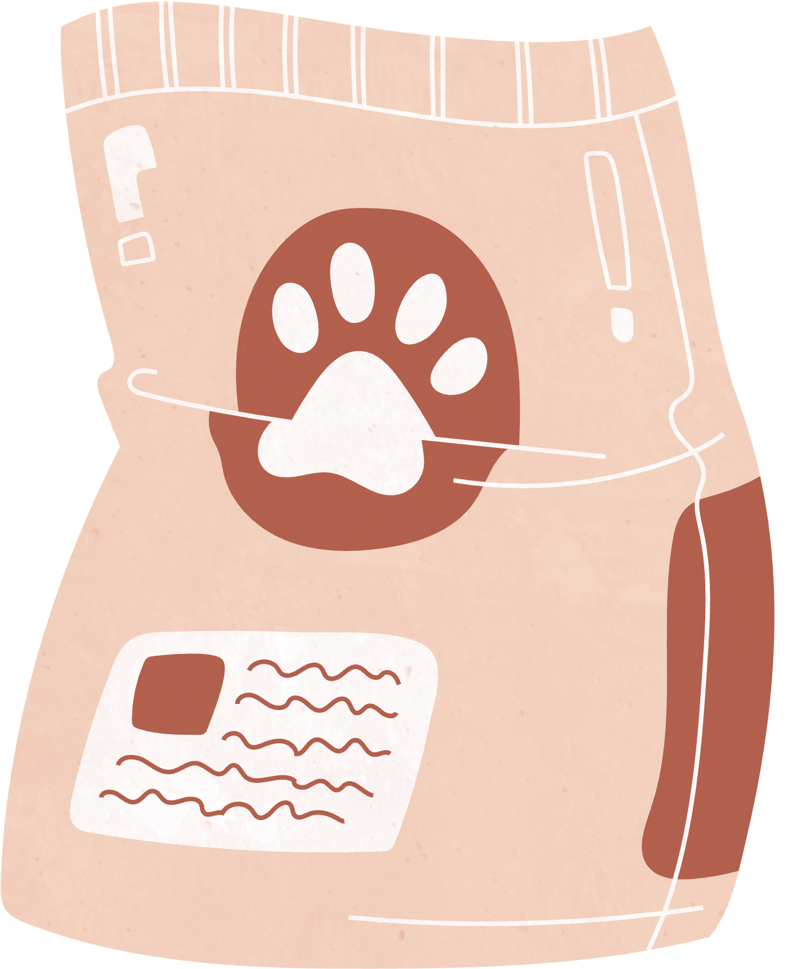
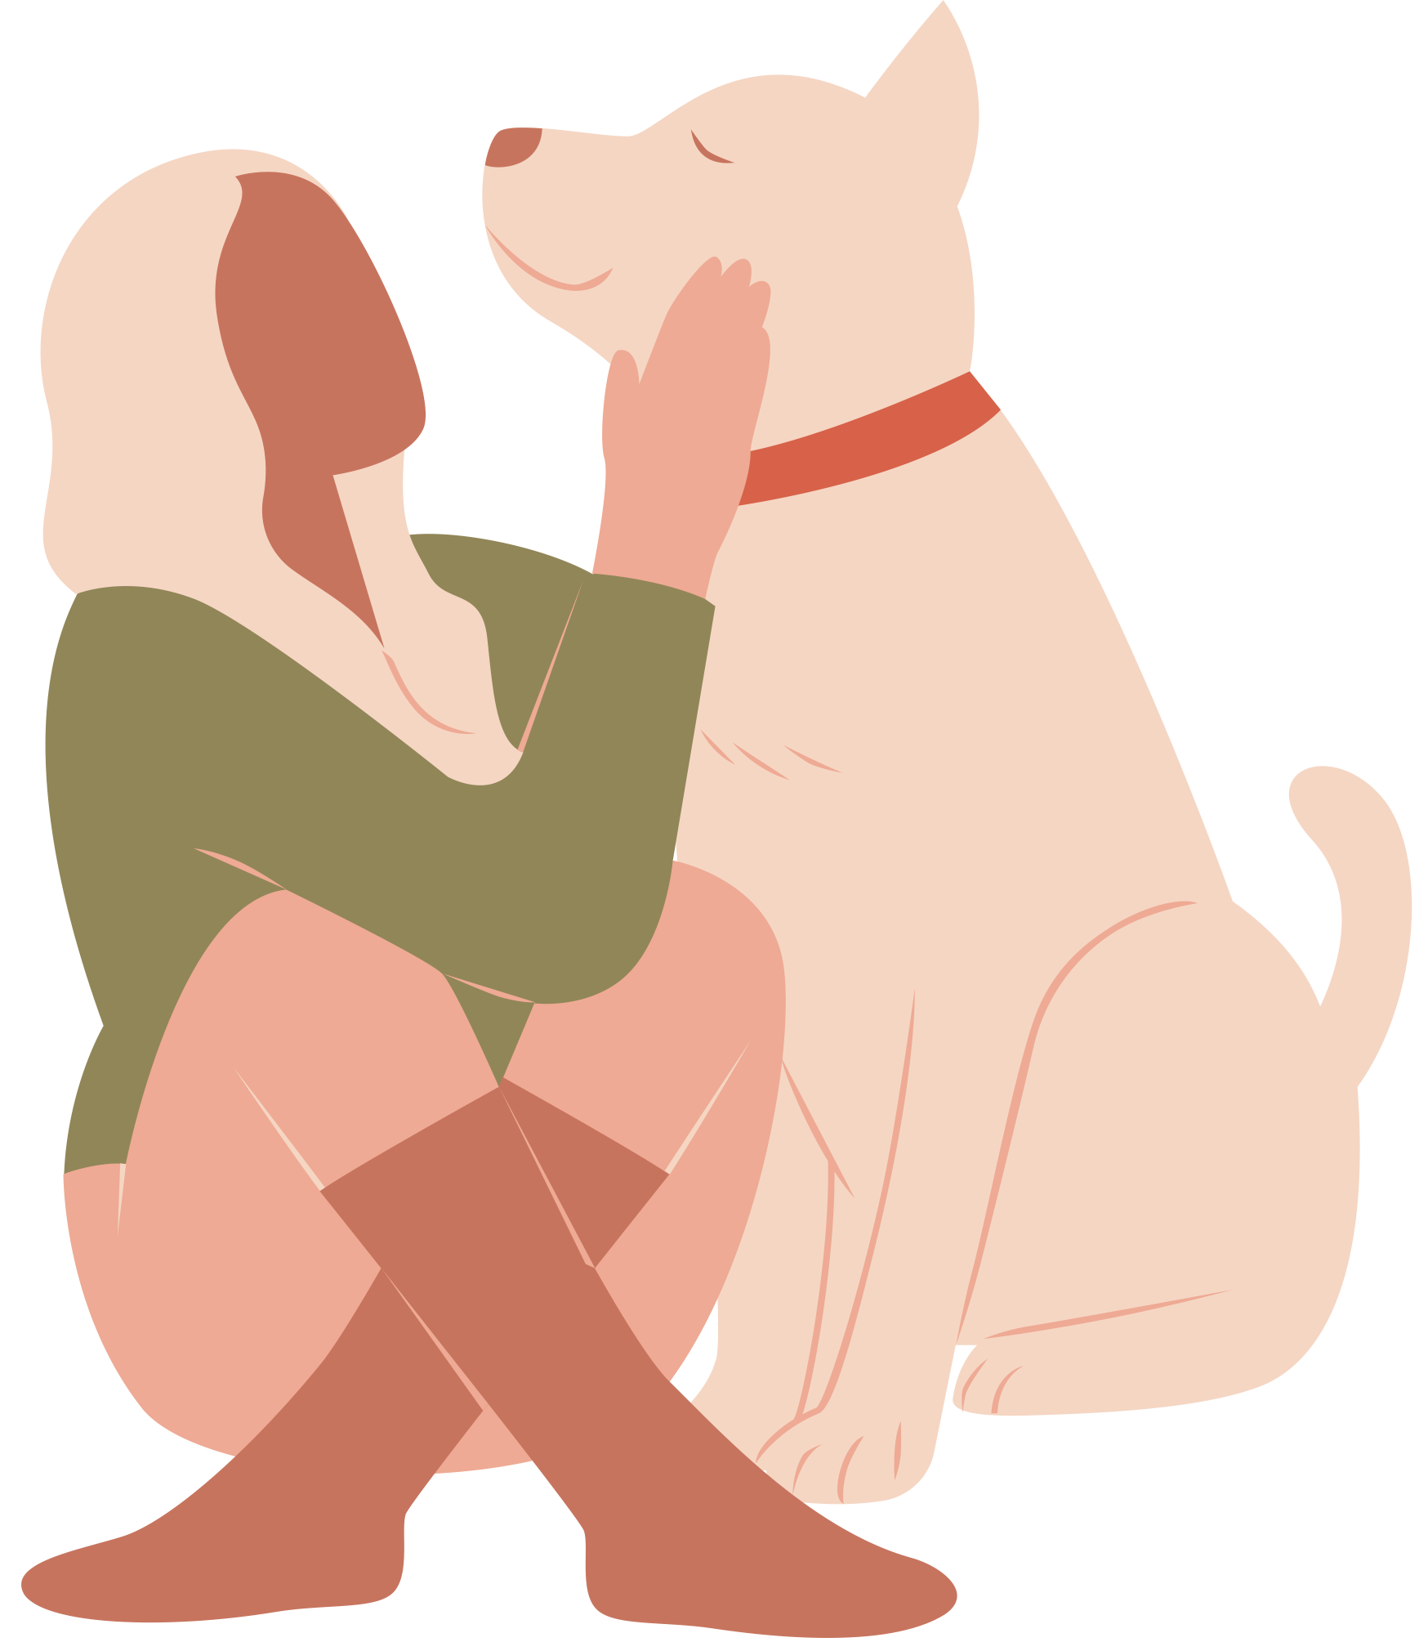
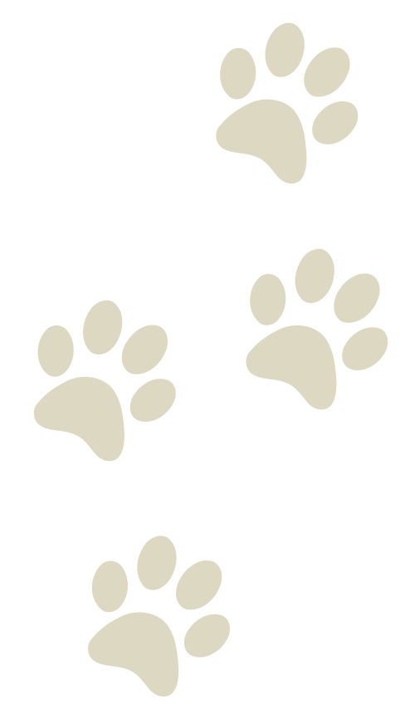
Dog Grooming
PRICE LIST
Toy
Small
Medium
Large
$7
$9
$11
$13
Toy
Small
Medium
Large
$7
$9
$11
$13
Premium Spa
Shampoo + Blowdry + Nails + Ears + Massage + Cologne + Haircut
Toy
Small
Medium
Large
$7
$9
$11
$13
Special Bath
Shampoo + Blowdry + Nails + Ears + Massage + Cologne
Basic Service
Shampoo + Blowdry + Nail + Ears

