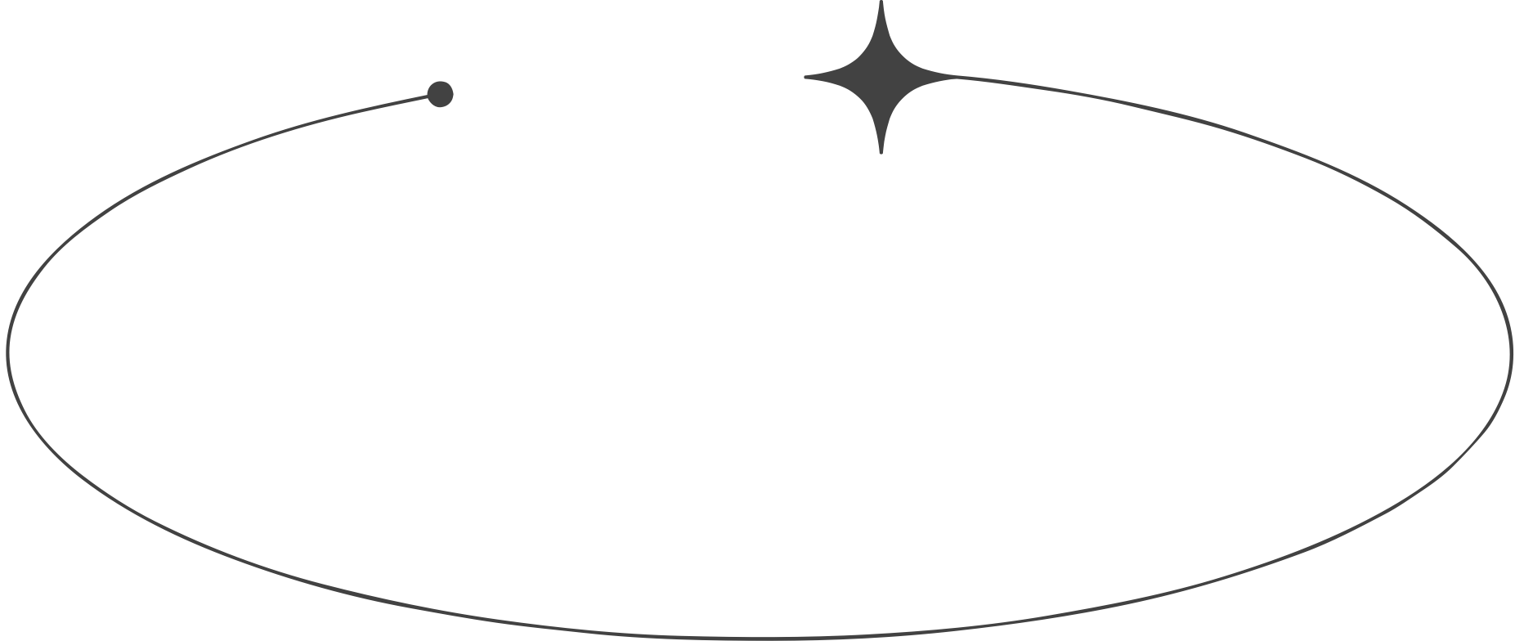
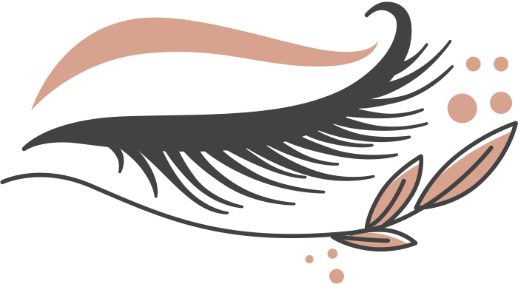
LASH
PRICE LIST
Eyelash Extensions
$40
$20
$30
$30
$15
$10
$20
Lash Lift
Master Stylist Upgrades
Lash Upgrades
Eyebrow Shaping etc.
Full Set Upgrade
Brow Lamination

