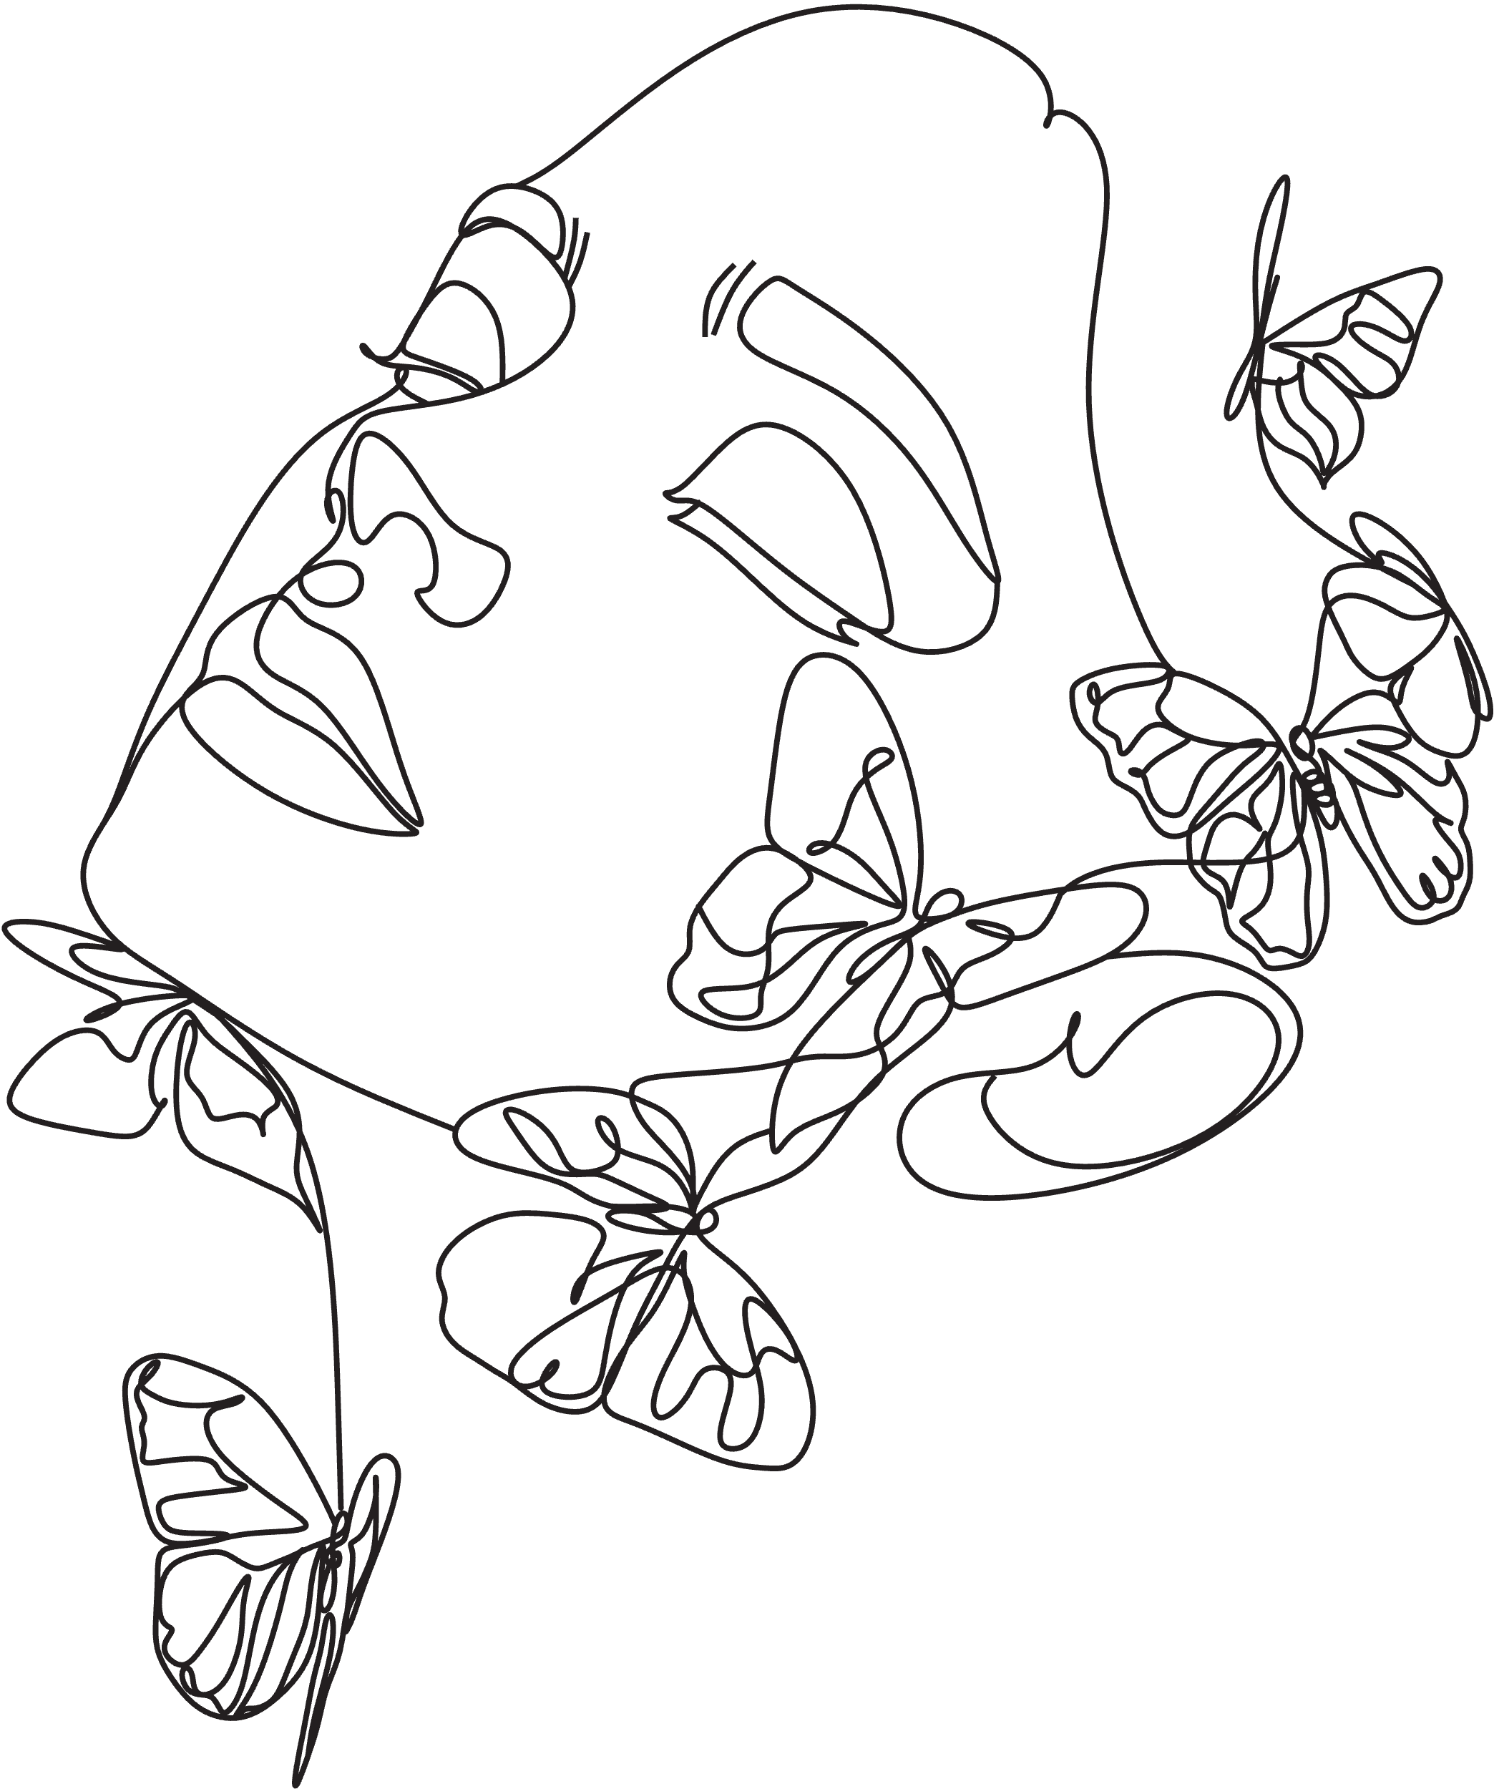
NAILS
Classic manicure
$45
Express manicure
$55
MAKE-UP
Cleanse, make-up & lashes
$45
Cleanse & make-up
$35
Make-up lessons
$60
EYECARE
Eyebrow wax & shape
$25
Eyebrow tint
$25
Eyelash tint
$25
Full set of lashes
$45
Makeup
PRICE LIST

