 | KID TO DO LIST
 | ☐ |  | 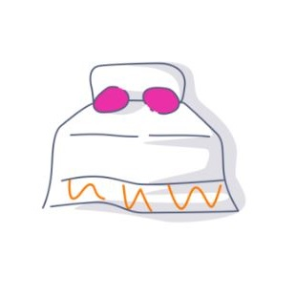 |  | Make Bed |  | ☐ |  | Brush Teeth
 | ☐ |  | Get Dressed |  |  |  | ☐ |  | 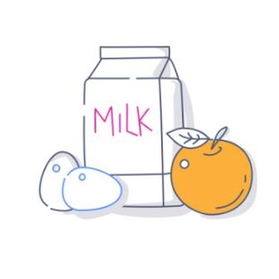 |  | Have Breakfast
 | ☐ |  | 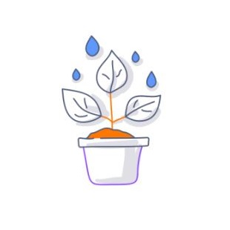 |  | Water Flowers |  | ☐ |  | Do Homework
 | ☐ |  | Help Grandma |  |  |  | ☐ |  | 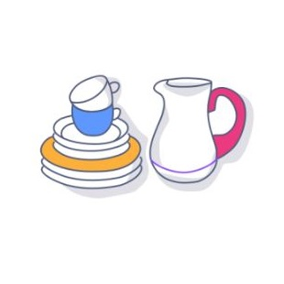 |  | Clean Dishes
 | ☐ |  | 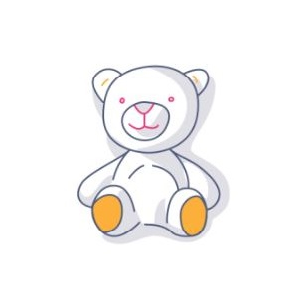 |  | Pick Up Toys |  | ☐ |  | Take a dog for a walk

