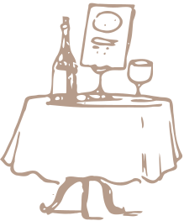
Restaurant
To Do List
No.
To Do
Yes/No
Notes

