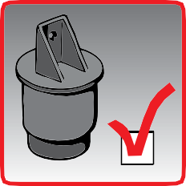
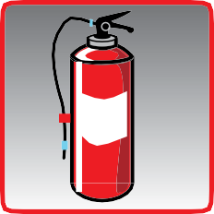
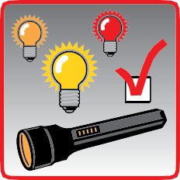

VEHICLE CHECKLIST
For professional truck drivers
Emergency Equipment
Be prepared and don’t begin a journey without appropriate emergency equipment!
First aid Kit
Emergency Vest
Warning Triangle
Fire Extinguisher
Lights And Devices
Ensure all lights and on-board devices are properly working before the journey!
Front, rear, and indicator lights
Side lights, warning lights, and reflectors
Spare lightbulbs, fuses, and flashlight onboard
Recording devices such as Tachograph, gpS, etc
WHEELS And Suspension Systems
make sure that the wheels and suspension systems are in proper conditions!
1x

1x
Check tyre profile and absence of damage (eg punctures)
Check tyre pressure and ensure bolts are tightened
Check suspension system
Check for a spare wheel and at least one wheel chock per vehicle
*Always refer to your vehicle’s owner’s manual and relevant national legislation

6:00 0km/h

Vehicle checks must be performed regularly by all drivers to avoid preventable incidents and accidents. The UICR and IRU have put together this checklist to assist drivers in ensuring adequate state of their vehicle.*


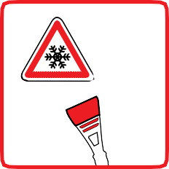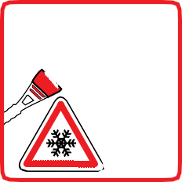
Fluids
Check for the correct level of fluids before the journey as indicated by the manufacturer!
OIL
Check for leaks!
oil
Coolant
Windshield Liquid
Connections
Check your vehicle’s connections before your journey!
air and power connections
Landing legs
Fifth wheel and kingpin
Battery, alternator and starter
Load Securing And Security
Check for your load’s securing and vehicle’s security before your journey!
Check that the transport unit is locked or properly sealed (TIR)
Check that the load is properly secured
Check that the curtainsider is properly fastened
Check that the transport unit is not damaged
Precautions In Winter
Pay special attention in difficult meteorological conditions!
de-Ice Windshield
Remove snow and ice from vehicle
Remove snow from the front grill and the distance control unit
Use appropriate winter equipment

