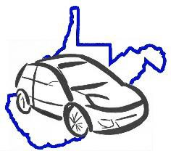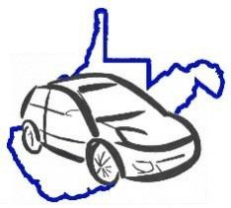
Fleet Vehicle Inspection Checklist
Page 1 of 1
X = Satisfactory O = Requires Attention

DATES

VEHICLE INSPECTION:

PRE-START UP
am
pm
am
pm
am
pm
am
pm
am
pm
Comments:
Check all fluids

(oil, washer, transmission)

INTERIOR (Start Engine)
Fuel Level

Horn

Sterring Wheel (Feel)

Foot Brake/Parking Brake

Registration / Insurance Cards

Heat/Defrost/AC

Interior Lights

Upholstery, Loose Objects

Seatbelts/Child Car Seats

First Aid Kit/Body Fluids Kit

Fire Extinguisher

Emergency (chains, flares, flashlight, blankets)

WINDOWS/MIRRORS
Wipers/Washers

Mirrors/Glass Clean/Clear View

EXTERIOR
Head Lights (High/Low)

Turn Signals (Front/Rear)

Emergency Flashers

Tires (Wear, PSI with gauge)

Spare Tire (Pressure)

Tail Lights/Back-Up Lights

Exhaust (Sound/Emmissions)

Dents / Scratches

UNDER CARRIAGE
Obvious Leaking fluids

Loose/Hanging Objects

DRIVER'S INITIALS

Last 6 of VIN:

License Plate:

Odometer Reading:

Make and Model:

Driver Name:

Agency:

