Vehicle Service Inspection Checklist Form
Key: OK (Passed Inspection)
X (Not Acceptable)
N/A (Not Applicable)
Notes:
PLEASE READ CAREFULLY BEFORE SIGNING: In understand that this checklist reflects the general condition of my vehicle when released to Dealer Name Here, Inc. for service but does not include mention of any hidden defects. Should such defects appear/be found during the service of my vehicle, I instruct Dealer Name Here, Inc. to contact me, or my representative, for authorization to repair any defect that would affect the proper and safe completion/operation of said service, provided it is in their capacity to repair. My authorization gives Dealer Name Here, Inc. permission to make the necessary repairs at my expense. I also understand that these additional repairs may cause some delay in completion of my service. I further understand that some, or possibly all, of the gasoline in my vehicle will be used to move my vehicle in and about your premises for road testing and reasonable additional mileage will be accrued.
Customer/Representative Signature:
Inspector:
Date:
Page 1 of 3
Date Mileage In Mileage Out Customer Name Year Make Model
VIN Gas ¼ ½ ¾ F Incoming Inspection By: Outgoing Inspection By:
ITEM
IN
OUT
ITEM
IN
OUT
Battery

Gauges

Brakes

Dash Lights

Front Air Conditioning

Suspension Noises

Rear Air Conditioning

Other Chassis Problems

Heater

Radio

Speakers/Radio

Carpet

Walls

Headliner

Jacks/Tools

Door Locks

Power Window – Driver Side

Power Window – Passenger Side

Sun Visors

Dome Lights

Headlights

Tail Lights

Brake Lights

Directional’s

Adaptive Equipment:
Lift

Lift Control

Magnet Entry

Hand Control

Power Door Opener

Power Parking Brake

List Other Equipment:
Antenna(s)

Inside Mirror

Aux. Battery

Cell Phone

Vehicle Side Mirrors

Passenger’s Seat

Driver’s Seat

Rear Seat

2nd Row Driver’s Seat

2nd Row Passenger’s Seat

Cargo Door

Wash/Wiper

Spare Tire

Power Steering

Television

Cruise Control

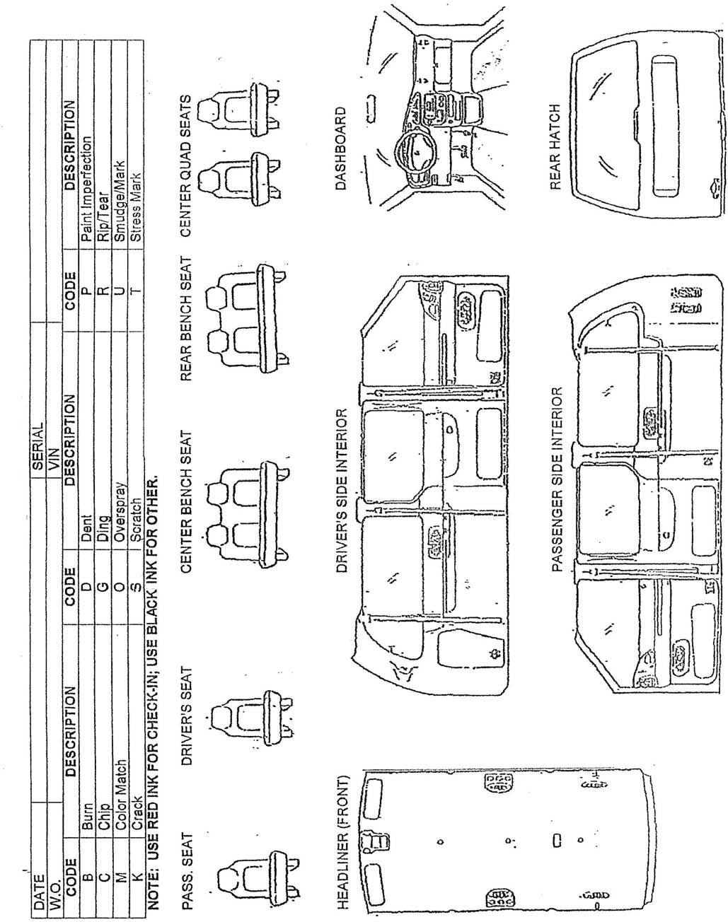
Vehicle Service Inspection Checklist Form
Page 2 of 3

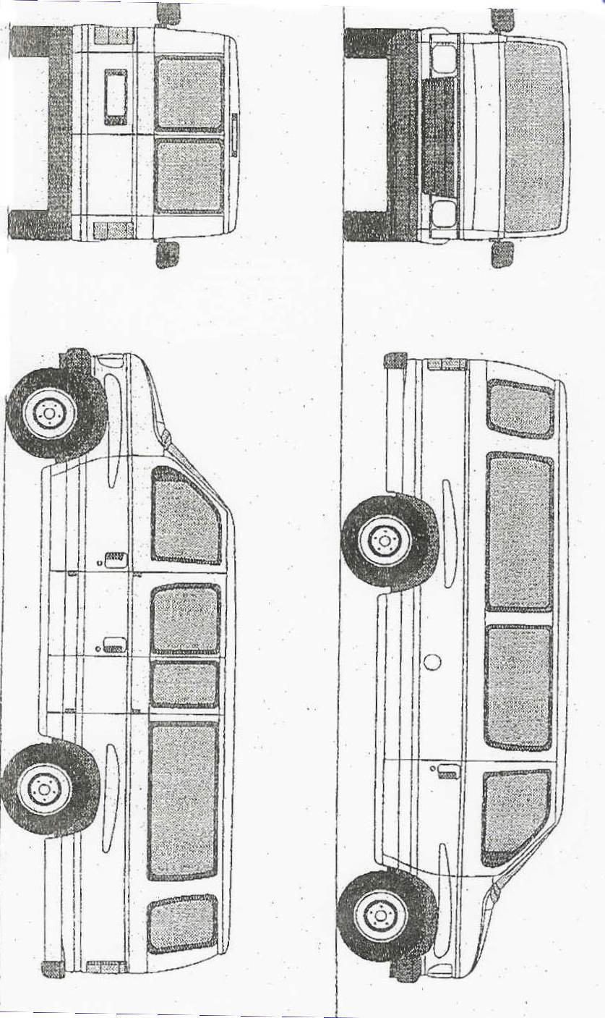
Vehicle Service Inspection Checklist Form
Page 3 of 3

