





























































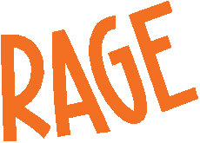
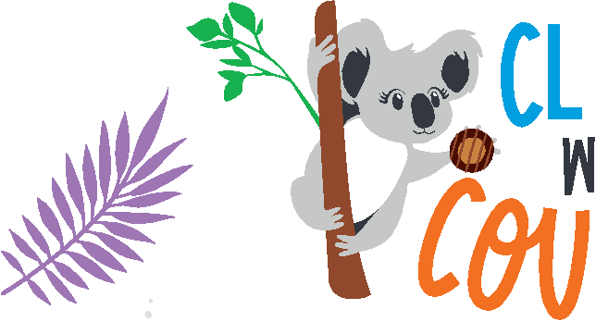










vision board template

Cookie season goal # 4: Cookie season goal #5:




























Cookie season goal #6:




The GIRL SCOUTS® name and mark, and all associated trademarks and logotypes, are owned by Girl Scouts of the USA. The LITTLE BROWNIE BAKERS® name and mark, and all associated trademarks are owned by Ferequity Inc., an afiliate of Ferrero Int’l, S.A. ®, ™ & © 2021 Ferequity Inc. CWC_042821

