
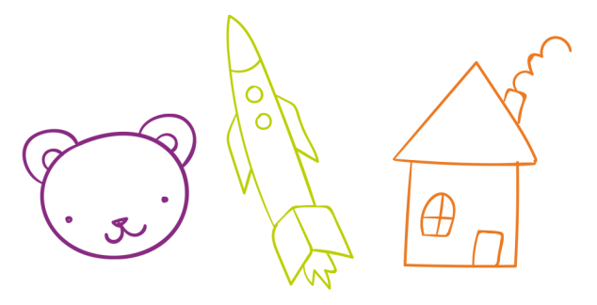
BEHAVIOR CHART
Ashley’s
THU
WED
SUN
SAT
FRI
TUE
MON
I didn’t talk back
I didn’t yell or scream
I helped feed the dog
I used please and thank you
I helped my sister with her homework
I helped mom cook dinner
I shared my snacks with my sister
I clean up my room
BEHAVIORS

