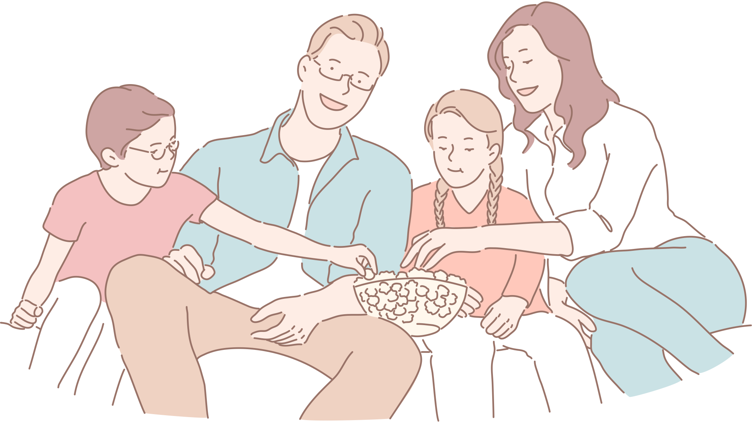

FAMILY ECOMAP
Hobbies
School
Friends
Hobbies
School
Friends
Child 1
Child 2
Family
Work
Hobbies
Material family
Father
Mother
Work
Family
Material family

