LANDLORD ESTOPPEL CERTIFICATE ESTOPPEL CERTIFICATE
THIS ESTOPPEL CERTIFICATE is given as of the day of , 2017, by THE CITY OF ARLINGTON (“Landlord”) at the request of AGUSTAWESTLAND PHILADELPHIA CORPORATION of Philadelphia, Pennsylvania, (“Tenant”), for the benefit of VAN BORTEL AIRCRAFT, INC., a New York corporation (“Sublessee”).

RECITALS

- In accordance with the terms and provisions of a certain Lease Agreement between the City of Arlington and Agustawestland Philadelphia Corporation dated December 1, 2011, as amended by Lease Modification #1 dated February 24, 2015 and the Consent and Estoppel to the Lease Agreement dated May 12, 2015 pertaining to a certain premise (the “Property”) located at Arlington Municipal Airport.

- Tenant proposes to sublease its leasehold interest in all of the Leased Premises, and to assign the Leases Agreement Lease, to Sublessee.

STATEMENT

Landlord hereby confirms and represents that:

  - A true and complete copy of the Lease Agreement, as amended to date, is attached hereto as Exhibit “A”. Tenant has accepted possession of the Leased Premises;

  - Improvements and space required to be furnished according to the Lease Agreement have been satisfactorily completed.

  - Tenant has fulfilled all its duties of an inducement nature and, to Landlord’s knowledge, Tenant is not in default in the performance of any of the obligations it undertook under the terms of the Lease Agreement;

  - The primary term of the Master Lease commenced on December 1, 2011, and expires on November 30, 2041;

  - Tenant has two five-year remaining options to extend the term of the Lease Agreement;

  - The monthly base rental under the Lease Agreement is $21,760.23 until December 1, 2017.

  - Tenant has not deposited any security deposit with Landlord, and Tenant is not entitled to credit for any other sums on deposit with Landlord;

  - All rent, charges or other payments due Landlord under the terms of the Lease Agreement have been paid through September 1, 2017, and Tenant has not prepaid any rent or other charges more than 30 days in advance of the dates on which that rent or those charges have become due under the terms of the Lease Agreement;

  - Landlord knows of no claims, counterclaims, credits, defenses or set-offs that it currently has against Tenant in connection with the tenancy created by the Master Lease; and

  - To Landlord’s knowledge, Tenant is not in material default in respect of any of its obligations and no event has occurred, and no condition exists, that would permit Landlord to terminate the Lease Agreement with the passage of time, the giving of notice or both.

This Certificate shall inure to the benefit of and may be relied upon by sublessee.

IN WITNESS WHEREOF, Landlord has executed this Estoppel Certificate on the

day of , 2017.

CITY OF ARLINGTON

By:

James F. Parajon, Deputy City Manager

Exhibit “A”

LEASE AGREEMENT BETWEEN
THE CITY OF ARLINGTON AND AGUSTA US, INC

This Lease Agreement, made and entered into this the 1st day of December, 2011, by and between the CITY OF ARLINGTON, TEXAS, a Texas Municipal Corporation
{"Lessor" or "City") and AGUSTA US, INC., its heirs, subscribers, or assignee ("Lessee").

WITNESSETH THAT

WHEREAS,

WHEREAS,
the City is the owner of the real property known as the Arlington Municipal Airport (the "Premises"); and

the City and Lessee are mutually desirous of entering into this agreement for the benefit of the public for the construction of certain improvements, rental of the improvements, and marketing of Leasehold interests in the improvements. In consideration of the rents to be paid and other considerations hereunder, the mutual promises and agreement of the parties hereinafter set forth, the City hereby enters into this agreement and leases, lets and demises to the Lessee certain portions of the premises located at the Airport, together with all buildings, structures, improvements, additions and installations existing or to be constructed thereon, together with the real property all described in Exhibit "A" attached hereto ("the Leased Premises") during the term of this agreement upon the following tenns and conditions:

ARTICLE 1 TERM

The initial term of this agreement shall be for thirty (30) years, beginning upon the "Effective Date"of December 1, 2011.

ARTICLE 2 LEASED PREMISES

The Leased Premises consist of the foilowing:

  - Real property consisting of approximately Ninety-Eight Thousand, Eight Hundred Fifty-One (98,851) square feet as shown on Exhibit "A", attached hereto and incorporated herein by reference as if written word for word; and

  - Any existing improvements thereon, and approved improvements to be constructed or installed on the Leased Premises during the term, or option periods, as show on Exhibit "B", attached hereto and incorporated herein by reference as if written word for word.

ARTICLE 3
USE OF LEASED PREMISES

The Lessee may occupy and use the Leased Premises for the following purposes:

  - Aircraft sales, engineering and design, flight testing, and aircraft maintenance; and

  - For any other aviation related activity or incidental uses in connection with any aviation related activity, upon prior written approval of the City's Airport Manager, except the sale of aviation products as provided for in subsection 2 of Article 14 of this agreement.

ARTICLE 4 RENTAL

  - For the use, marketing and occupancy of the Leased Premises herein granted, the Lessee agrees to pay to the City beginning December 1, 2011, and throughout the term of this lease a monthly rental to be computed as follows:

    - For the real property and the improvements existing and to be constructed the sum of Twenty Thousand Seven Hundred Fifty-Eight Dollars and Seventy­ One Cents ($20,758.71) annually to be paid in twelve equal monthly installments of One Thousand Seven Hundred Twenty-Nine Dollars and Eighty-Nine Cents ($1729.89) and continuing monthly thereafter subject to rent increases as provided herein. Monthly payments shall be subject to a rental increase or decreases at the end of the third year and at the end of each three (3) year interval thereafter, as noted in Article 4.1c.

    - All monthly rents shall be paid on the 10111 day of each month in advance at the office of the Airport Manager or at such other offices as may be directed in

writing by the Lessor. Ifrents are not received by the 101
\
the Airport Manager

may notify Lessee in writing of the delinquency. If rents are still not paid three additional days after a notice is delivered, Lessee shall be in default.

Rate Adjustments:

    - Years I - 3. The annual rent for the Leased Premises (Exhibit "A") shall be twenty-one cents ($.21) per square foot per year, payable in twelve (12) equal monthly payments as noted in Article 4. la.

All monthly payments specified in 4.1a shall be subject to an increase at the end of the third year of this Lease and at the end of each three (3) year interval thereafter including option period s, if any. Subject to a maximum increase of twenty (20%) for any single increase over the immediately prior annual payment, the new annual payment shall be equal to the greater of the following:

      - The prevailing rental rate for the mean of all lease rates for similar leases (unimproved premises - land only) then and there in effect at Arlington Municipal Airport executed after the Airport Minimum Standards for Commercial Aeronautical Activities was adopted in May 1989; or

      - The annual payments charged Lessee during the immediately preceding Lease year; or

      - The percentage change, if any, in the consumer price index over the immediately preceding three (3) years as determined by the United States Bureau of Labor Statistics -CPI All Urban Consumers for the Dallas Fort Worth Area.

ARTICLE S EXTENSION OF TERM

The City hereby grants Lessee, its heirs, successors, and assigns the following extension options:

  - First Option Period: Five (5) years beginning at the expiration date of the initial term.

  - Second Option Period: Five (5) years beginning at the expiration date of the first option period.

  - As a condition for the exercise of each option, Lessee shall give written notice of Lessee's intent to exercise its option no later than one hundred eighty (180) days prior to the expiration date of the term of the agreement in effect.

  - All conditions and covenants contained herein shall remain in force during any and all extension periods. During any option period , no additional rentals shall be charged for any leasehold improvements added or constructed by Lessee, or sublessee, during the term of the lease or any option period, as long as such improvements are within the Leased Premises shown in Exhibit "A".

  - The right of Lessee, its heirs, successors, or assigns to exercise this option(s) is conditioned on proper notice, required in Section 5.3 of this subsection and is further conditioned upon Lessee, its heirs, successors, or assigns having cured any defaults in the performance of this agreement by the beginning date of the extension of the term for which such notice is given.

  - Lessee shall not have the right to exercise such options if this lease has been terminated for any reason or reasons, or Lessee is in default as to any provision or condition of the lease prior to the exercise of an option granted under this section.

  - At the conclusion of the entire 40 year period enumerated above, should the Lessor desire to again lease the premises, Lessee shall have the right to lease such based on a rate as the market may bear.

ARTICLE 6
ACCEPTANCE, CARE, MAINTENANCE, IMPROVEMENTS AND REPAIR

  - Lessee warrants that it will inspect the Leased Premises and accept possession of the Leased Premises and the improvements thereon in their "as is" condition when accepted, and subject to all limitations imposed upon the use thereof by the rules and regulations of the Federal Aviation Administration and the City of Arlington, and will admit upon acceptance its suitableness and sufficiency for the uses permitted hereunder. Except as may otherwise be provided for herein, the City shall not be required to maintain nor to make any improvements, repairs or restoration upon or to the improvements located thereon. City shall never have any obligation to repair, maintain or restore, during the term of this lease, any improvements on the Leased Premises including but not limited to, buildings, pavements, landscaping, gates and fences.

  - Lessee, its heirs, successors or assigns shall throughout the term of this agreement assume the entire responsibility, cost and expense, for all repair, reconstruction and maintenance whatsoever on the improvements and maintain improvements thereon in a good workmanlike manner, whatever such repair or maintenance be ordinary or extraordinary, structural or otherwise. Additionally, Lessee, without limiting the generally hereof, shall:

    - Maintain the premises in a clean and orderly condition and appearance and all improvements thereon and all of the Lessee's fixtures, equipment and personal property which are located on any part of the Leased Premises.

    - Provide and maintain on the Leased Premises all obstruction lights, similar devices, and safety equipment required by law, rule, order, ordinance, resolution or regulation;

    - Repair any damage caused by Lessee to the Leased Premises or caused by any agent, employee, representative or business invitee.

    - Take measures to prevent erosion, including planting, irrigation and replanting of grasses and landscaping with respect to all portions of the Leased Premises not paved or built upon.

    - The Lessee will be responsible for the maintenance and repair of all utility service lines placed on the Leased Premises by Lessee including, but not limited to, service water lines, service gas lines, fire hydrants, electrical power, sanitary sewers, storm sewers and all common taxiways, unless those lines do not serve Lessee.

Repair any disturbed areas of the Airport outside of the Leased Premises caused by Lessee, or any agent, employee, representative, or contractor of Lessee.

  - In the event the Lessee fails to commence to maintain, clean, repair, replace, rebuild or repaint within a period of ten (10) days after written notice from the Lessor to do any reasonable maintenance or repair work required to be done under the provisions of this agreement, other than preventive maintenance, or to diligently continue the completion of any repairs, replacement, rebuilding, painting or repainting as required under the agreement; then, the Lessor may, at its option, and in addition to any other remedies which may be available to it, enter the premises involved, without such entering causing or constituting a cancellation or breach of this agreement or an interference with the possession of the Lease Premises, and repair, replace, rebuild or repaint all or any part of the Leased Premises or the improvements thereon, and do all things reasonably necessary to accomplish the work required, any the cost and expense thereof shall be payable to the Lessor by Lessee on demand. Provided , however, if in the opinion of the Lessor, the Lessee's failure to perform any such maintenance endangers the safety of the public, the employees or property of the or other tenants at the Airport, and the Lessor so states same in its notice to Lessee, the Lessor may, at its sole option, in addition to all other remedies which may be available to it, elect to perform such maintenance at any time after the giving of such notice, and Lessee agrees to pay to the Lessor the cost and expense of such performance on demand. Lessor hereby agrees, that Lessee placing orders for any structural components, and requesting bids on all repairs constitutes "commencing (sic) to repair, etc..."for purposes of this subsection.

Furthermore, should the Lessor, its officers, employees, or agents undertake any work hereunder; Lessee hereby waives any claim for damages, consequential or otherwise, as a result therefrom unless said damages are the result of Lessor's gross
,negligence. The foregoing shall in no way affect or alter the primary obligations of the Lessee as set forth in this agreement, and shall not impose or be construed to impose upon the Lessor and obligations to maintain the Leased Premises, unless specifically stated otherwise herein.

  - Plans and specifications for construction of all improvements and major repairs or replacements undertaken by the Lessee shall be submitted to and receive the written approval of the Lessor's Airport Manager and if necessary Federal Aviation Administration (FAA), and no such work shall commence until such written approvals are obtained, which the Airport Manger's approval shall not be unreasonable withheld or delayed . Lessee shall first submit or cause to be submitted to Lessor for written approval, the proposed architectural or engineering plans, and specifications of the proposed work in such detail so as to allow a proper review for approval or disapproval, IfFAA approval of the work is not needed, Airport Manager shall advise Lessee within fourteen (14) calendar days after receipt of the written request along with plans and specifications of City's approval or disapproval. If FAA approval of the work is needed, Lessee will submit to FAA any forms or documentation required for FAA review and approval and provide a copy of the FAA submitted forms or documentation to the Airport Manager. The Airport Manager shall advise Lessee within fourteen (14) calendar days after receipt of FAA's approval or disapproval. Upon approval from Lessor and if necessary FAA, Lessee must then obtain all necessary building permits from the City. When constructing any building or improvement upon the Leased Premises , the plans and specifications shall be prepared by Texas state-licensed architects and engineers. Lessee will accomplish the work as approved in accordance with the plans and specifications, or as the same may thereafter be modified with the consent of Lessor's

Airport Manager. Within sixty (60) calendar days of the issuance of the certificate of occupancy for any work inaccordance with this section, Lessee shall provide the Lessor's Airport Manager with a complete full size set of as-built plans.

    - Lessee shall include in all Lessee construction contracts the following prov1s1ons:

      - Contractor does hereby contract to waive all claims, release, indemnify, defend and hold harmless the City of Arlington and all of its officials, officers, agents and employees, in both their public and private capacities, from and against any and all liability, claims, losses, damages, suits, demands or causes of action including all expenses of litigation and/or settlement, court costs and attorney fees which may arise by reason of injury to or death of any person or for loss of, damage to, or loss of use of any property occasioned by error, omission or negligent act of contractor, his officers, agents, employees, subcontractors, invitees or any other persons, arising out of or in connection with the performance of this contract, and contractor will at his or her own cost and expense defend and protect the City of Arlington from any and all such claims and demands.

      - Contractor does hereby contract to waive all claims, release, indemnify, defend and hold harmless the City of Arlington and all of
1 its officials, officers, agents and employees, from and against any
- and all claims, losses, damages, suits, demands or causes of action, and liability of every kind including all expenses of litigation and/or settlement, court costs and attorneys fees for injury or death of any person or for loss of, damages to, or loss of use of any property, arising out of or in connection with the performance of this contract. Such indemnity shall apply whether the claims, losses, damages, suits, demands or causes of action arise in whole or in part from the negligence of the City of Arlington, its officers, officials, agents or employees. It is the express intention of the parties thereto that the indemnity provided for in this paragraph is indemnity by contractor to indemnify and protect the City of Arlington from the consequences of the City of Arlington's own negligence, whether that negligence is a sole or concurring cause of the injury, death or damage.

      - In any and all claims against any party indemnified hereunder by any employee of the contractor, any subcontractor, anyone directly or indirectly employed by any of them or anyone for whose acts any of them may be liable, the indemnification obligation herein provided shall not be limited in any way by any limitation on the amount or for the contractor or any subcontractor under workers' compensation or other employee benefit acts.

    - Lessee shall require the contractor, in all Lessee construction contracts, to furnish insurance in such amounts as specified in this Lease.

    - Lessee agrees that all work to be performed by it or its contractor, including all workmanship and materials, shall be of good quality and shall be performed in full compliance with the architectural and engineering plans approved by the City of Arlington Building Officials. Lessee shall assume the risk of loss or damage to all such work prior to the completion thereof. Lessee shall repair or replace any such loss or damage without cost to Lessor.

    - Lessee shall deliver within five (5) calendar days of a request from Lessor's Airport Manager, drawings and specifications detailing any changes or modifications made in or to the improvements initially approved by Lessor.

    - Lessee shall discharge all obligations to contractors, subcontractors, materialmen, workmen and/or other persons for all work performed and for materials furnished for or on account of Lessee as such obligations mature.

(.f) Lessee expressly agrees in the making of any repairs on the improvements that, except with the written consent of the Lessor, it will neither give nor grant, nor purport to give or grant any mechanic's lien upon the Leased Premises or upon any improvements thereupon in the process of construction or repair, not allow any condition to exist or situation to develop whereby any party would be entitled, as a matter of law, to a mechanic lien against said Leased Premises and improvements thereon, and Lessee will discharge any such lien within ninety (90) days after notice of filing thereof. Nothing herein shall prohibit any lien by a lender or mortgagee.

- Nothing in this Lease shall be construed as an agreement by the Lessor to waive any lien the Lessor may have, constitutional, statutory or contractual, upon any leasehold improvements on the property.

- The complete cost of developing all necessary plans and specifications as provided herein and the construction of improvements and facilities which sup­ port the Lease whether off site or upon the Leased Premises by Lessee shall be borne solely by Lessee and be at no expense to Lessor whatsoever. Lessee shall be responsible for the repair or replacement of any offsite areas disturbed by the development of the Leased Premises.

  - Construction of Phase I improvements permitted by the City of Arlington and shown in Exhibit "B" will be completed within twelve (12) calendar months from the date that the building permit is issued. Lessee will apply for the building permit for Phase I no later than six months after the Effective Date of this Lease and diligently pursue, and take all necessary and reasonable actions, to obtain the building permit as soon thereafter as possible. Lessee will be the responsible party for making application to the City of Arlington for any and all required building permits.

  - LESSEE shall complete construction of Phase I within twelve (12) months of the first day of the month after the building permit is issued.

  - For the purpose of this LEASE, "Phase I" shall mean remodeling and improvement of the interior and exterior of the existing hangar/office on the Leased Premises in accordance with Exhibit "B".

  - LESSEE shall apply for the building permit for Phase II improvements no later than twenty-four months after the Effective Date of this Lease, and diligently pursue, and take all necessary and reasonable actions, to obtain the building permit as soon thereafter as possible. Lessee will be the responsible party for making application to the City of Arlington for any and all required building permits.

  - LESSEE shall complete construction of Phase II within twelve (12) months of the first day of the month after the building permit is issued.

  - For the purpose of this LEASE, "Phase II" shall mean construction of an approximate 7,000 square foot office building.

  - For the purpose of this LEASE, "begin construction" shall mean all building permits have been issued.

  - For the purposes of this LEASE, "complete construction" shall be defined as the date the certificate of occupancy is issued. Said certificate of occupancy shall not be unreasonably withheld.

  - Lessee shall conduct its operations hereunder in an orderly and proper manner, considering the nature of such operation so as not to unreasonably annoy, disturb, endanger or be offensive to others.

  - In the construction of any and all drainage improvements, Lessee shall comply with City of Arlington Subdivision Rules and Regulations as well as any other applicable statute, law, ordinance, rule or regulation, and Lessee will obtain prior written approval from the City Manager or his designee for all plans and specifications relating to drainage improvements including any off site letters of permission as determined by the accepted engineering plans.

ARTICLE 7 INSPECTION BY CITY

  - The Lessor or its authorized agents may enter upon the Leased Premises at any time between 8:00 a.m. and 5:00 p.m., Monday through Friday, for any purpose con­ nected with the performance of Lessor's or Lessee's obligations hereunder, in the exercise of its governmental functions in order to inspect the performance of Lessee's obligations under this Lease, or to inspect safety compliance. In case of an emergency or if necessary to ensure the health, safety and welfare of the public and/or Airport tenants, Lessor may enter upon the Leased Premises at any time.

  - The Lessor, its authorized agents and authorized agents of other governmental agencies, including the Federal Aviation Administration, shall have the right to enter the Leased Premises, whether publicly or privately owned, to conduct safety inspections of

items or areas in order to determine compliance with all federal, state and municipal laws, ordinances, rules and regulations. Lessee covenants to observe and comply with all applicable laws, rules and regulations pertaining to aviation systems and aeronautical activities.

ARTICLE S
ADDITIONAL OBLIGATIONS OF LESSEE

  - Lessee shall take all reasonable measures not to produce in the Airport any disturbance that interferes with the operation by the Lessor or the Federal Aviation Administration or its designated agent of air navigation, communication or flight equipment on the Airport. Lessee shall control the conduct and demeanor of its officers, agents, employees, invitees, and upon objection from Lessor concerning the conduct, demeanor of any such person, Lessee shall immediately take all lawful steps necessary to remove the cause of the objection.

  - Lessee shall comply with all health and safety laws, requirements of any other federal, state or municipal laws, ordinances, rules, regulations and requirements, applicable to the Leased Premises and the improvements thereon and its operations at the Airport hereunder.

  - Lessee shall comply with all written instructions of the City in disposing of its trash and refuse at Lessee's expense, and shall use a system of refuse disposal approved by the City. The manner of handling and disposing of trash, garbage and other refuse and the frequency of removal thereof from the Airport premises shall at all times be subject to the rules, regulations, and approval of City.

  - Lessee shall not do, not permit to be done, anything which may interfere with the effectiveness or accessibility of the drainage system, sewage system, fire protection system, sprinkler system, alarm system, fire hydrant s and hoses, if any are located on the Leased Premises.

  - Any and all emergencies involving aircraft, Police Department, Fire Department or an ambulance shall be reported to the Airport Manager or his designee immediately after contacting the appropriate public safety agencies.

  - Lessee's automobiles, trucks or other vehicles and ancillary equipment shall not operate on the main taxiway or runway.

  - Lessee shall repair any damage to any off site improvements caused by or resulting from any activities or operations of the Lessee, or Lessee's agents, employees and contractors.

  - Lessee will provide the City with keys, combinations, or access codes to all gates installed on Leased Premises.

  - Lessee will provide the City with an inventory of all aircraft stored on Leased Premises; such inventory will include aircraft type and registration number ("N­ Number"), and will be provided annually when requested by the Airport Manager.

ARTICLE 9
SUBLETTING, ASSIGNMENT, AND LEASEHOLD MORTGAGES

  - Lessee may at its option, at any time, subject to the written approval of the City, which approval shall not be unreasonably or arbitrarily withheld , convey, sell, mortgage, transfer, assign all or a portion of Lessee's leasehold estate and all or a part of Lessee's rights, title and interest hereunder, including its right to use and occupy all or a portion of the Leased Premises and all of its right and interest in and to any portion of all buildings, other improvements and fixtures now or hereafter placed on the Leased Premises; and in such event, upon Lessee's written request to City, City will, within thirty (30) business days, obtain and provide through its agent all necessary documentation, Estoppel agreements, transfers and releases such that the assignee, heir, lender, transferee, or successor of the leasehold estate in the improvement will obtain all rights and interest in the leasehold estate of that improvement from the City and Lessee. Such documentation will include an Owner's Consent to Mortgage of the Leasehold Estate which will allow the assumption of such prorate share of the lease by the mortgagee. Any costs incurred for the preparation of documentation required hereunder will be at the expense of Lessee, its transferees or assignees. The City agrees to recognize all leasehold mortgagees or any purchasers of the leasehold at foreclosure in the same manner as an assignee of this lease. No mortgagee or trustee or anyone that claims by, through, or under a leasehold mortgage or leasehold estate shall, by virtue thereof, acquire any greater right in the Leased Premises and in any building or improvements thereon than Lessee then had under this lease, and provided further that any assignee, transferee, purchaser, or leasehold mortgagee and any indebtedness secured by a leasehold interest thereby shall at all times be and remain inferior and subordinate to all of the conditions, covenants and obligations of this lease and to all of the conditions, covenants and obligations of this lease and to all of the rights of the City hereunder. In no event shall Lessee have the right to encumber, subordinate or render inferior in any way City fee simple title in and to the Leased Premises. A copy of any ground lease, assignment, estoppel and/or contract of sale executed by Lessee relative to the Leased Premises will be delivered to the Airport Manager to be kept on file.

  - Except as provided herein, if Lessee should desire to sublet any or all of the Leased Premises, Lessee may do so only after receiving the written consent of Lessor. Any such subletting, if permitted, shall not release Lessee from its obligations hereunder . Lessee may sublet space for aircraft storage space without written approval of the City.

    - Any and all subletting shall be subordinate to this Lease and subject to the Arlington Municipal Airport's rules, regulations and Minimum Standards for Commercial Aeronautical Activities. Lessee shall be responsible for the sublessee's compliance with all federal, state and municipal laws, ordinances, rules and regulations.

    - A copy of each sublease executed between the Lessee and a sublessee shall be delivered to the Lessor's Airport Manager within ten (10) calendar days of execu­ tion.

    - All sublessees shall comply with Arlington Municipal Airport Minimum Standards for Aeronautical Commercial Activities for those commercial activities

as described in Article 3 above. For those commercial activities not described in Art 3, sublessee must first obtain approval from the Airport Manager before conducting such activities. Approval of such will not be unreasonably withheld.

  - Lessee shall be allowed to assign this Lease, in whole or in part, with the prior written consent of the Lessor. For purposes of this Lease, the sale or transfer of fifty percent (50%) or more of the stock, assets, or business of Lessee shall constitute an assignment requiring prior written consent of the Lessor.

  - Subject to Lessee's and/or any sublessee's authorization, any such Leasehold mortgagee, assignee, transfer, or purchaser at its option, at any time before the rights of lessee shall have been terminated, may pay any prorate share of the rents due hereunder or may effect any insurance, or may pay any taxes or may do any other act or thing or make any other payment required of the Lessee by the terms of this lease, or may do any act or thing which may be necessary and proper to be done in the observance of the covenants and conditions of this Lease, or to prevent the termination of the lease and may use insurance proceeds to pay any sum required to be paid by Lessee hereunder; and all payments so made and all things so done and performed by any such leasehold mortgagee, assignee, transferee or buyer shall be as effective to prevent a forfeiture of the rights of the Lessee hereunder as the same would have been if done and performed by the Lessee instead of by such leasehold mortgages, assignees, transferee, or buyer.

  - No leasehold mortgagee, assignee, transferee or buyer of the rights or interest of any portion or all of the leasehold interests of Lessee hereunder shall be or become liable to Lessor as an assignee of this lease or otherwise for the payment or performance of any obligation of lessee until it expressly assumes by written instrument the payment or performance of such obligation, and no assumption of liability shall be inferred from or result from foreclosure or other appropriate proceedings in the nature thereof or as the result of any other action or remedy provided for by any leasehold mortgage, or from a conveyance or assignment pursuant to which any purchaser at foreclosure shall acquire the rights and interest of Lessee under the terms of this lease. All assignments shall be on the condition that the assignee accepts and agrees to the prorated share of all of the terms, conditions and provisions of this Agreement and agrees to accept and discharge the prorated share of all of the covenants and obligations of the Lessee hereunder, including but not limited to the payment of all sums due and to become due by Lessee under the terms hereof.

  - Upon request by Lessee to the Airport Manager and upon the approval by the City, the City will execute, upon written request, a partial assignment with the assignee using like terms necessary to allow the purchaser of such interest in the leasehold improvements to assume a prorated obligation of this agreement. If ten (10) days pass after Lessee's request for assignment approval with no response, this new request is not approved or denied in writing by the expiration of the tenth (10) day next following delivery, the assignment shall be deemed approved. Upon an assignment of all or part of the leasehold interests a new monthly ground rental rate will be established for Lessee by reducing the rental amount in Section 4.la by an amount equal to the amount assessed the assignee of the Leasehold interest.

  - During such time as Lessee's leasehold estate is subject to a leasehold mortgage, this Lease may not be modified or voluntarily surrendered without the prior written consent of the leasehold mortgagee; provided, however, that this Lease may be terminated without the consent of the leasehold mortgagee if a default or other cause of termination under this Lease occurs and is not corrected or satisfied in accordance with the terms and conditions of the lease.

ARTICLE IO INGRESS AND EGRESS

10.1 The Lessee shall have the right of ingress and egress to and from the Leased Premises by means of roadways, common aircraft taxiways, and/or all runways, to be used in common with others having rights of passage thereon.

l0.2 The use of any such roadway, taxiway or runway shall be subject to the Arlington Municipal Airport Rules and Regulations. City may, at any time, temporarily close or consent to or request the closing of, any such roadway so long as the City installs reasonable means of ingress and egress to the Lessee Premises. The Lessee hereby releases and discharges the City, its officers, employees and agents; and all municipalities and other governmental authorities and their respective successors and assigns, from any and all claims, demands, or causes of action which the Lessee may now or at any time hereafter have against any of the foregoing, arising or alleged to arise out of the closing of any street, roadway or taxiway provided that the City constructs a reasonable means of access to the Leased Premises. The Lessee shall not do or permit anything to be done which will interfere with the free access and passage of others to space adjacent to the Leased Premises or on any streets or roadways near the Leased Premises.

  - It is Lessee's responsibility to provide at its cost the design and construction of any off site improvements necessary to provide access to the Leased Premises including necessary surveys, in accordance with the City's Subdivision Rules and Regulations and other applicable codes.

  - Due to building code requirements for separation of curb cut out sections, Lessor reserves for the City, any future tenants leasing any and all portions of the property adjacent to the west of the Leased Premises, or such tenants' agents, employees, representatives or business invitees, the right of vehicular ingress and egress from Collins Street along the most direct route of standard size through the Leased Premises to access the adjacent vacant property to the north of the Leased Premises in order to provide future access to the adjacent property to the west of the Leased Premises. This reservation is for vehicular ingress and egress to access the property adjacent to and west of the Leases Premises only and is not to be utilized for any other purpose by the City, any future tenants leasing any and all portions of the property adjacent to the west of the Leased Premises, or such tenants' agents, employees, representatives or business invitees.

  - Furthermore , Lessee does hereby agree and acknowledge that the mutual access easement areas depicted in Exhibit "A" will remain common ingress and egress areas. These mutual access areas shall be used in common with others having rite of passage thereon, and Lessee shall not do or permit anything to be done which would interfere

with the free access and passage of others to and from their respective leased properties, taxiways, streets, and/or roadways.

ARTICLE 11
INSURANCE, DAMAGE OR DESTRUCTION

  - In the event of damage or destruction to any of the improvements upon the Leased Premises, the City shall have no obligation to repair or rebuild the improvements or any fixtures, equipment or other personal property installed by Lessee pursuant to this agreement. Upon the failure of Lessee to repair or rebuild the City may, as agent of Lessee, repair or rebuild such damage or destruction at the expense of Lessee which expense shall be due and payable on demand, but only to the extent that insurance proceeds are available to Lessee.

  - Upon completion of all the work, the Lessee shall certify by a responsible officer or authorized representative that such rebuilding and repairs have been completed. Nothing herein contained shall be deemed to release the lessee from any of its repair, maintenance or rebuilding obligations under this agreement.

  - In no event shall Lessee be obligated to provide equipment and fixtures in excess of those existing prior to such damage or destruction. Lessee agrees that such work will promptly commence and proceed to completion with due diligence; subject to delays beyond Lessee's control.

  - Prior to commencement of any activity permitted on the Leased Premises as provided in this lease, Lessee shall purchase and maintain, at its own expense, hereinafter stipulated minimum insurance with companies duly authorized to do business in the Sate of Texas and satisfactory to the Lessor's Risk Manager. All insurance coverages shall require that the City be named as an additional insured, and provide for 30 days written notification to the City prior to cancellation and provide a written notification of non­ payment within 10 days.

    - Fire and Extended Coverage Insurance covering the improvements presently existing on, or hereafter created on the Leased Premises (excluding concrete or asphalt ramps, taxiways, aprons, underground utilities or roadways), against loss or damage by fire, windstorm hail, tornado, explosion, water, lightning, rain, sleet, snow, sprinkler leakage, riots, civil commotion, vandalism, malicious mischief, and aircraft/vehicle damage. This type of insurance shall be carried with a company or companies satisfactory to Lessor and in an amount of coverage not less than replacement cost of the property dedicated to or necessary to performance of Lessee 's obligations under this agreement, and the policy or policies of insurance shall be issued to the Lessee and Lessor, as their interests may appear. In the event of damage to such buildings and structures, Lessee will immediately notify Lessor of the nature and extent of such damage. If damage results in the partial or the total destruction of a building, improvement or structure which has been erected by Lessee, mortgagees and assignees agree to apply all insurance proceeds to the rebuilding of the improvements as approved by the City.

    - Lessee's Liability Insurance

      - Should Lessee employ personnel to perform labor on airport property, Lessee shall secure a Workers' Compensation statutory policy endorsed to provide a waiver of subrogation as to the City of Arlington; Employer's Liability Insurance of not less than $100,000.00/$500,000.00/$100, 000.00

      - Public Liability Insurance; Owner, Landlord and Tenants Liability, Including Airport Premises Operations and Other Premises Operations, Independent Contractor's Liability, Contractual Liability and Owners and Contractors Protective Liability fully insuring Lessee's, Lessee's officers, directors, agents, employees, invitees and Lessee's Independent Contractors (or subcontractors), and any of Lessee's Sublessees liability for injury to or death of City of Arlington employees and third parties.

      - Comprehensive Automobile and Truck Liability Insurance, covering owned, leased, hired, and non-owned vehicles with combined single minimum limits of $500,000.00 per occurrence, for bodily injury or property damage.

    - Construction Insurance

      - For construction of any permanent improvement erected by or on behalf of the Lessee, the Lessee or his contractor shall purchase and maintain, until final completion and acceptance of all work, Builder's Risk Insurance, All Risk Form in an amount equal to one hundred percent (100%) of the construction contract value, as amended, Completed Value Form. This policy shall be written jointly and in the names of the City of Arlington, the Lessee, the Contractor, subcontractors and Sub­ subcontractors as their interest may appear. The policy shall have the endorsements as follows:

        - This insurance shall be specific as to coverage and shall not be contributing insurance with any permanent insurance maintained on the property:

      - Prior to the commencement of construction of any permanent improvement, Lessee or his Contractor shall purchase and maintain until final completion and acceptance of all work:

        - Public Liability Insurance. Including Premises Operations, Independent Contractors, Contractual Liability and Owners and Contractors Protective Liability, coverage to include the indemnity provisions of the construction contract. Coverage shall apply as specified under Section 1l(B)(2) with combined single limits of liability for bodily injury and property damage of not less than
$1,000,000 per occurrence.

        - Workers' Compensation Insurance with the same coverage's and limits as specified under Section 11(B)(l ) above;

        - Comprehensive Automobile and Truck Liability Insurance with the same coverages and limits as specified under Section ll(B)(3) above.

        - Policy Endorsements and Special Conditions

- In all insurance policies previously described herein, the City of Arlington shall be named as an additional insured warranting no operational interest.

(2) The term "Owner" or "City of Arlington" shall include all Authorities, Boards, Bureaus, Commissions, Divisions, Departments and Offices of the City of Arlington and individual members, employees, and agents thereof in their official capacities, or while acting on behalf of the City of Arlington.

- Certificates of each insurance policy required herein, together with a statement by the issuing company to the extend that said insurance policy will not be cancelled or materially changed without thirty (30) days prior notice being given to the City of Arlington shall be delivered to the Airport Manger, City of Arlington , 5000 South Collins Street, Arlington , Texas, 76018, prior to either beneficial occupancy of the Leased Premises or the commencement of any construction of permanent improvements , whichever is applicable.

- The term "Permanent Improvements" is meant to include, but is not limited to, buildings, structures, wings, annexes to buildings paved areas, utility lines, roads, fences, walls or anything affixed to any building in such a manner as to become a fixture under Texas law.

- It being the intention that the insurance policies shall protect all parties to the contract and be primary coverage for all losses covered by the policy, insurers shall have no right of recovery or subrogation against the City of Arlington and shall provide the City of Arlington with a Waiver of Subrogation.

- The policy clause "Other Insurance" shall not apply to the City of Arlington where the City of Arlington is insured on the policy.

- Companies issuing the insurance policies shall have no recourse against the City of Arlington for payment of any premiums or assessments for any deductibles which all are at the sole risk of the Lessee.

- IfLessee employs a general contractor, Lessee shall require its general construction contractor to carry the required insurance until final completion and acceptance of all work. Certificates evidencing such

coverage and satisfactory to the City shall be provided to the Airport Manager prior to commencement of construction.

- Lessee shall not do or permit to be done any act or thing in or upon the Leased Premises which will invalidate or be in conflict with the Certificate of Occupancy or the Texas Sate Standard Form of fire, boiler, sprinkler, water damage, or other insurance policies covering the buildings and the fixtures therein, and, the Lessee shall, at its own expense, comply with applicable rules, orders regulations or requirements of any local Board of Fire Underwriters or any other similar body having jurisdiction.

- Approval, disapproval, or failure to act by the City of Arlington regarding any insurance supplied by Lessee (or any of Lessee's Sub­ Contractors or Sublessees) shall not relieve the Lessee of full responsibility or liability for damages and accidents as set forth in the insurance documents. Neither shall the bankruptcy, insolvency, or denial of liability by the insurance company exonerate the Lessee from liability.

- Any of such insurance policies required under this Section may be written in combination with any of the others, where legally permitted; provided, however, that none of the specified limits stated herein may be lowered thereby.

- In the event that any claim for loss, or damage exceeds the limits of the insurance polices and/or is not insured under the terms of the policies, the negligent party shall stand the risk at their sole expense. Ifthe Lessee is negligent, the Lessor shall have the right to terminate this Lease unless sufficient payment or additional security is furnished by Lessee to cover the loss or damage. Ifthe Lessor is negligent for the loss or damage, the Lessee shall be held harmless for the amount of loss or damage not covered by the insurance policies covering the operations under this contract. Article X, Section 6, of the City's Charter, any person who may have a claim against the City must file written notice thereof with the City Secretary within 180 days after the injury or damage occurred, and this requirement cannot be waived by any insurance carrier or by any City official.

- It is understood and acknowledged by both parties that the minimum amounts for insurance, as provided for in subsection (b)(2) of this Section 11 may be adjusted to the then prevailing amounts for insurance required by the Lessor at any time that rental rates are subject to adjustment in accordance with Article 4(1)(c) of this lease agreement or the nature of Lessee's operations change.

ARTICLE 12 LIABILITIES AND INDEMNITIES

  - City shall not in any way be liable for any cost, liability, damage or injury, including cost of suit and reasonable expenses of legal services, recovered by any person whomsoever, occurring on the Leased Premises, as a result of any operation, works, acts or omissions performed on the Leased Premises, including but not limited to any claim arising from the sale or availability of alcoholic beverages for human consumption or the actual consumption of alcoholic beverages by Lessee, its sublessees or tenants, guests or invitees, whether business or otherwise.

  - Lessee agrees to indemnify, save and hold harmless, the City, its officers, agents, servants, and employees from any and all damage and expenses recovered by any person, firm or corporation by reason of injury to, or death of, any person or persons, and damage to, destruction or loss of any and all property, including City personnel and City property, directly or indirectly arising from, or resulting from, any operations, works, acts or omissions of Lessee, its agents, servants, employees, contractors, sublessees or tenants.

  - The Lessee agrees to save and hold the City, its officers, employees, agents and representatives free and harmless of and from any loss, liability, expense, or claim for damages in connection with any actual infringement of any patent, trademark or copyright arising from any claim of such arising out of the operations. The Lessee shall indemnify and hold harmless the City from any claim for commission or brokerage made by any such broker when such claim is based in whole or in part upon any act or omission of the Lessee.

  - In any and all claims against any party indemnified hereunder by any employee of the Lessee, any contractor or subcontractor, anyone directly or indirectly employed by any of them or anyone for whose acts any of them may be liable, the indemnification obligation herein provided shall not be limited in any way by any limitation on the amount or for the Lessee or any contractor or subcontractor under worker's compensation or other employee benefit acts.

ARTICLE 13
ENVIRONMENT AL CONCERNS AND MONITORING REQUIREMENTS

  - Lessee hereby releases, discharges and holds Lessor harmless and agrees to indemnify Lessor for claims, liabilities, suits, damages, expenses and fines arising out of or resulting from any sudden or gradual or any other release, discharge, spill, contami­ nation or pollution by or from hazardous wastes or substances caused by Lessee, its contractors, subcontractors, agents, officers, invitees and representatives , existing, created or occurring on or under the Leased Premises . Lessee's obligations and liabilities under this section shall continue so long as Lessor remains responsible for any release, spills, discharges or contamination of hazardous substances or wastes existing on the Leased Premises or resulting or caused by or attributable to the Lessee.

  - Lessee acknowledges that its uses of the Leased Premises and the operations, maintenance and activities conducted thereon may be subject to federal, state and local environmental laws, rules and regulations, collectively referred to as "Governmental Regulations", including without limitation, the Comprehensive Environmental Response, Compensation and Liability Act ("CERCLA"), as amended, the Resources Conservation and Recovery Act ("RCRA"), as amended, and the regulations promulgated thereunder. As a material covenant of the Lease, Lessee, at its sole expense, shall comply with all such present and future Governmental Regulations, applicable to Lessee's construction, operations, maintenance, use and activities on the Leased Premises.

  - Lessee shall, at its sole expense, make all submissions and provide all information to the appropriate governmental authorities of the state, including the Texas Water Commission ("TWC") or any other successor agency, the Texas Commission on Environmental Quality ("TCEQ"), the United States Environmental Protection Agency ("USEPA") or any other local, state or federal authority or agency which requires submission of information regarding any spill, discharge or other reportable release of hazardous wastes or substances. Lessee shall provide in a timely manner, copies of all such submissions and information to Lessor's Airport Manager or his/her designated agent.

  - Should a governmental authority having jurisdiction over environmental matters, including but not limited to the TWC, TCEQ, USEPA or Lessor, determine that a response, plan or action be undertaken due to any spill, discharge, contamination, release or pollution of hazardous substances or wastes existing at the execution of this Lease or occurring, arising or resulting during the balance of the term of the Lease, whether · sudden or gradual, accidental or intentional, on the Leased Premises, Lessee shall, at its sole expense, prepare and submit the required plans and undertake, implement and dili­ gently perform the required action, response or plan to completion in accordance with the rules and direction of such governmental authority(ies) and to the satisfaction of Lessor. Lessee's obligations under this section shall arise if there is any existing spill, discharge, release, contamination or pollution at the Leased Premises.

  - Lessee's obligation under this section shall survive any assignment or subletting of the Leased Premises. Furthermore, Lessee's obligations under this section shall survive the termination of this Lease as to any activity or omissions which occurred during the term of the Lease.

  - The term "hazardous wastes" is used herein as it is defined in 42 U.S.C. Section
69.01 et seq. The term "hazardous substances" is used herein as it is defined in CERCLA. These terms shall also include, for the purposes of the Lease, any substance requiring special treatment, handling, manifesting and records according to a governmen­ tal authority.

ARTICLE 14
RULES AND REGULATIONS SIGNAGE AND DEVELOPMENT STANDARDS

  - Lessee agrees to observe and obey any and all rules and regulations and all other Federal, State and Municipal rules, regulations and laws and require its officers, agents,

employees, contractors, and suppliers, to observe and obey the same. City reserves the right to deny access to the Airport and its facilities to any person, firm or corporation that fails or refuses to obey and comply with such rules, regulations and law. Lessee herby acknowledges receipt of a current copy of such Arlington Municipal Airport Rules and Regulations and the Arlington Municipal Airport Minimum Standards for Commercial Aeronautical Activities and Design Standards.

  - There shall be no fuel sales permitted on any portion of the Leased Premises without the approval of the City.

  - Signage shall comply with City ordinances and Development Standards for the Arlington Municipal Airport, whichever is more restrictive.

  - The City shall make available its approved Development Standards for Arlington Municipal Airport and all aspects of the Leased Premises, including any structures of any type, shall comply. The parties recognize that the standards may change from time to time. The standards applicable to a project are those in effect at the time of the permit application for that project.

ARTICLE 15 UTILITIES

Except as may be specifically agreed to in writings signed by Lessee and Lessor, if any, Lessee will bear costs, expenses and fees of extension connections and tapping charges for water and sanitary sewer facilities in accordance with the Ordinances of the City of Arlington. Any storm sewer construction on the Leased Premises necessitated by the erection of additions to or improvements to or upon the Leased Premises in order to provide for drainage will be the responsibility of Lessee. Lessee will, at its expense, also make arrangements for the installation or connection of whatever private utilities it may desire or need in connection with the use of improvements or additions made by the Lessee to the Leased Premises. Lessee acknowledges that Lessor is not responsible for providing electric, telephone and/or natural gas utility service to Lessee. Any construction performed by Lessee within any utility easement area must meet utility company criteria for design and construction in such easement area. Any and all connections to water and sewer lines must occur at the utility connection points agreed to by Lessee and Lessor. Unless agreed to by Lessee and Lessor all costs incurred with any relocation of existing utility lines or facilities or installation of additional utility lines or facilities shall be entirely at Lessee's expense.

ARTICLE 16
NON-DISCRIMINATION

  - The Lessee, its heirs, personal representatives , successors in interest, and
assigns, as a part of the consideration hereof, and subject to the rights of Lessee its sublessee's, heirs, assigns, and transferees, does hereby covenant and agree as a covenant running with the land that all facilities constructed, maintained, or otherwise operated on the Leased Premises will be available to the public. The Lessee shall maintain and

19

operate such facilities and services in compliance with all United States Government requirements imposed now or in the future, including Title 49, Code of Federal Regulations, Department of Transportation, Subtitle A, Office of the Secretary, Part 21, Nondiscrimination in Federally Assisted Programs of the Department of Transportation­ Effectuation of Title VI of the Civil Rights Act of 1964, and as said Regulations may be amended.

  - The Lessor and Lessee, for itself, its personal representative, successors in interest, assigns and heirs, as a part of the consideration hereof, do hereby covenant and agree a covenant running with the land that (1) no persons on the grounds of race, color or national origin shall be excluded from participation in, denied the benefits of, or be otherwise subjected to discrimination in the use of the Leased Premises; (2) that in the construction of any improvements on, over, or under such land and the furnishing of services thereon, no person on the grounds of race, color, or national origin shall be excluded from participation in, denied the benefits of, or otherwise be subjected to discrimination; (3) that the Lessee shall use the Leased Premises in compliance with all other requirements imposed by or pursuant to Title 49, Code of Federal Regulations, Department of Transportation, Subtitle A, Office of the Secretary Part 21, Nondiscrimination in Federally Assisted programs of the Department of Transportation Effectuation of Title VI of the Civil Rights Act of 1964, and as said Regulations may be amended.

  - The Lessee assures that it will undertake an affirmative action program as required by 14 CFR Part 152, Subpart E, to insure that no person shall on the grounds of raee, creed, color, national origin, or sex be excluded from participating in any employment activities covered in 14 CFR Part 152, Subpart E, to insure that no person shall be excluded on these grounds from participant in or receiving the services or benefits of any program or activity covered by this subpart. The Lessee assures that it will require that its covered suborganization provide assurances to the Lessee that they similarly will undertake affirmative action programs and that they will require assurances from their suborganizations , as required by 14 CFR Part 152, to Subpart E, to the same effect.

  - Lessee assures that it will comply with pertinent statutes, Executive Orders and such rules that are promulgated to assure that no person shall, on the grounds of race, creed, color, national origin, sex, age or handicap be excluded from participating in any activity conducted with or benefiting from federal assistance. This paragraph obligates the Lessee or its transferee for the period during which federal assistance is extended to the Airport program, except where federal assistance is to provide, or is in the form of personal property or real property or interest therein or structures or improvements thereon. In these cases, this paragraph obligates the party or any transferee for the longer of the following periods:

    - The period during which the property is used by the sponsor or any transferee for a purpose for which federal assistance is extended, or for another purpose involving the provision of similar services or benefits; or

    - The period during which the Airport sponsor or any transferee retains ownership or possession of the property. In the case of contractors, this paragraph

binds the contractors from the bid solicitation period through the completion of the contract.

ARTICLE 17
RIGHTS OF ENTRY RESERVED

In the event that any personal property of Lessee shall obstruct the access of the City, its officers, employees, agents or contractors, or the utility company furnishing utility service to any of the existing utility, mechanical, electrical and other systems, and thus shall interfere with the inspection, maintenance or repair of any such system, Lessee shall move such property, as directed by the City or said utility company, in order that access may be had to the system or part thereof for inspection, maintenance or repair. If Lessee shall fail to so move such property after direction from the City or said utility company to do so, the City or the utility company may move it, and the Lessee hereby agrees to pay the costs of such moving upon demand, and further Lessee hereby waives any claim for damages as a result therefrom, except for claims for damage arising from the City's sole negligence.

ARTICLE 18 ADDITIONAL RENTS AND CHARGES

18.1 Except as provided in Section 4, in the event Lessee, its lender, heir, assignee or successors fails within ten (10) days after receipt of written notice from City to perform or commence to perform any obligation required herein to be performed by Lessee, the City may enter the Lease Premises (without such entering causing or constituting a cancellation of this agreement or an interference with the possession in such Leased Premises by Lessee) and do all things reasonable necessary to perform such obligation, charging to Lessee the cost and expense thereof, and Lessee agrees to pay to the City upon demand such charge. City hereby agrees that placing orders for any structural components and requesting bids on all repairs constitutes '"commencing (sic) to repair, etc..."for purposes of this subsection.

18.2 If the City elects to pay any sum or sums or incur any obligation or expense by reason of the failure, neglect or refusal of Lessee to perform or fulfill any one or more of the conditions, covenants or agreements contained in this agreement, or as the result of any act or omission of Lessee contrary to said conditions , covenants or agreements. Lessee hereby agrees to pay the sum or sums so paid or expense so incurred by the City as the result of such failure, neglect or refusal of Lessee. In such event, the total of such amounts may be added to any installment of rent thereafter due hereunder, and each and every part of the same shall be and become additional rent recoverable by the City in the same manner and with like remedies as if it were originally a part of the rent provided for in this agreement. The Lessee has the right to contest any request as unreasonable and unnecessary .

ARTICLE 19 DEFAULT

  - The following events shall be deemed to be events of default by Lessee under this Lease:

    - Lessee shall fail to pay any installment of rent or late charge if such charge exists, and such failure shall continue for a period of ten (10) calendar days after notice of such default is delivered to Lessee, as stipulated in Section 4.1b of this Lease.

    - Lessee shall fail to provide proof of insurance as required by this Lease or fail to carry the required coverages of insurance as required by this Lease, and either such failure shall continue for a period of three (3) business days after notice of such delinquency is delivered to Lessee.

    - Lessee shall fail to comply with any term, provisions, clause, sentence, covenant or any other item of this Lease, except as specifically described above, and shall not cure such failure within a reasonable number of days as specified in written notice to Lessee.

    - It is recognized that if Lessee is adjudged a bankrupt , or makes a general assignment for the benefit of creditors, or if a receiver is appointed for the benefit of its creditors, or if a receiver is appointed on account of its insolvency , such could impair or frustrate Lessee's performance of this Lease. Accordingly, it is agreed that upon the occurrence of any such event, Lessor shall be entitled to request of Lessee or its successor in interest adequate assurance of future performance in accordance with terms and conditions hereof. Failure to comply with such request within ten (10) calendar days of delivery of the request shall entitle Lessor to exercise the rights and remedies set forth below.

    - Lessee transfers, sells or otherwise conveys its right, title or interest in this Lease to another person, party or entity, without the prior express written consent of Lessor.

    - Ownership of Lessee is transferred , sold or otherwise in any way conveyed to a third party, person, or entity, without the prior express written consent of Lessor; provided however, that such transfer or conveyance will not be an event of default if: (1) said transfer occurs by operation of law due to death of a stockholder or owner, or by court order upon dissolution of marriage; and
- the Leased Premises is still operated in accordance with the terms and provisions of this Lease; and (3) the Lessor is notified of such transfer and City Council ratification of said transfer is obtained within one hundred twenty (120) days of transfer if due to death and within sixty (60) days of the transfer if due to dissolution of marriage.

  - Upon the occurrence of any event of default specified above, Lessor shall have the option to pursue any one or more of the following remedies without any notice or demand whatsoever:

    - Terminate this Lease in which event Lessee shall immediately surrender the Leased Premises to Lessor; and if Lessee fails to do so, Lessor may, without prejudice to any other remedy which it may have for possession or arrearages in rent, enter upon and take possession and expel or remove Lessee and any other person who may be occupying said Leased Premises or any part thereof, by force if necessary, without being liable for prosecution or any claim of damages therefore; and Lessee agrees to pay to Lessor on demand the amount of all loss and damages which Lessor may suffer by reason of such termination, whether through inability to relet the Leased Premises on satisfactory terms or otherwise.

    - Enter upon and take possession of the Leased Premises and expel or remove Lessee and any other person who may be occupying the Leased Premises or any part hereof, by force if necessary, without being liable for prosecution or any claim of damages therefore; and if Lessor so elects, relet the Leased Premises on such terms as Lessor shall deem advisable and receive the rent thereof; and Lessee agrees to pay to Lessor on demand any deficiency that may arise by reason of such reletting.

    - Enter upon the Leased Premises by force if necessary, without being liable for prosecution or any claim of damages therefore and do whatever Lessee is obligated to do under the terms of this Lease; and Lessee agrees to reimburse Lessor on demand for any expenses which Lessor may incur, thus effecting compliance with Lessee's obligations under this Lease; and Lessee further agrees that Lessor shall not be liable for any damages resulting to Lessee from such action.

  - No reentry or taking possession of the Leased Premises by Lessor shall be construed as an election on its part to terminate this Lease, unless written notice of such intention shall be given to Lessee. Notwithstanding any such reletting or reentry or taking possession, Lessor may at any time thereafter elect to terminate this Lease for a previous default not cured either by the Lessee, or if Lessee failed to cure an event of default under this Section within an initial cure period and such occurred three times over a six month period, or, in the event of a purely monetary default, by Lessor drawing upon the Letter of Credit. Pursuit of any of the foregoing remedies shall not preclude pursuit of any of the other remedies herein provided or any other remedies provided by law, nor shall the pursuit of any remedy herein provided constitute a forfeiture or waiver of any payments due to Lessor hereunder or of any damages accruing to Lessor by reason of the violation of any of the terms, provision, and covenants herein contained. Lessor's acceptance of payments following an event of non-monetary default hereunder shall not be construed as Lessor's waiver of such event of default. No waiver by Lessor of any violation or breach of any of the terms, provisions and covenants herein contained shall be deemed or constitute a waiver of any other violation or breach of any of the terms, provisions and covenants herein contained. Forbearance by Lessor to enforce one or more of the remedies herein provided upon an event of default shall not be deemed or

construed to constitute a waiver of such default. The loss or damage that Lessor may suffer by reason of termination of this Lease or the deficiency from any reletting as provided for above shall include the expense of repossession and any repairs or remodeling undertaken following possession. Should Lessor at any time terminate this Lease for any default, in addition to any other remedy Lessor may have, Lessor may recover from Lessee all damages Lessor may incur by reason of such default, including cost of recovering the Leased Premises and reasonable attorney's fees expended by reason of default.

ARTICLE 20 TERMINATION BY LESSEE

  - In addition to any other right of cancellation herein given to Lessee, or any other right to which it may be entitled by law, equity or otherwise, as long as Lessee is not in default in payment to City of any amounts due City under this agreement. Lessee may cancel this agreement and thereby terminate all of its rights and unaccrued obligation to the City hereunder; by giving City at one hundred eighty days (180) advance written notice.

  - Before the end of the term hereof, Lessee may terminate this lease and any or all of its obligations hereunder at any time that the Lessee is not in default in the payment of any amount due the Lessor by giving Lessor sixty (60) days written notice upon or after the happening of any one of the following events:

    - The assumption by the United States Government, or any agency or instrumentality thereof, of the operation, control or use of Arlington Municipal Airport for National Defense in such a manner as to preclude Lessee for a period of ninety (90) days or more, from using such airport in the conduct of its business. Lessor shall not be liable to Lessee if the latter is so dispossessed, but for any time that such takes place, the rental required of Lessees shall be abated, and that period of time shall be added as an extension of the term of the lease. The foregoing provision is not intended to waive any rights or privileges which either Lessor or Lessee may possess as to compensation of any kind from the United States Government, or any agency or instrumentality thereof, for such an assumption of use or control of Arlington Municipal Airport as is described in this Article.

    - A material default on the part of the Lessor to meet and observe any of the covenants herein contained, if such default has continued for a period of sixty (60) days or more after written notice to Lessor by Lessee, unless Lessor has begun, and is continuing in good faith, to remedy the default in such interval.

ARTICLE 21 CONDEMNATION

  - Ifduring the term of this lease, all of the Leased Premises should be taken for any public or quasi-public use under any governmental law or by right of eminent domain, or

should be sold to the condemning authority under threat of condemnation, this agreement shall terminate and the Lessee, its heirs, successors and assignees shall be paid just compensation for the leasehold estate and improvements in accordance with Texas eminent domain law. Rent shall be abated during the unexpired portion of this lease effective as of the date of the taking of the premises by the condemning authority.

  - Ifless than all, but more than fifty percent (50%), of the Leased Premises is taken for any public or quasi-public use under any governmental law or by right of eminent domain, or should be sold to the condemning authority under threat of condemnation, Lessee may terminate the lease by giving written notice to Lessor within thirty (30) days after possession of the condemned portion is taken by the entity exercising the power of condemnation. If the Leased Premises are partially condemned and Lessee fails to exercise the option provided in the preceding paragraph to terminate the lease, or if less than fifty percent (50%) of the Leased Premises are condemned, this lease shall not terminate but Lessor shall immediately , at its sole expense, restore and reconstruct the building and other improvements situated on the Leased Premises to make them reasonably tenantable and suitable for the uses for which the premises are leased. The minimum fixed rent payable under Article 4 of this lease shall be adjusted equitably during the unexpired portion of this lease.

  - Lessee, assignees, successors, heirs shall each be entitled to receive and retain such separate awards and portions of lump sum awards as may be allocated to their respective interests in any condemnation proceeding. The termination of this lease shall not affect the rights of the respective parties to such awards.

  - Regardless of any other provision of this Article, no condemning authority shall be required to pay more than the then current fair market value of the Leased Premises.

ARTICLE 22
SURRENDER AND RIGHT OF RE-ENTRY

  - Upon the cancellation or termination of this agreement, Lessee agrees peaceable to surrender the Leased Premises to the City. Upon any such cancellation or termination, the City may re-enter the Leased Premises together with all improvements and additions thereto at City's election. Furthermore , upon such cancellation or termination, and for a reasonable time thereafter (not exceeding thirty (30) days after such cancellation or termination), Lessee shall have the right to remove its personal property, fixtures and trade equipment which it may have on the Leased Premises, provided the removal thereof does not impair, limit or destroy the utility of said Leased Premised .

  - If Lessee fails to remove its property within thirty (30) days after the terminat ion of or expiration of this Lease, Lessor may remove such property to a public warehouse for deposit or return the same in its own possession. If the Lessee fails to take possession and remove such property, after paying any appropriate rental fees, within sixty (60) days after termination of the Lease, the property shall be deemed to be abandoned and Lessor may sell the same at public auction.

ARTICLE 23 SERVICES TO LESSEE

City covenants and agrees that during the term of the agreement and all extensions it will operate the Airport for the benefit of the public provided, however, that the City, with the concurrence of FAA, may prohibit or limit any given type, kind, or class of aeronautical use of the Airport if such action is necessary for the safe operation of the Airport or necessary to serve the civil aviation needs of the public. The City further agrees to maintain all, runways, approaches, lighting, fences, safety areas, and all taxiways in good repair. City agrees further to keep in good repair hard-surfaced public roads for access to the Leased Premises and likewise to maintain its water and sanitary sewer facilities in areas designed for utilities to the Leased Premises for access thereto by Lessee in accordance with Ordinances governing same.

ARTICLE 24
LIMITATION OF RIGHTS AND PRIVILEGES GRANTED

Except for the exclusive right of Lessee to possession of the Leased Premises, no exclusive rights at the Airport are granted by this agreement and no greater rights or privileges with respect to the use of the Leased Premises or any part thereof are granted or unintended to be granted to the Lessee by this agreement, or by any provision thereof, than the rights and privileges expressly and specifically granted hereby.

ARTICLE 25 NOTICES

  - All notices, consents and approvals required or desired to be given by the parties hereto shall be sent in writing, and shall be deemed sufficiently given when same is hand delivered or deposited in the United States Mail, sufficient postage prepared, registered or certified mail, return receipt requested, addressed to the recipient at the address set forth below:

To: Airport Manager
City of Arlington
P.O. Box 90231
Arlington, Texas 76004-3231

To Lessee: Agusta US, Inc.
Attn: Robert LaBelle, Authorized Agent 4846 S. Collins Street
Arlington , Texas 76018

  - Such addresses shall be subject to change from time to time to such other addresses as may have been specified in written notice given by the intended recipient to sender.

ARTICLE 26 HOLDING OVER

  - A holding over by Lessee after the termination of this lease and after written notice by City to vacate such premises, continued occupancy thereof by Lessee shall constitute Lessee a trespasser.

  - Any holding over by Lessee beyond the sixty (60) day period permitted for removal of fixtures without the written consent of the City shall make the Lessee liable to the City for rent.

  - All insurance coverage that Lessee is required under the provisions hereof to maintain in effect shall continue in effect for so long as Lessee, or any of Lessee's sublessees or tenants occupy the Leased Premises or any part thereof.

ARTICLE 27 INVALID PROVISIONS

The invalidity of any provisions, articles, paragraphs, portions, or clauses of this agreement shall have not effect upon the validity of any other part or portion hereof, so long as the remainder shall constitute an enforceable agreement.

ARTICLE 28 MISCELLANEOUS PROVISIONS

  - All remedies provided in this agreement shall be deemed cumulative and additional and not in lieu of, or exclusive of, each other, or of any other remedy available to the City, or Lessee, at law or in equity, and the exercise of any remedy, or the existence herein of other remedies or indemnities shall not prevent the exercise of any other remedy.

  - Ifprior to expiration of eighteen (18) months after the effective date of this Lease, Lessee shall deliver notice to the City that despite all reasonable efforts, Lessee's financing has not been approved, or that construction plans of the improvements are not approved by the City, this lease shall become automatically cancelled and shall thereafter be null and void. Lessee and City agree that the dates stated herein may be extended by mutual agreement in writing.

Force Majeure

  - Neither party shall be deemed in violation of this agreement if it is prevented from performing any of its obligations hereunder by reason of labor disputes, acts of God, acts

of the public enemy, and acts of superior governmental authority or other circumstances for which it is not responsible or which is not in its control.

Quiet Enjoyment

  - The City covenants that Lessee shall and may peaceably and quietly have, hold, manage, market and enjoy the Leased Premises exclusively to it during the term and all option periods hereof as provided in this Agreement.

General Provisions

  - Lessee shall not use, or permit the use of, the Leased Premises, or any part thereof, for any purpose or use other than those authorized by this agreement without approval of the Airport Manager.

  - This agreement shall be performable and enforceable in the City of Arlington and County of Tarrant, Texas, and shall be construed in accordance with the laws of the State of Texas.

  - This agreement is made for the sole and exclusive benefit of the City, Lessee, their successors, assigns, heirs, and the public.

  - Subject to the limitations upon assignment herein contained, this Lease shall be binding upon and inure to the benefit of the parties hereto, their respective successors and assigns.

  - In the event of any ambiguity in any of the terms of this agreement, it shall not be construed for or against any party hereto on the basis that such party did not author the same.

  - All covenants, stipulations and agreements in this agreement shall extend to and bind each party hereto, its legal representatives, successors, assigns and heirs.

  - The titles of the articles of this agreement are inserted herein for convenience only, and are not intended and shall not be construed to affect in any manger the terms and provisions hereof or the interpretation or construction thereof.

  - For purposes of this Lease, including its intended operation and effect, the parties specifically agree that:

    - The Lease only affects matters/disputes between the parties to this Lease, and is in no way intended by the parties to benefit or otherwise affect any third person or entity, notwithstanding the fact that such third person or entities may be in contractual relationship with Lessor or Lessee.

    - The terms of this Lease are not intended to release, either by contract or operation of law, any third person or entity from obligations owing by them to either the Lessor or Lessee.

  - Nothing herein contained shall create or be construed to create a co-partnership or joint venture between the City and the Lessee. The City and the Lessee each expressly disclaim the existence of such a relationship between them.

ARTICLE 30 INDEPENDENT CONTRACTOR

Lessee covenants and agrees that it will perform the work hereunder as an independent contractor, and not as an officer, agent, servant or employee of City; that Lessee shall have exclusive control of and exclusive right to control the details of the work performed hereunder, and all persons performing same, and shall be liable for the acts and omissions of its officers, agents, employees, contractors, subcontractors and consultants; that the doctrine of respondent superior shall not apply as between City and Lessee, its officers, agents, employees, contractors, subcontractors and consultants; and nothing herein shall be construed as creating a partnership or joint enterprise between City and Lessee.

ARTICLE 31 SUBORDINATION CLAUSES

This agreement is subject and subordinate to the following

  - The City reserves the right to develop and improve the Airport as it sees fit, regardless of the desires or view of Lessee, and without interference or hindrance by or on behalf of Lessee, provided Lessee is not deprived of the use of the Airport or access to the Leased Premises.

  - The City reserves the right to take any action it considers necessary to protect the aerial approaches to the Airport against obstruction, together with the right to prevent Lessee from erecting or permitting to be erected any building or other structure on the Airport which, in the opinion of the City, would constitute a hazard to Aircraft.

  - Because the Leased Premises is situated upon a public airport Lessee's right in the airspace above the Leased Premises are limited to those rights granted pursuant to Federal Aviation Administration rules, regulations and orders, as promulgated and amended from time to time.

ARTICLE 32
PRIORITY OF DOCUMENTS AND CONTROLLING AUTHORITY

  - In the event of conflict or ambiguity or discrepancy between the documents and controlling authorities listed below, priority of interpretation shall be in the following order:

    - Applicable federal (including but not limited to Federal Aviation Regulations, Federal Aviation Administration Construction Requirements) and state laws, rules and regulations, as amended ;

    - Arlington City Code requirements including but not limited to the subdivision rules and regulations, zoning, landscape standards and construction sections of the Code of the City of Arlington;

    - Arlington Municipal Airport Minimum Standards, as amended;

    - Arlington Municipal Airport Design Standards, as amended.

  - Each of the documents and authorities listed above are incorporated herein by reference as if written word for word.

ARTICLE 33 ENTIRE AGREEMENT

  - The agreement consists of Article 1-32.2, inclusive, and Exhibits "A" and "B".

  - This constitutes the entire agreement of the parties hereto and may not be changed, modified , discharged or extended except by written instrument duly executed by the City and the Lessee. The parties agree that no representations or warranties shall be binding upon the City or the Lessee unless expressed in writing in this agreement of lease or attached Exhibits.

IN WITNESS WHEREOF, the parties hereto have executed this agreement on the day and year written above.

AGOSTA US,INC.

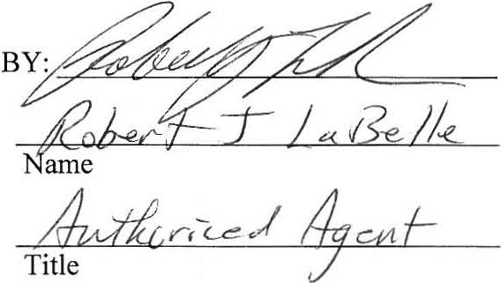

CITY OF ARLINGTON, TEXAS

BY
ROfiRT BYRD
Inte · Manager

ATTEST:

r c

APPROVED AS TO FORM:
JAY DOEGEY, City Attorney

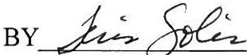

THE STATE OF TEXAS COUNTY OF TARRANT
§
AGOSTA US,INC.
§ Acknowledgment

BEFORE ME, the undersigp.¢ author.i.!Y, a No,tar)'. Public in and for the State of Texas, on this day personally appearedJ:Sowri .j. Lo,_ M_le..... ' known to me (or
proved to me on the oath of or through
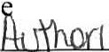
--,----------=----=- ,,,=-- (description of identity card or other document)) to be the person whose name is subscribed to the foregoing instrument, and acknowledged to me that he same for and as the act and deed of AGOSTA US, INC., and as
xecuted
·· thereof, and for the purposes and consideration therein expressed and in the capaci therein stated.

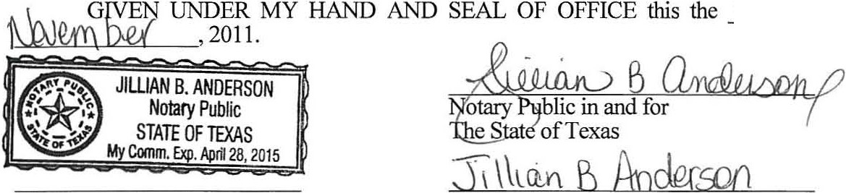
My Commission Expires Notary's Printed Name
\S±h
day of

THE STATE OF TEXAS COUNTY OF TARRANT

§
CITY OF ARLINGTON, TEXAS
§ Acknowledgment

BEFORE ME, the undersigned authority, a Notary Public in and for the State of Texas, on this day personally appeared ROBERT BYRD, known to me to be the person whose name is subscribed to the foregoing instrument, and acknowledged to me that he executed same for and as the act and deed of the CITY OF ARLINGTON, TEXAS, a municipal corporation of Tarrant County, Texas, and as the INTERIM CITY MANAGER thereof, and for the purposes and consideration therein expressed and in the capacity therein stated.
GIVEN UNDER MY HAND AND SE F OFFICE this the 3D--t-l1day of
D-..le.Y'f'\be. ,2011.
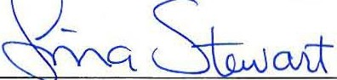

f-';{"\Notary Public, State of Texas
;,.:;,_. .jj My Commission Expires
At1}'t1,,
TINA STEWART
""1t{.M ,
February 14, 2015

0'2, \L\ ·2.D l'S

Notary ublic in and for The State of Texas
\ ,na S-\c.vP-r+

My Commission Expires Notary's Printed Name

Exhibits ''A" and "B"

I r i--
1
I
I
I

i i: J:
I
j )
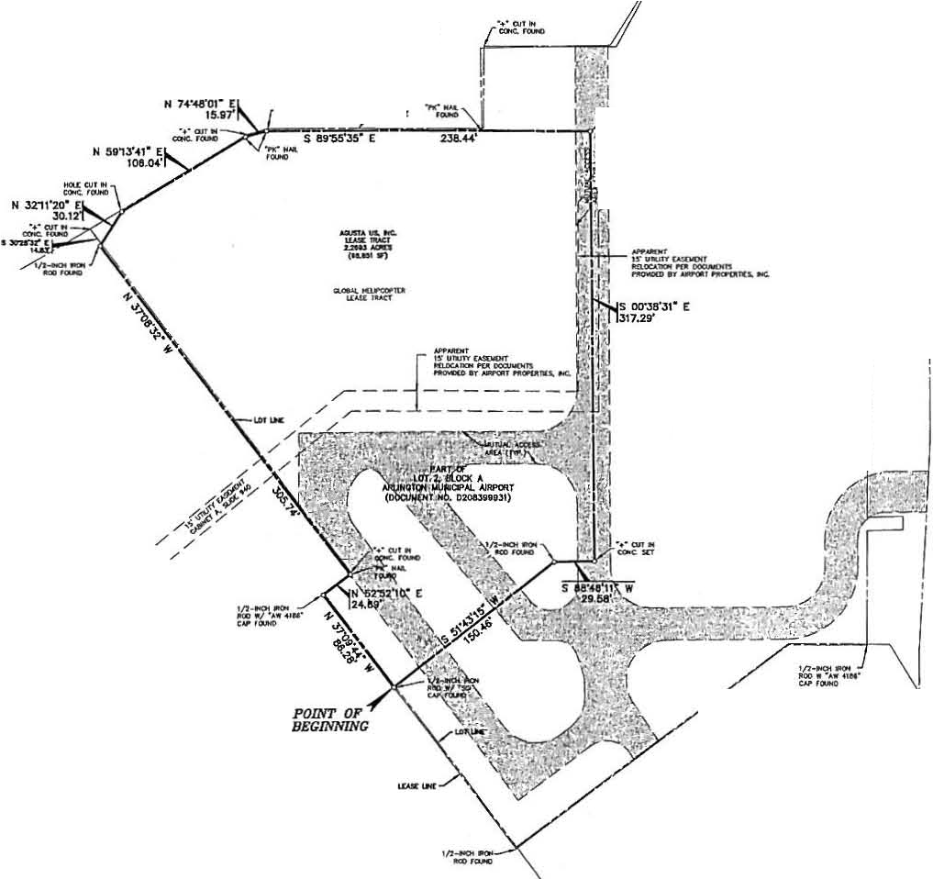
r J / ///t, >,,1I
I
--···"'""

DIUICAJl'ffOJtO, · O'
aA - -UI,

.,.-.1.,1a,,-( -#.•-&1M.,U,....,..w. ........,-.; lt .. ... ... #(...,..,._.°""',.,__. _ ,_...,
_.,...,,....,,.,
_,.....f!M _ _

:.-::-w..,..
4 .......-..l'l,tf
hrt, .fllll#LM&J -_ ....,_ .........._..,_

UlT1, 8l.OCl( A
I
AIIUNOro.. MIMIOPAL AlfPCflf

/ / // / / I, :
.,_.,.£..-
.-......,,.,...._ _,,,_ ...._.._ .,..._._ .,..;.,_.....,._t--t"

i (OOOJMOIT 0209,ltHJI)
aoq,;.....n,..
•. ....,.#.4..................._.....,............,,......,.....,._...,. _ __ ..,.

/ /
I
/;. ._ /
I ""ill·.,., At! ,
I
·.-..-.-.,.-.,_-.-,-_•-r.-c. ..-....,H,#-...,.....-,.,..,..-

/ / /
' I I
--Sl .._._....,,,
_. ....... .,..,...., ... --,,,_ ...

· w,i :..,
fr. / /
i-. 1
_.... "..,,......".'.......,....____.,.._...U....l,l,,t_.i..-.ck .•...._ .,,...,... .-•.
...... ..
=·..._
--

I I I
H)oCI( ....,... ._......,..,,"
...,--....---...-....----

I iJJ/ / /
,..,..,.....
.....

llfloirtll.l:f' .,_...... ..
CM4, ._ .,._,.,..., ...,,.. ..
. .c -

I,.
• jl /
:if

4-C.. 41

IAOt tlllooi' ... .,..._ _

• ·1/ I
§lj
...,.,
_..e-c, • .......,
..._ ....... .,_ c-c. ......,.....,...., ...,..._ _ ,,. ..
-
.c ....,..

........._...._ ._...,_,_,....,.,.1..1...1..-...,.,._ •.
..
........, .. ...., ,,,.._,.
,AIII.,.._. ..,,.•._. .._.....,._, ..

I I
"""-._................_.".,....... ,,_-.t., .......,•.
I
I
i 31
8!j
ti:;! 51
c·

...c,w,,,iz; ......_ .. ,,- _...-- ....,,.,.,......................
ICJoCC .....,... ..._ _ ....,.,.._... ---.........,_ .,_ _ .,.._.
, N' ...fif f t/1-_Nol _ _ _ _

< '
t= i
i

I
I
j
'
Ii
n
II
d
I

I I
i
l01"2."1LO<CTK A AIU'tOTON .-.NCIPM. AIN'CRT (OOQIWDU NO. 0208lUhlt)

- Of l4, aCJaC A
<1) 1
I

I I
I I
a!i, I
ii6<
!,i!I j
i
I
I
I

I
...,.,11 ,,._ .,,...,..., ,,_-.t. ,-'-"'-•-.t .,..,..,or
-.a,_.....
....,.,.,._,_....__._..__ .. . .-. .....-........-_
&aQ_.,,.,. _,,_

•u•cr.n,1CAnt
_...... ....., ._-,,.. _....._ _ ..,. ,_.,,_..,
..--.
,..._,...,
....... .,..-_..._,S.-,ltllr'-
 .-...R....-,.¥...._,i-,..._ ..,..
.....L ...-
'•
I
Ii
!
1

I!
,.t,i
+1

LOT l, M.0. 0< A
M!Hla"M.MU'Qlllf
(OOC1IUOl"f H0. 02()11.3.113p

NIIM010N WUNICPM. A#alT
j
(OOCllWOIT NO. OWIJln.ll)

I
I
2.2&93 ACRE TRACT =
PART OF LOT 21 BLOCK A AND i
LEASE EXHIBIT 11
PART OF LOT 31 BLOCK A fi
f
ARLINGTON MUNICIPAL AIRPORT
AN ADDITION TO THE CITY OF .ARUHC. TON, TEXAS AND BEING OUT
I
OF THE
  - L4CY SURVEY, ABSTRACT No. 020
',\
i
..c=-n
(N2:) 22!-"U (Pt10Ht}
1

": I
I
TAJUIANT COUNTY• TE-- _ ·i
m- 1>"GlJ1= = ===: 1

LIi

T cx»N«,
,,:- .4' _I

':,T COl,iw, ...-.« tt•i:;;::-_i , MA...,IJ Rl.-C J
.UAI,_. . ....- OEXfDB A\lf.>/ ji
.,.lila. 1-11-614 --

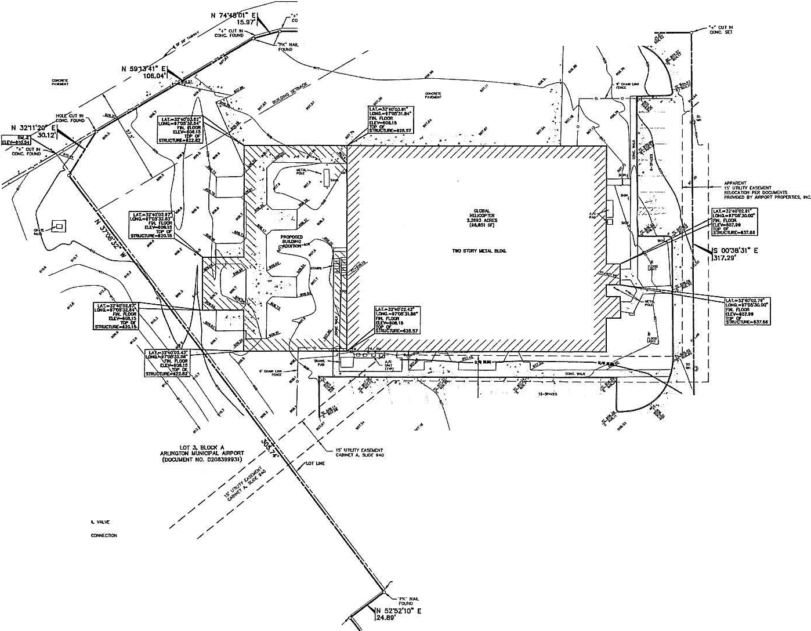
tOT 1.9lOO( A I!
    - YIMIQP &I *SRPaU.- - - --', HO. 020aJWOJI) IJ
coocuimn

i . ··°"""".'._' _ £':':
--,·,c-,i \I
=a!::

: ..r---:-:;,------- =«· ..,
/ .
!
/
/

/ /
i
/ /
//_."!-i"''• / /
J <?p //
i
/
/
-::a.""? ";.". ''

i
'I/
i ,p
I· ?'/
i
I
!
•
I

....,
7'"1' f ,-,:,V
..
·
·1111JJY £A.'lD,Otf ff..-0,
ltO..O A- llI'$
(

f'AAT «
lOT 2. Ill.CO( A
,1
NU-ICTOH WVhlaPAL »>t?ORT (T No. 0200.Jfie.JI)

II
s;guj

I
I

I
l

I

I -
I !

I ::i 11
'1 2ti:: ;,:.
, s
I
Ii
I
•
ie

"-•.
-.
-U01.T.S.T­.....,...,.W

f'MT Of
LOT 2. BL00t A
p
I
I
I

L-1:!: e:::.-..,,:»
--
P--"•.,
NU-I W\JNKJP>L. IJRPORT I
(DQQ.NEHl' NO. D20AJGOOJI)
!
I I
•

·.o.
".."..".M., I I

-..... 1"°'-
I
I
... ""1C$11:N.....
-...-
_JII-- r,. I I

-"""
lll..n'ICSl<X...
,:.. ; !

"'a 1V90X
_
_
.... ,V,llf'OU:
1,· / S M-481t · I

-----..nuc
---nJt.l'OKIIUO
-...- ujG mu,ocu,cs
--._ U/l; Tl•,....
.. ,
-----

I/J·N -

PARTIAL TOPOGRAPHIC EXHIBIT •

-U/OW...C
rJf Ull4"

-·--- """
01$1N;.Of S
"r ,+// I

""'
.t.,.__ _ "''"
"°1'0o.ll:OIIJ lf/C'(' t#'Rf
\, ,/ /
/ .p$l',",,(
PART OF LOT 21BLOCK A AND PART OF LOT 3,BLOCKA
ARL NGTON MUN CIPAL AIRPORT
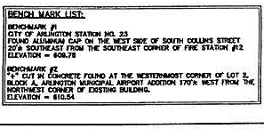
AN ADDITION TO THE CITY OF ARLINGTON, TEXAS AND BEING OUT OF THE
lf.D. LACY SURVEY, ABSTRACT No. 929
-. -Im-
TARRANT COUNTY, TEXAS
1>"GlJ1= ==
I
,.. I

,,,,_ )(

··201, 8
w-=

'="'° ,·,,.:4 \
:1!/f.:.
LIii '-' .('MDH COMPANY, = 14·119-1 0-49 1

:
\\ (6a2) t.u-J262 (PHOHE)
'=: "'E :1'
- ··-
-,a_·(i
:,lff

L. O,Ctoo1-..11-111f-lO'(LO'IQ

-..._,>

-1J\gustaWestland

November 28, 2011

Mr. Bob Porter,A irport Manager Arlington Municipal Airport
MailStop 34-0100
P.O.Box 90231 Arlington, TX 76004-323

RE: Agusta US, Inc., Ground Lease, Arlington Municipal Airport, TX

Dear Mr. Porter,

Iam writing to let you know that Ihave binding authority as Managing Director of Agusta us,Inc.to
execute the new ground lease on behalf of Agusta which will be effective December 1,2011. In order to be consistent with my signing of various documents,Ihave used the title "authorized representative." Please feel free to contact me if you have any questions regarding this matter.

Sincerely,

Managing Director,
Agusta US, I nc.
267-234-2824

THE STATE OF TEXAS §

COUNTY OF TARRANT §

LEASE MODIFICATION NO. 1

THIS LEASE MODIFICATION NO. 1 (hereafter "Modification No. 1") is entered into on this 24th day of February, 2015, by and between the CITY OF ARLINGTON, TEXAS, a municipal corporation located in Tarrant County, Texas (hereinafter referred to as "CITY"), acting by and through its City Manager or his designee, AGUSTA WESTLAND PHILADELPHIS CORP. f/k/a AGUSTA US,
INC., its heirs, subscribers, or assignee (hereafter referred to as "LESSEE").
W I T N E S S E T H:

WHEREAS, CITY and Agusta US, Inc. have heretofore entered into a Lease Agreement relative to property at the Arlington Municipal Airport, approved by the City Council by Resolution No. 10252011-001 on December 1, 2011 (hereinafter referred to as "Lease"); and

WHEREAS, CITY and LESSEE now desire to amend the Lease as set forth below; NOW, THEREFORE,

FOR AND IN CONSIDERATION of the covenants, duties and obligations herein contained, the parties do mutually agree that except as provided below, all other terms and conditions of the Lease shall remain unchanged and in full force and effect. In the event of any conflict or inconsistency between the provisions set forth in this Modification No. 1 and the Lease, this Modification No. 1 shall govern and control. In consideration of the foregoing and for other good and valuable consideration, the parties hereto agree to amend the Lease as follows:

I.

Article 2, entitled LEASED PREMISES, of the Lease is hereby amended, so that hereafter said Section shall be and read as follows:

SECTION 2.2, Any existing improvements thereon, and approved improvements to be constructed or installed on the Leased Premises during the term, or option periods, as shown on Exhibit "B", attached hereto and incorporated herein by reference as if written word for word. This does not include perimeter fencing and gates within such perimeter fencing or adjacent to such perimeter fencing. All perimeter

fencing and gates within such perimeter fencing or adjacent to such perimeter fencing (hereinafter referred to as "City Fencing and Gates") is solely owned and controlled by the City.

Article 6, entitled ACCEPTANCE, CARE, MAINTENANCE, IMPROVEMENTS AND REPAIR, of the Lease is hereby amended, so that hereafter said Section shall be and read as follows:

SECTION 6.1, Lessee warrants that it will inspect the Leased Premises and accept possession of the Leased Premises thereon in their "as is" condition when accepted, and subject to all limitations imposed upon the use thereof by the rules and regulations of the Federal Aviation Administration and the City of Arlington, and will admit upon acceptance its suitableness and sufficiency for the uses permitted hereunder. Except as may otherwise be provided for herein, the City shall not be required to maintain nor to make any improvements, repairs or restoration upon or to the improvements located thereon. City shall never have any obligation to repair, maintain or restore, during the term of this lease, any improvements on the Leased Premises including but not limited to, buildings, pavements, landscaping, gates and fences; except for City Fencing and Gates. The City shall have a right of ingress and egress across the leased premises at all times to maintain and repair City Fencing and Gates.

II.

LESSEE recognizes that this Amendment shall commence upon the day first written above and continue in full force and effect until termination in accordance with its provisions of the Lease.

Executed on the date first written above.

LESSEE:
AGUSTA WESTLAND P.11..........., ELPHIA CORPORATION
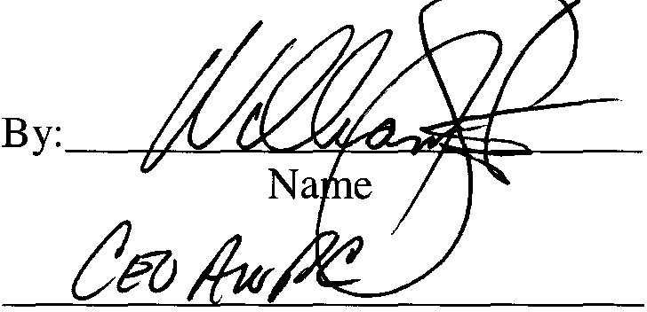

Title

LESSOR:

/ "\

CITY OF ARLINGTON,,_3EXAS
By:J2{l{l
Deputy City Manager

ATTEST:
rl &-J.
- MARY . PINO
Chy Secretary

APPROVED AS TO FORM:
Teris Solis, City Attorney

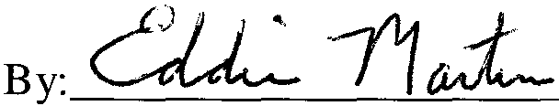

THE STATE OF th,11 ', '\_,, ,I• ("- §
AGUSTAWESTLAND PHILADELPHIA CORPORATION COUNTY OF ?id,lph 1ll.. § ACKNOWLEDGMENT

BEFORE ME, the undersigned authority, a Notary Public in and for the State of ·.:p<'11,,>,Jl vc, vi i C\.. , on this day personally appeared
t-:0 . 1.t , c"'v' H:'-'t r'--+ , known to me (or proved to me on the oath
of or through ----------------- (description of identity card or other document)) to be the person whose name is subscribed to the foregoing instrument, and acknowledged to me that he/she executed
same for and as the act and deed of AGUSTAWESTLAND PHILADELPHIA CORPORATION, and as (' £. c, thereof, and for the purposes and consideration therein expressed and in the capacity therein stated.

A+:vd , 2015. ift··:=. IL- ·· .

-------·····--
...

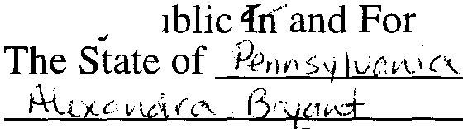
GIVEN UNDER MY HAND AND SEAL OF OFFICE this the
. .kt I l: : .•,..
-·· 7
1!i_ day of

Notary's Printed Name My Commission Expires )J c J Iif, J.C , 't COMMONWfAl.lH Of PENNSYLVNM
NOJAIIIAL SEAL ALEXANDRA BRYANT
Notify Pultllc
C 1 1Y OF PHILADELPHIA, PHILADELPHIA CNTY '
My Commission Expires Nov 14, 2018

THE STATE OF TEXAS §

COUNTY OF TARRANT §

City Acknowledgment

- •"""''''
ANN CHERYL RINEY
t'( ·= MV Commission Expires
//;-' tf:; Notary Public, State ot Texas
,. r. ./.fl
tf. ,
July 01 2018
I
I
BEFORE ME, the undersigned authority, a Notary Public in and for the State of Texas, on this day personally appeared JAMES F. PARAJON, known to me to be the person whose name is subscribed to the foregoing instrument, and acknowledged to me that he executed same for and as the act and deed of the CITY OF ARLINGTON, TEXAS, a municipal corporation of the State of Texas, Tarrant County, Texas, and as the Deputy City Manager thereof, and for the purposes and consideration therein expressed and in the capacity therein stated.
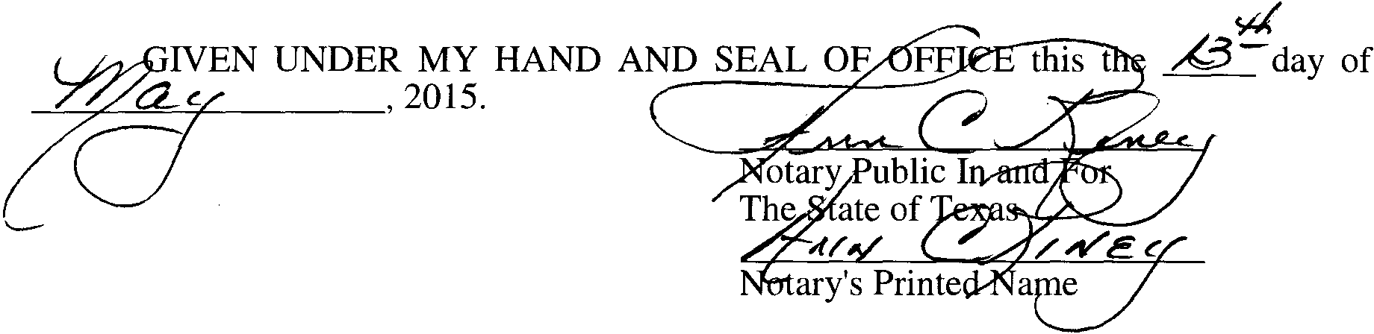
My Commission Expires

<N-J<Cc··.u·wrm

l1Ut:JfJl'ffO#OFMOr@"Y
:-=---,_-.•·.,.h.l.,.:_=,.:.,_..,__.._,._,...,h, _r,.,_;(._::,.._,-__::__....n.,L...,........
=""'

.,_,...,J.wt'
Nl'G,:..,.,......,.,..,._. ...,._,..._.._.,. .,...,-.-........,.,.......w ..,, ,..,_..,.. _ _ _ •..1.-
.,,..._....,.,--r
...,._ _....-----ut.......
........._It _ •-t-t •......-1'H#f lW N•1'Jt"'-'.._iliP' _
_.,R.,,.,....,.,..__ .....,J_il:l.io.ll.il. J.iJrl.,_._1.1.1.1.....,,..,,..1.11,1.,,....r-f....,,._i, ......,...-,,w-.,..,,,,,,__.,.,...-'.".".
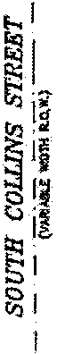

...................-.,............ --.............. .,, - --OIWtl
-=-•·.....
,
, ...
Mwtrt#......_ .t,-.H ...-.,-Jo.Q loof ... ,,lol# tr .. _.i•
,:1 •1 _.¥-t, ........,.,Nll.0$ ..., ,.. • .,... _ _ ff .... .,,,.,.

_ n...._ ..,........,._-'-"•.._,;,..,,._. ,,..._
I
_...."".,,,,,,.,_
_..,,t

...... .._-_,,.,,,,,,...,..,...,.J,._f -_"_*..r.i,....----'11.&:lll.... ,..t..·+· ...._,,...,.,., ....
I
M' l":O'OMilf..l; n..-..A-:.l....-_-.l.,-.,..,.,,,,,,.-..-, .............,...,....,,_.,.,. •..w­
aj 1KNl:Z, .....,.. .._ .......,,,,....lw ---...· .....,,.,,, .........,._

_.....,

._.._ wJIIMAof W•l/l--HI NII_, _ _, ...

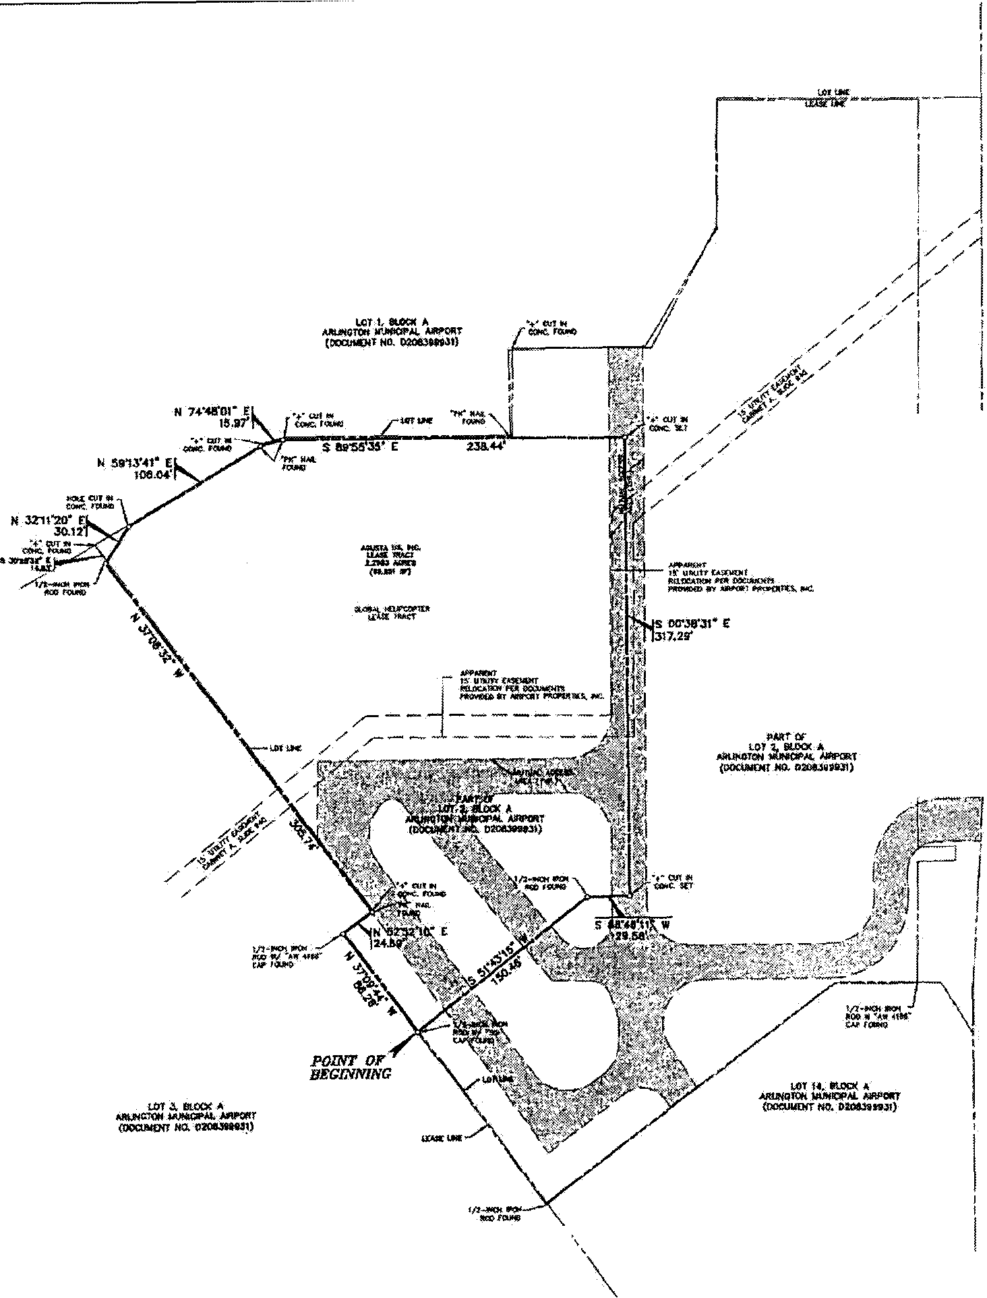
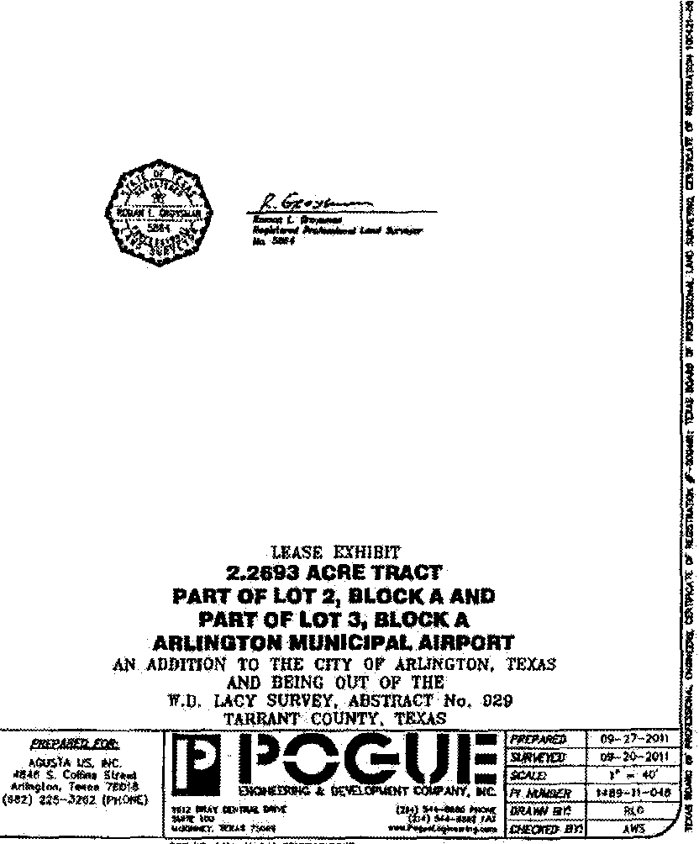
_-.-............ _o'4i,.l.'...,_ r,_,,.t.t
I' -... ,... _.,..,...,, . .---ucu,,r'""'""..,l'lf/lllacr
COl'livM¢'4U'-*"•:.UMJ-ll/"""4.._,,_
I

6U•!!JV"! tlEIITIFICAQr
i .. ..::.:.:...M.;:,.,.i:&:!:.:,. -..t::;tJr... ....-..-, z
I
., .,.,,.,......,,



...,..,
--.,,..
.
.o.,..
i.o..ls.t.ol_MOMO'
  - DN\l
I I
P 1
,, ..,4,,_, CO,OiTlll!!l.11.li.'o'lt
---
1.1,1,1,1.'.Q.D,'N,llliC>lt CQffCJl(H
--..

lR,ofl'ICff'al.:JIIOI..
...,flC11GN."1.Jl'GU

_ ..._ ,QH.l'OWd
-··-•,.-111/llIIHU
....-llolll-- 1,f!'Jl:11"1"1.11Mr
_·__•- .'f D.l.lt,t ..=...,
-V/t.CMU.C:
IP\JT 5
(eM,J WIJIIQW>f4 1

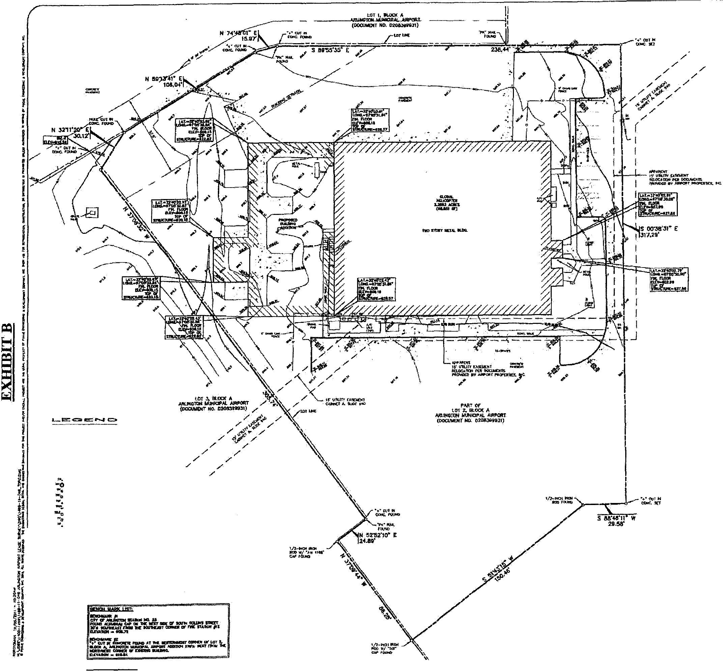
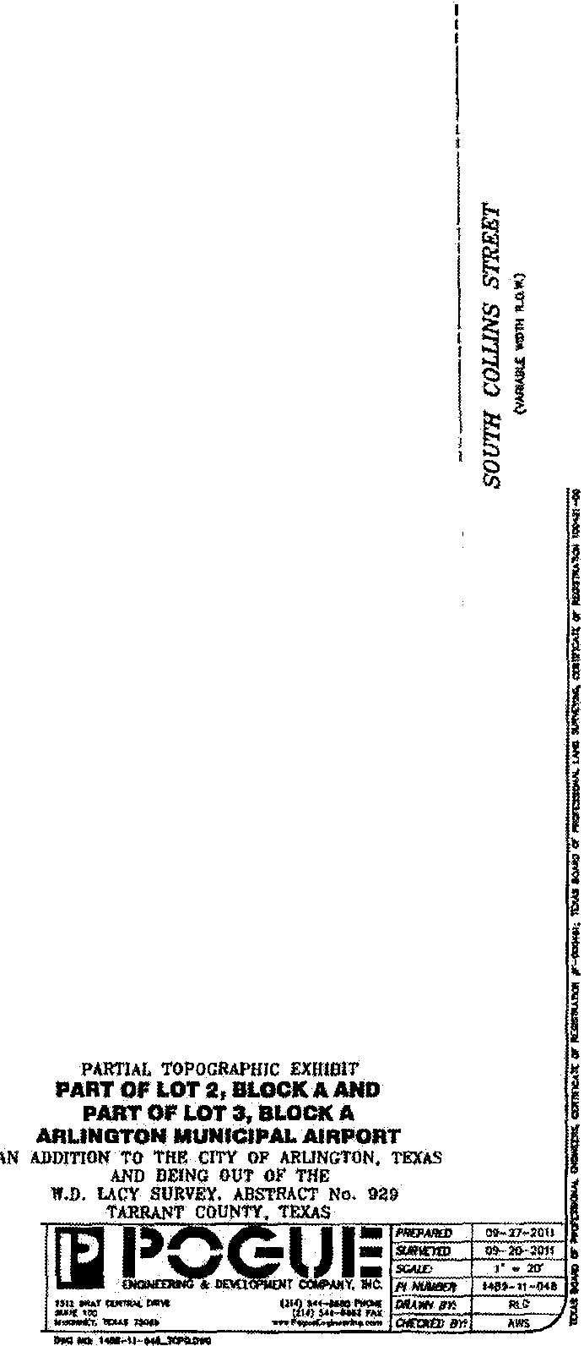

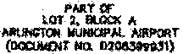
M w!?UVIIW' :r

L

AQJSTA. U 1"C
---
t« S. Coffioo.¥ s.i.,.._1
Mlo,,1f111, r,•..,,,01a
(i,tt1) :.!U-2 )

TH E ST/\TE OF TEXAS §

CONSENT A ND ESTOPPEL
COUNTY OF TARRANT §

THIS CONSENT (th i s "Consen t") dated as of the_\ ·2...lrVd\ ay of
M "- / . 20 1 5, i s

made by and between CITY OF ARLI NGTON (the ·'City"). AG USTAWESTLAND PHILADELPI IIA CORPORATrON ("/\G USTA"') and an address of 3050 Red Lion R oad, Ph i l ade l ph i a, PA 1 1 1 94.

W I T N E SS E TH:

WHER E/\S, the Ci ty and AG USTA W ESTLAN D TILT ROTOR fka AG USTA US, INC (entered i nto a lease agreement dated Decem ber I . 20 1 1 for ai rport properly (the "Agreement'"); and

WH ERE/\S, AG USTA WESTLAN D TI LT ROTOR lka AG USTA US, I NC merged wi th
/\G USTA effecti ve December 31 , 2014 and AG USTA assumed all ri ghts and respon si bi I iti es u nder the Agreem ent; and

WH ER EAS, any assum ption of rights i n the Agreement requ i res the consent of the City pursuant to the terms of the /\greem ent and AG UST/\ seeks the consent; NOW , Tl I ER E l70R E,

I n considerati on of the mutual covenants and agreem ents set forih in the Agreement and for other good and va luabl e considerati on, the receipt and suffi ciency of wh ich are hereby acknowledged, the Ci ty hereby agrees as follows:

I . The Ci ty hereby consents to the assum ption of the rights and responsibil i ti es of the
/\greement by AG UST/\.

- The Agreement i s i n full force and effect and has not been m odified, suppl em ented or amended in any way except as set forth herein and AG USTA agrees to be bound thereby.

- /\G USTA has provide assurances reasona bly satisfactory to the Council of i ts q ual i fications, character, the effect of the assum pt ion and such other matters as the Arl i ngton CITY Council deemed relevant

- A l l conditi ons u nder the Agreement to be performed by any of the parties wh ich are prerequisite to the fu l l effecti veness of t he Agreement have been sati sfied as of the date hereof.

- As of the date hereof, to the knowledge of the City, there exist no factua l circum stances or condi ti on s which, with not ice or th e lapse of time, or both , would gi ve rise to any obl igati on of any party to the Agreement which, if not satisfied, w ill constitute a defaul t on the part of either party to the Agreement, or constitute the basis for a claim or cause of action .

(1)

- Th e Ci ty hereby agrees t hat the A GU STA sha l l be enti tl ed to rely upon the statements m ade herein.

- Th i s Consent may not be m od i fi ed oral l y, but only by wri tten i nst rumen t, and const i t utes the enti re agreem ent between the part i es with respect to the subject matter h ereof.

- The Agreement and a ll of the terms, covenants and cond i ti ons thereof remain i n ful l force and effect and AG USTA agrees to be bound thereby.

- All notices wh ich are req ui red or desi red to be sen t to the Lessee u nder the Agreemen t sha l l be del i vered, pursuant to the terms of the Agreemen t, to t he fol low i n g 3050 R ed Lion Road, Phi ladelph i a, PA 1 1 194.

I 0. Thi s Consent may be executed i n one or more facsim i l e counterparts, each of w h ich shall be deemed an origi nal but, when taken together, shal I constitute one Con sent.

1 1. If the merger bet ween AG USTAW ESTLAN D TI LT ROTOR fka AGUSTA U S, fNC and AG U STA fai ls then th i s consent i s n u ll and void .

IN WITNESS WHEREOF, the City has caused th i s Consent to be executed t h e day and year fi rst above written.

AG USTA WESTLAND PH I LA DELPHI A COR PORATION

B Y fe
/ JJe /;?7.' h2.eV"'
Typed or Pri nted Nam e
{t;.,a) D c.,.., J.-.,
CTyped or Prin ted Ti tl e a
yfe/)J

Date

WI TN ESS:

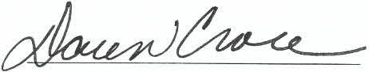

(2)

ATTES;:

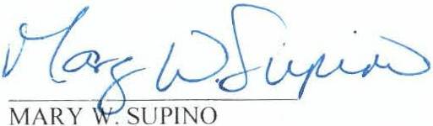
City Secretary
CITY OF A RLINGTON
/' P;1"---'
BY +f1-/ J-,-
Ja111es F. Par4jon
Deputy City Manager

APPROVED AS TO FOR M :
TER IS SOLIS, City Attorney

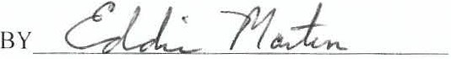

(3)

TH E STATE OF Pen nsyl vania §
§
COU TY OF Y\,c"- §

AG USTA
Acknowled gmen t

BEFORE ME. the undersigned authorit). a 1ota1) Publ i c i n and for the State of Pen nsyl vania, on th i s d ay persona l ly appeared _(],, y £ -Ul.. . ,,ho is kno\\ n lo
e or \\ ho ,,a pro ed to me ( description of identity card or
other document issued by thefederal or stale gm·em111e11t containing the p icture ond signature of tlu! ack1101rledgi11g person ) to be the person and officer ,,hose name i s subscri bed to the foregoing i nstrument , and acknowledged to me that he/she executed same for and as t he act and deed of AG USTAWEST LA ND PHILADELPH IA CORPORATION, a roarc...-.l..¢.1"\ _ of the State
of I)\o,l>,)(\re. , and as the C:brporr,,4-f :::eew::\eqz. therebf. and for the purposes and considera tion therei n expressed, and in the capacity therein expr ssed.

G I V EN UN DER M Y H AN D AN D SEAL OF OFFICE on t his the d'.?S
- , 2015.
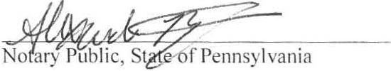

/Seed! COMMONWEALTH Of PfNNSYLVNM
NOTARIAL SEAL ALEICANOAA IIIYANT
Notlry Mlle
CITY OF PHILADELPHIA. l'HILAOELPHIA CNTY
My Comml11lon Explrn Nov 14, 2018
day of

_tl. 1:e xo nc!ro,. n m,,+
Notary's Pri nted Nam

TII E STATE OF TEXAS §
§
COUNTY OF TARRANT §
CITY OF ARLI NGTON, TEXAS
Acknowledgmen t

Before me, the undersigned authority, a Notary Public in and for the Stale of Texas, on thi s day personal l y appeared J ames F. Parajon, known to me to be the person and officer whose nam e i s subscribed to the foregoing i nstrument, and acknowledged to me that he executed same for and as the act of the CITY OF ARLINGTON, TEXAS, a Texas munici pal corporation, and as Depu ty City Manager thereof. and for the purposes and considerat ion therei n expressed .

GI E:' UN DER M Y H AN D AN D SEAL OF OFFICE on this the d 9-i:f_ d ay of
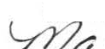

[Se
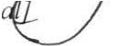

.,......C'J¥-
, 20 15.

f I , \'.i;,,, A N N CHERYL RI NEY
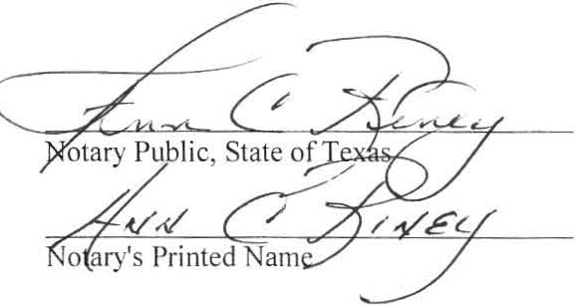

1 ;.. ..,:. Y/' •:.,,Ee,
My Comm1ss1on Expires

[} '' ····'."\ Notary Publi<:, State of Texas
.,.,;.;0;, ' ' July 01, 2018
-·1-; ' ,,,,,,, ;;;;;.;;;;;;;;;;;;;;;;;;;;;;;.;;;;;.;;;;;;J
(4)

