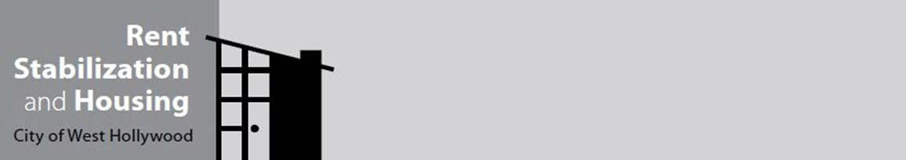

ESTOPPEL CERTIFICATE

8300 Santa Monica Blvd., West Hollywood, CA 90069 p: (323) 848-6450 Email: rsh@weho.org

Pursuant to the City of West Hollywood Rent Stabilization Ordinance Section 17.52.010(6), an estoppel certificate in a landlord-tenant context is defined as a document signed by a tenant which precludes allegation or denial of a certain fact or state of facts. Tenants who are presented with an estoppel certificate by the landlord or the landlord’s agent cannot be required to sign it unless it is a form provided by the city. A tenant’s refusal to sign an estoppel certificate other than the one on a form provided by the city cannot be the basis for an unlawful detainer or any other adverse action against the tenant.

The purpose of this certificate is to confirm the current status of your lease of the rental unit identified below. Your signature on this certificate is not a waiver of any of your rights under the City of West Hollywood Rent Stabilization Ordinance. You may, however, be bound by statements that you make in this form to the extent that those statements do not conflict with the ordinance. Therefore, it is important that you read this certificate carefully before providing any answer.

The reverse side of this form is to be filled in by the tenant or tenant’s representative, not by the landlord. Tenants cannot be required to sign this form if it has been filled in by the landlord or the landlord’s representative. Tenants must be given at least 48 hours to review this form before being required to sign it.

ESTOPPEL CERTIFICATE

- This certificate concerns the lease for , Unit ,
(Street Address)
in the City of West Hollywood, California.

- I, , began my tenancy on .
(Tenant’s Name) (Date)
- The current monthly rent actually paid is $ which is due on the day of each month. Rent is currently paid through .
(Date)

- The current amount of security deposit held by the landlord is $ .

- Is the lease for your tenancy written or oral? ◻ Written ◻ Oral

- The original lease has not been modified except as follows:

- I have no knowledge of any defaults (violation of lease obligations) by either the landlord or the tenant, except as follows:

- There are no disputes between the landlord and tenant concerning the lease, the rental unit, or the provision of any housing service except as follows:

- I have the following pets (provide the number of pets and a brief description, or if no pets check no pets.):

  - No Pets

- I am in full possession of the rental unit and have not sublet or assigned any portion of it except:

Tenant Signature Date

Print Name

(Pursuant to City of West Hollywood Rent Stabilization Ordinance 17.52.010[6])

