Rental Move-In and Move-Out Checklist

Disclaimer
This is a general move-in/move-out checklist provided for informational

purposes only. Zillow Group, Inc. does not make any guarantees as to the suﬃciency of the items included in this checklist or their compliance with applicable laws. This resource is not a substitute for the advice or services of an attorney; you should not rely on this resource for any purpose without consultation with a licensed attorney in your jurisdiction.


1

Rental Move-In and Move-Out Checklist

Instructions: Tenant(s) should complete this checklist just prior to or within 24 hours of moving in. The tenant(s) and landlord or property manager should review the property, then complete, and sign this checklist as a mutual agreement on the condition of the property upon move-in. Each party keeps a signed copy of the checklist. The tenant(s) and landlord or property manager should examine this checklist during the pre-move-out inspection and again after move-out to determine if any portion of the security deposit will be deducted for cleaning or repairs.

Tenant Name(s) :

Address & Apt. No : | City : | State : | Zip :
Move-In Date : | Inspection Date : | Time : | By :


Unless otherwise noted, the premises are in clean, good working order and undamaged. Use the key below.

Key & Abbreviations : NC Needs Cleaning NSC Needs Spot Cleaning

NP Needs Painting NSP Needs Spot Painting

NR Needs Repair RP Needs Replacing

LIVING ROOM
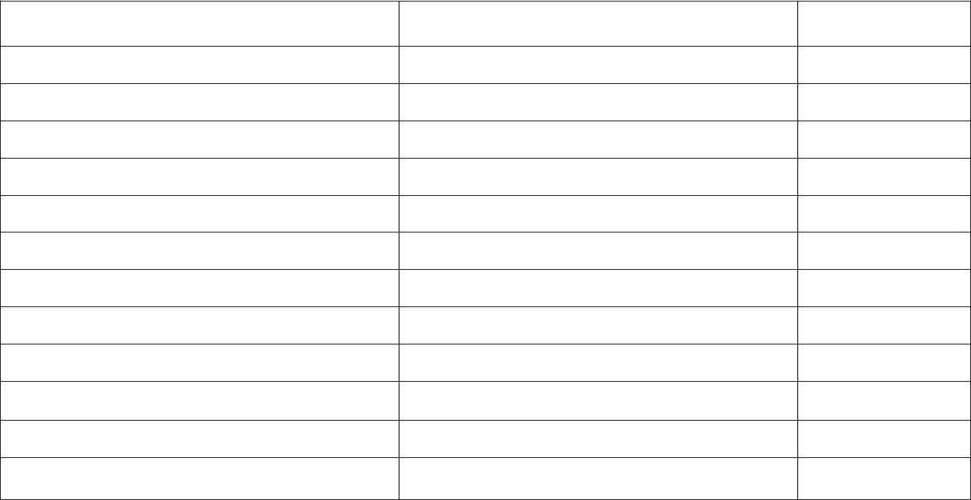

Floor

Walls

Ceiling

Doors

Windows

Screens

Shades/blinds

Closet

Light fixtures

Outlets/switches

Lightbulbs

Move-in

Move-out

Cost

Comments :

ENTRY/HALL
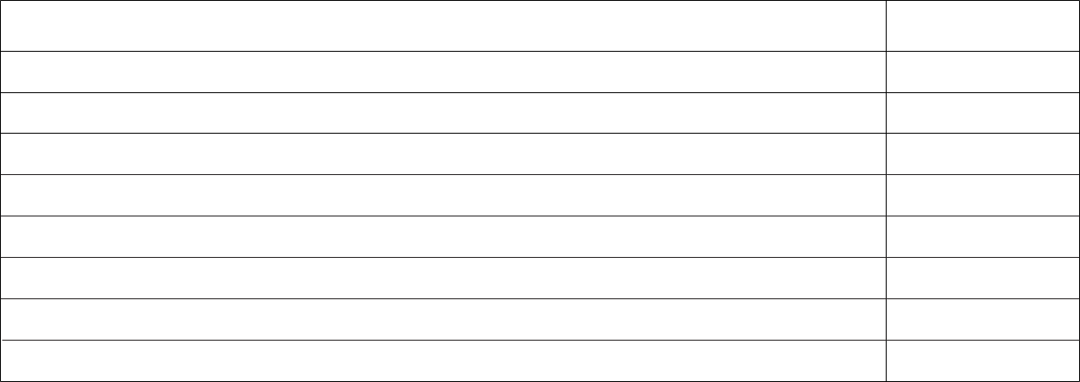

2

Floor

Walls

Ceiling

Light fixtures

Outlets/switches

Closet

Stairs

Move-in | Move-out

Comments :

Cost

BEDROOM #1

BEDROOM #2

Floor

Walls

Ceiling

Doors

Windows

Screens

Shades/blinds

Closet

Light fixtures Outlets/switches Lightbulbs

Move-in | Move-out | Cost

Comments :

Move-in | Move-out | Cost

Comments :

BATHROOM #1

3

BATHROOM #2

Floor

Walls

Ceiling

Doors

Windows

Screens

Cabinets

Drawers

Sink/plumbing

Shelves

Mirror

Tub/shower

Caulking

Counter

Fan

Light fixtures Lightbulbs Outlets/switches

TOILET

Bowl

Seat

Flush

Move-in | Move-out | Cost

Comments :

Move-in | Move-out | Cost

Comments :


KITCHEN
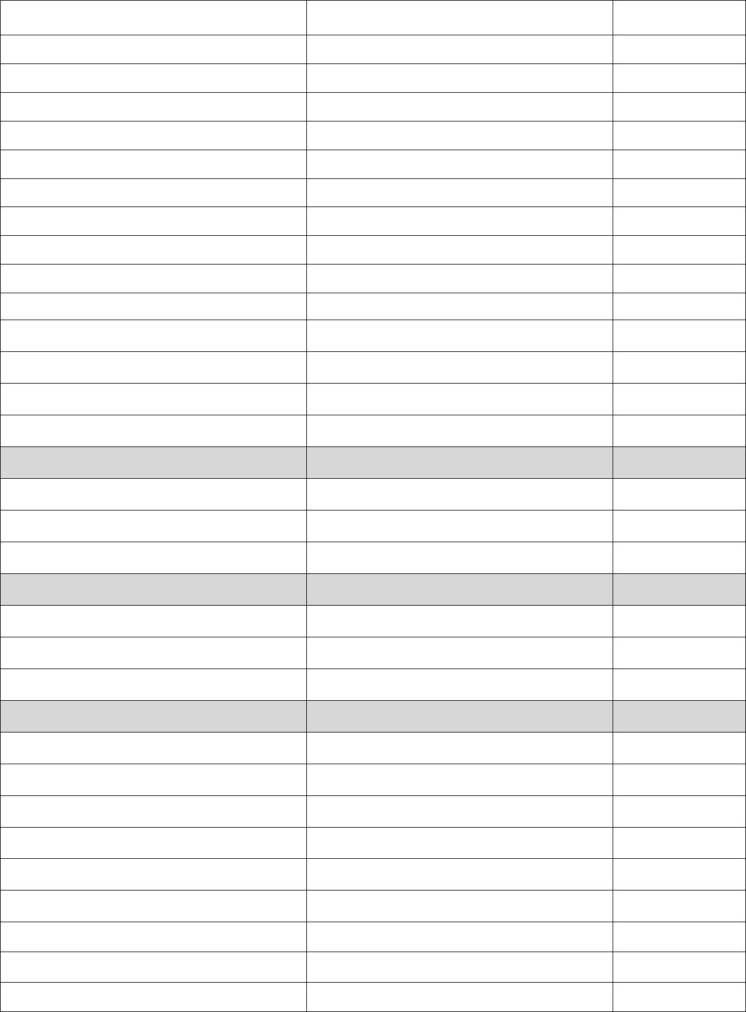

4

Floor

Walls

Ceiling

Doors

Windows

Screens

Cabinets

Drawers

Sink/plumbing

Counters

Fan

Light fixtures

Lightbulbs

DISHWASHER

Interior/parts

Exterior

Controls

REFRIGERATOR

Interior/parts

Exterior

Lights

STOVE/OVEN

Exterior

Burners

Vent

Timer/controls

Surface

Light

Racks

Drip pan

Move-in

Move-out

Cost

Comments :

DINING ROOM
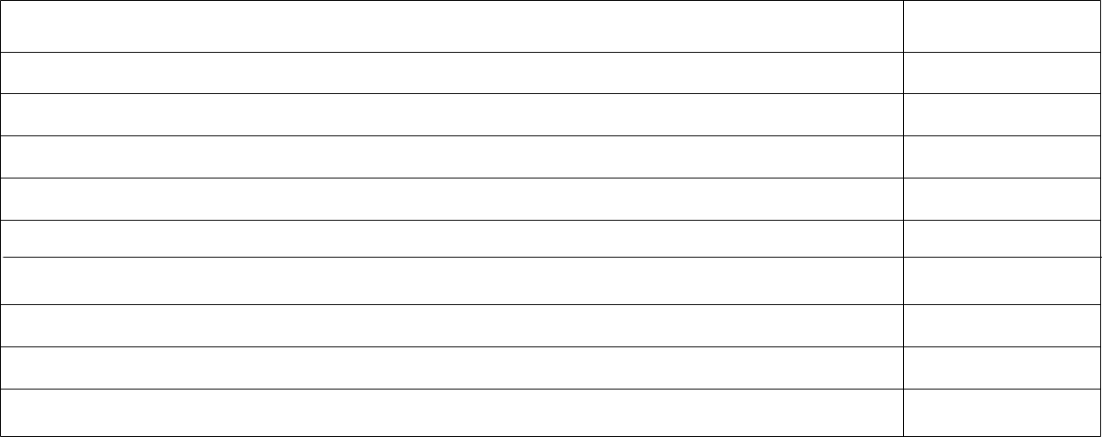

5

Floor

Walls

Ceiling

Doors

Windows

Screens

Shades/blinds

Light fixtures

Outlets/switches

Move-in | Move-out

Comments :

Cost

MECHANICAL
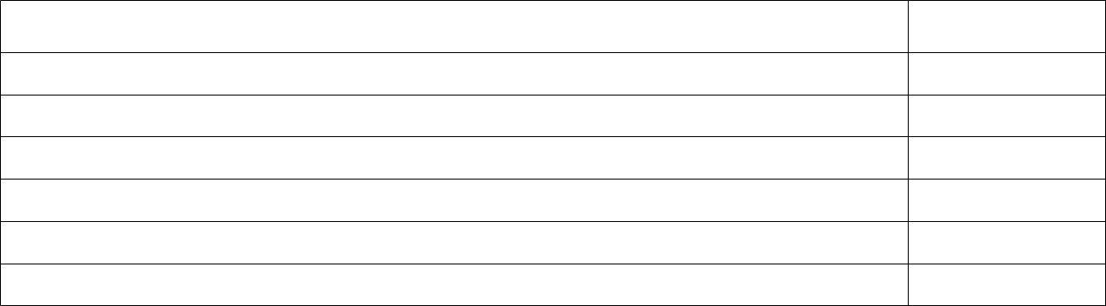

Water heater

Smoke detector

Thermostat

Heating

A/C

Move-in | Move-out

Comments :

Cost

Parking area Lawn/Garden Patio/Deck Washer/Dryer

OTHER
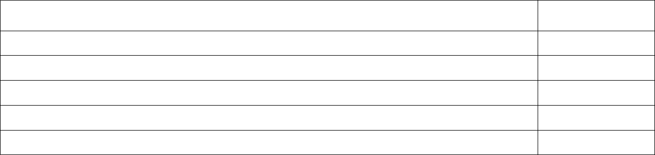

Move-in | Move-out

Comments :

Cost

TOTAL COST OF DAMAGES: $_______.______


6

Rental Move-In and Move-Out Checklist

I/we, _____________________________________________________________________________ (tenants), understand that unless otherwise

noted, all damages are under the tenant’s responsibility and will be deducted from the security deposit upon move-out.


Videos and/or photographs have been taken of the unit:

If yes, the original copies are in the possession of the

Yes

Landlord

No

Tenant

MOVE-IN INSPECTION |  |  | MOVE-OUT INSPECTION
Landlord/Agent Signature |  | Date |  | Landlord/Agent Signature | Date
Tenant Signature |  | Date |  | Tenant Signature | Date
Tenant Signature |  | Date |  | Tenant Signature | Date
 | Tenant Signature | Date |  | Tenant Signature | Date
 |  |  |  | Tenant’s Forwarding Address:

