MOVE-IN CHECKLIST


☐ | ☐
☐ | ☐
☐ | ☐
☐ | ☐
☐ | ☐
☐ | ☐
☐ | ☐
☐ | ☐
 | ☐
 | ☐
☐
☐ | ☐
 | ☐
☐ | ☐
☐ | ☐
☐ | ☐
☐ | ☐
☐
 | ☐
☐ | ☐
☐ | ☐
☐ | ☐
☐ | ☐
☐ | ☐
☐ | ☐
☐ | ☐
☐ | ☐
☐
☐
☐ | ☐
☐ | ☐
 | ☐
 | ☐
☐ | ☐
☐ | ☐
☐
☐
☐
☐


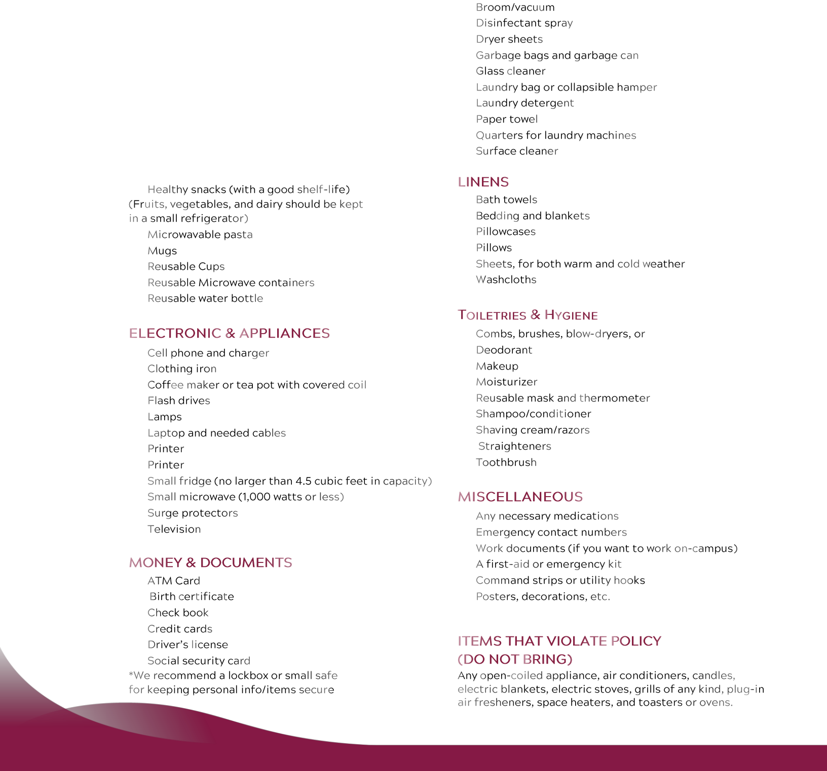


CHECKLIST FOR A SUSTAINABLE MOVE-IN

 DITCH THE CARDBOARD & REUSE


WAIT ON BIG PURCHASES


RECYCLABLE PACKAGING


DRYING RACK FOR CLOTHING


CFL OR LED BULBS FOR LAMPS
