INSTRUCTIONS: Use this list when the tenant first looks over the apartment and again right before moving out. Cross off the items on the list that do not apply. Make remarks (e.g. new, dirty, broken) in the space provided. Signatures are suggested, but not necessary. The tenant should give a copy of this checklist to the landlord shortly after moving in. This will provide a record of which, if any, damages to the apartment the tenant is responsible for.

 |  |  |  |  |  | MOVE-IN INSPECTION |  |  |  |  |  |  |  | MOVE-OUT INSPECTION
 | ROOM: |  |  |  |  | CONDITION: DAMAGES: |  |  |  |  |  |  |  | CONDITION: |  | DAMAGES:
 | Living Room:
Doors:
Ceiling:
Floor:
Carpeting:
Woodwork:
Walls:
Windows:
Window Screens:
Electrical:
Other:
 | Dining Room:
Doors:
Ceiling:
Floor:
Carpeting:
Woodwork:
Walls:
Windows:
Window Screens:
Electrical:
Other:
 | Kitchen:
Doors:
Ceiling:
Floor:
Carpeting:
Woodwork:
Pantry:
Walls:
Windows:
Sink:
Garbage Disposal:
Plumbing:
Electrical:
Refrigerator:
Freezer:
Range/Stove:
Oven:
Counter Tops:
Cupboard:
Other:
 |  |  |  |  |  |  |  |  |  |  |  |  |  |  |  |  | Page 1 of 2

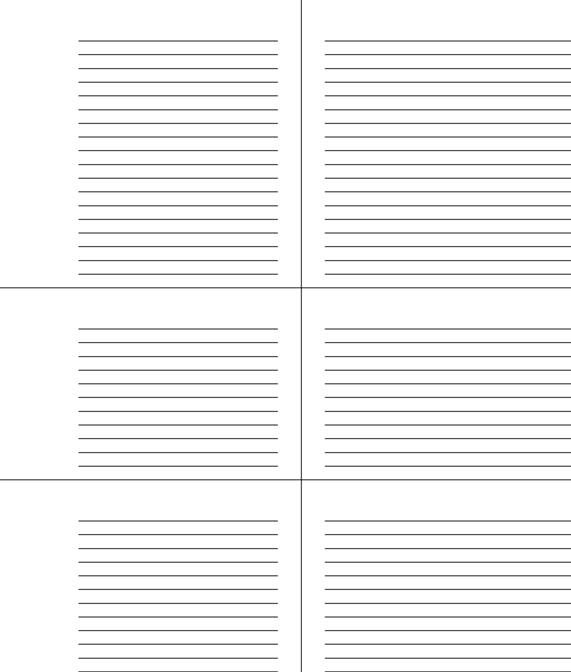
Bathroom:

Doors:

Ceiling:

Floor:

Carpeting:

Woodwork:

Linen Closet:

Walls:

Mirror:

Windows:

Window Screens:

Bathtub/Shower:

Sink:

Toilet:

Plumbing:

Counters:

Cabinets:

Electrical:

Other:

Bedroom:

Doors:

Ceiling:

Floor:

Carpeting:

Woodwork:

Closet:

Walls:

Windows:

Window Screens:

Electrical:

Other:

Other:

Doors:

Ceiling:

Floor:

Carpeting:

Closet:

Woodwork:

Walls:

Windows:

Window Screens:

Plumbing:

Electrical:

Other:

 | Tenant should keep a copy of this for his/her records.
Suggested Signatures: |  | MOVE-IN | MOVE-OUT
Tenant: ___________________ Date:__________ |  |  | Tenant: ___________________ Date:_________
Landlord: __________________ Date:__________ |  |  | Landlord: __________________ Date:_________
 |  |  |  | Page 2 of 2

