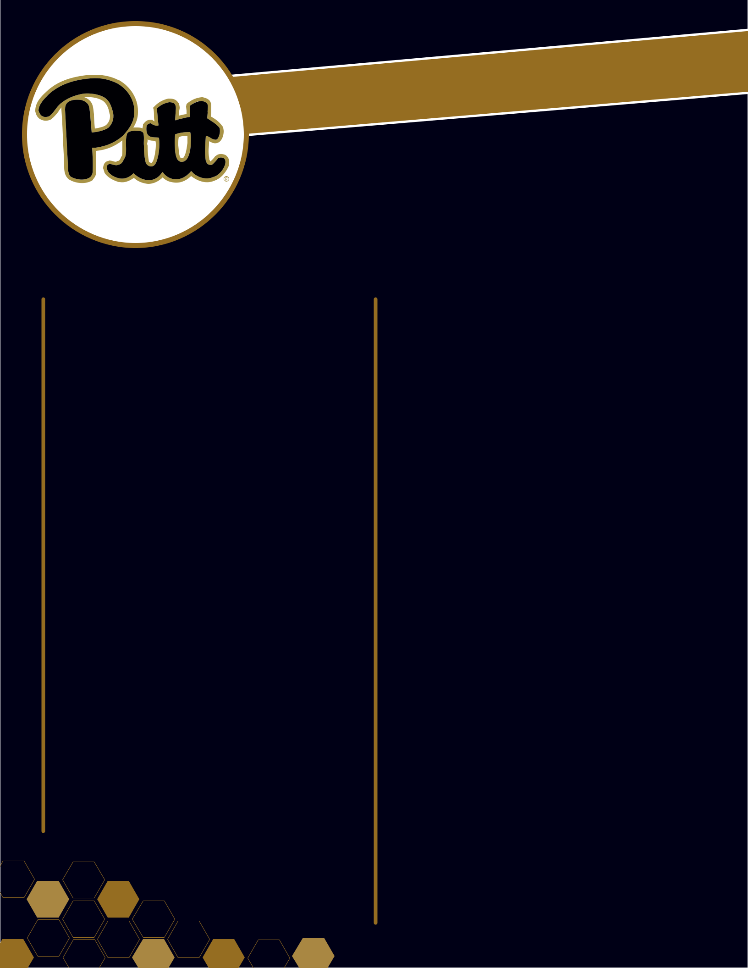

 Move-In C hecklist

Bed and Bath

- alarm clock

- blanket

- comforter

- mattress pad

- twin extra-long sheet set(s)

- pillowcases

- pillows

- decorative rug

- lamp (light bulbs - non halogen)

- robe

- loofah

- shower caddy

- shower shoes

- towel head wrap

- towels (bath, hand, washcloths)

- under the bed storage

Hygiene

- hair products/dryer

- makeup/moisturizers

- shaving accessories

- soap/shampoo

- toothbrush/toothpaste

- prescription medicines

- thermometer

- cleaning supplies

- first aid kit

 C leaning

- air freshener

- cleaning wipes

- laundry detergent pods

- dish brush

- dish soap

- drying rack

- laundry basket/bag

- fabric softener/dryer sheets

- hand sanitizer

- small ironing board

- iron with auto shut off

- lint roller

- trashcan

Useful Everyday/Personal

- ATM card

- Panther Card

- insurance cards

- social security card

- closet organizer

- driver’s license

- television (32” or smaller, with remote

and user manual)

- DVD player

- gaming system

- flashlight

- hangers

- message board/dry erase board

- picture frames

- sports equipment (ex. bicycle, rackets, balls)

- umbrella

- wall posters

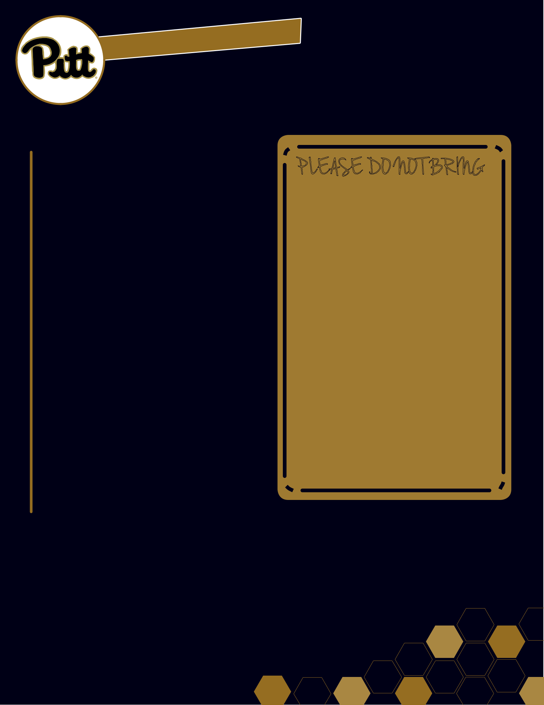
 Move-In C hecklist

Kitchen
- can opener

- dinnerware

- drinkware

- flatware

- microwave (800 watts or smaller)

- refrigerator (4.2 cubic feet or smaller)

- single cup coffee maker without burner

- water filter pitcher

- reusable water bottle

Study

- backpack

- computer/laptop

(charger and locking cables)

- laptop cooling pad

- calculator

- calendar

- dictionary/thesaurus

- loose leaf paper

- notebooks

- paper clips

- pencil holder

- pens/pencils

- stapler

- tape/post-its

P LEASE DO NO T BRING

- extension cord

(power strip with surge protector permitted)

- coffee maker with burner

- crockpot

- water boiler

- steamer/rice cooker

- toaster/toaster oven

- gas grill

- indoor grill

- hot plate

- open flame cooking device or heating unit

- air conditioner

- lava lamp, halogen, high intensity quartz lights

- candles or candle warmers

- pets

- space heater

- hover boards

*Please review the Student Code of Conduct and Residential Handbook for all University and on-campus policies.

