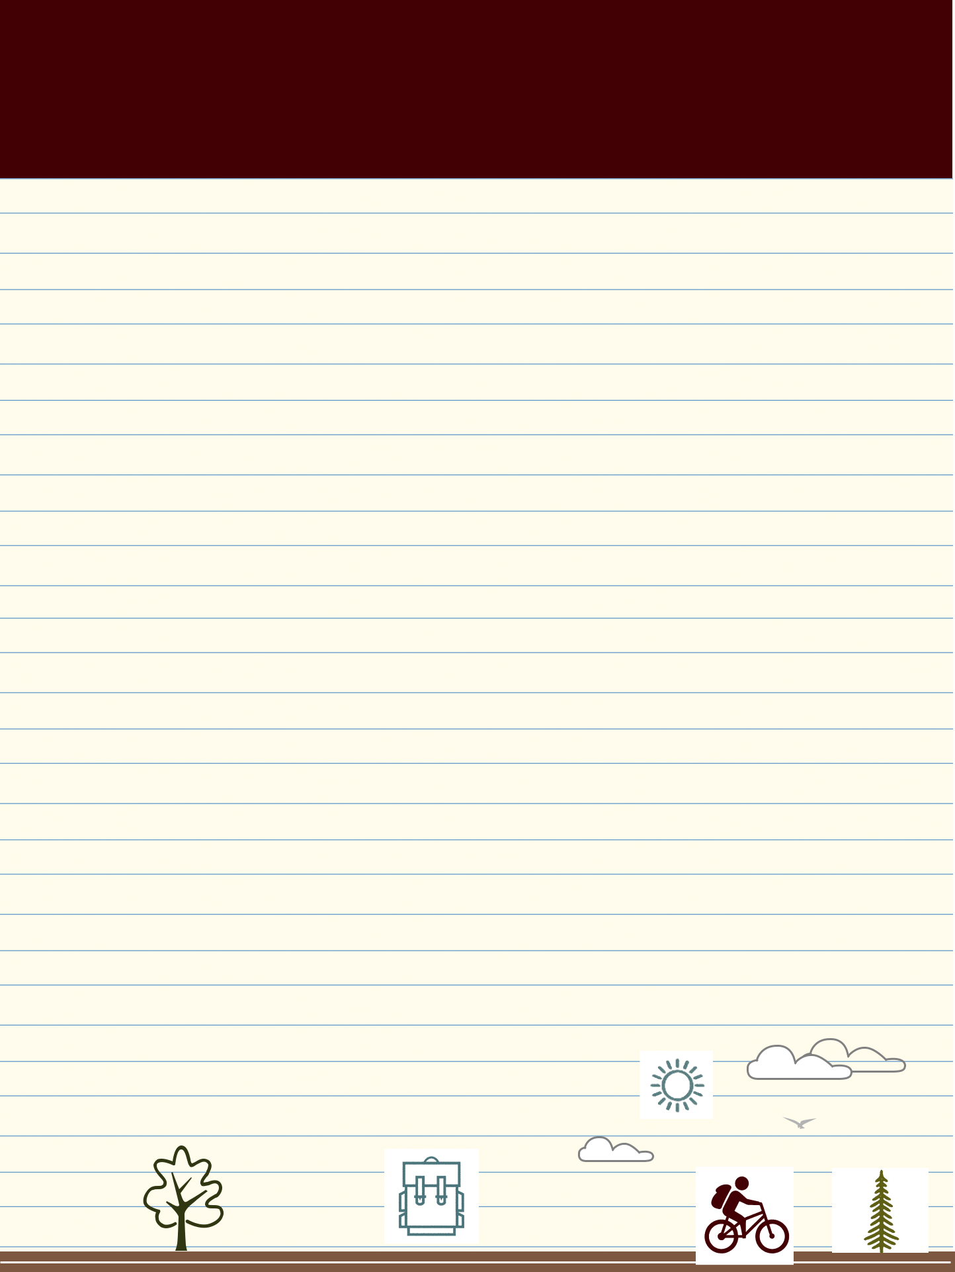

Move-in Checklist

BRING IT

HERE IS A LIST OF SUGGESTED ITEMS TO BRING TO ELON. NOT ALL ITEMS ARE REQUIRED:

BEDDING AND BATH

- Comforter/quilt

(The majority of rooms have extra-long twin beds. Single rooms in Global and Colonnades have full-sized beds)
- Bed sheets

- Mattress pad

- Pillows

- Pillowcases

- Reading pillow

- Throw blanket

- Bed riser (if you want additional under-bed storage)
- Bath towels

- Robe

- Hand towels

- Washcloths

- Loofah

- Shower caddy

- Shower shoes

(for community showers)

- Shower cap

ELECTRONICS

- Phone charger

- HDMI cord

- Coax cable cord

- TV

- Laptop

- Laptop charger

- Flash drive

- Speaker

- Clock/alarm clock

- Batteries

HEALTH & GROOMING

- Body wash/soap

- Travel soap container

- Toothpaste

- Dental floss

- Toothpaste holder

- Mouthwash

- Body lotion

- Deodorant

- Cologne/perfume

- Shampoo

- Conditioner

- Skincare products

- Hair grooming tools (combs, hairdryer, brush, etc.)
- Hair products

- Shaving kit

- Handheld mirror

- Nail clippers

- Eye drops

- Cotton swabs

- First aid kit

- Thermometer

- Prescription medicines

 Move-in Checklist


CLOTHES & LAUNDRY

- Clothes

(what you know you will wear, and consider the changing seasons)
- Umbrella

- Laundry basket and/or bag

- Laundry detergent

- Bleach

- Fabric softener

- Lint brush

- Stain remover stick

- Iron or steamer

- Ironing board

- Hangers

- Shoe rack

- Closet organizer

- Suitcase/luggage

CLEANING SUPPLIES

- Small vacuum

- Broom and dustpan

- Disinfectant wipes

- Cleaning spray

- Glass cleaner

- Toilet cleaner*

- Disinfectant spray

- Dish soap
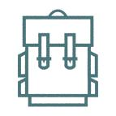



- Plunger*

- Toilet scrubber*

- Trash bags

- Trash can

- Febreeze

- All-purpose scrubber

- Paper towels

- Toilet paper*

- Tissues

*for students living in suites

STORAGE & ORGANIZATION

- Storage drawers

- Storage bins/containers

- Storage trunk with lock

- Bathroom sink organizer

- Desk mirror

- Desk organizer

- Makeup organizer

DÉCOR

- Wall art/posters

- Personal photos and pictures (avoid heavy frames)

- Damage-free hooks and strips (no nails allowed in walls)
- Push pins

- Curtain and spring rod

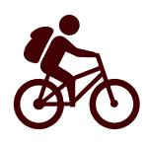

- Accent rug/carpet

- Desk chair cushion

- Desk lamp

- Stepstool (if using bed riser)

- Bulletin Board

SCHOOL SUPPLIES

- Bookbag

- Notebooks

- Binder

- Folders

- Planner/organizer

- Journal

- Mechanical pencils, pens, highlighter, whiteout
- Dry erase markers

- Paperclips

- Loose leaf paper

- Stamps

- Envelopes

- Index cards

- Scissors

- Tape

- Graphing calculator



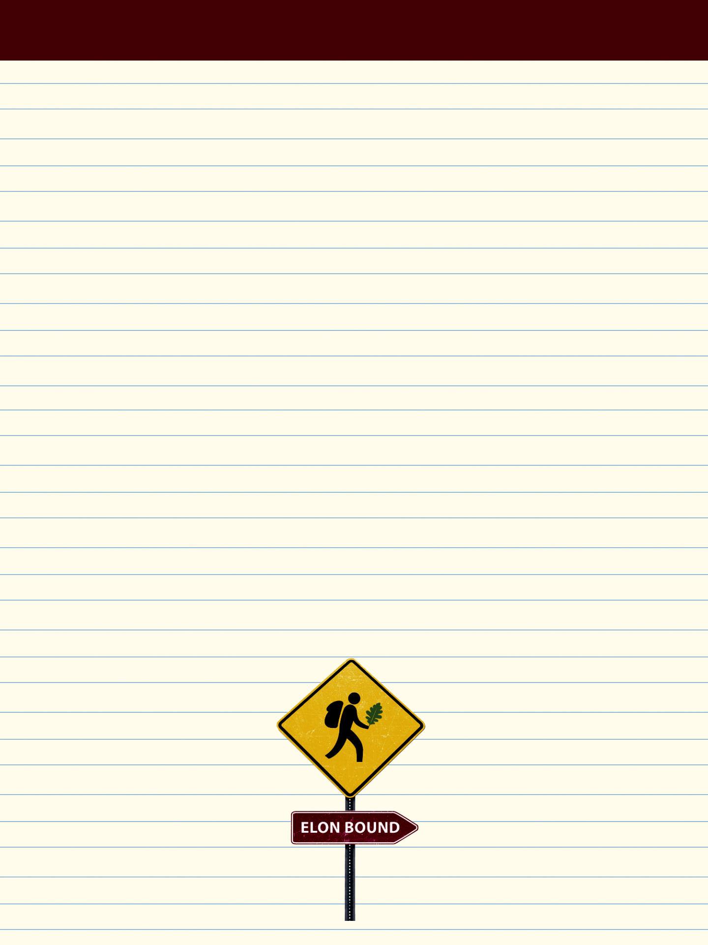

Move-in Checklist

LEAVE IT HOME

HERE IS A LIST OF ITEMS THAT ARE NOT ALLOWED IN RESIDENCE HALLS:

- Microwaves and toaster ovens (Students living in Danieley Center can bring for kitchen area only)
- Extension cords

- Halogen lamps

- Cinder blocks to raise beds

- Power tools

- Gas, charcoal or electric grills

- Candles (no candles are allowed at all), incense, or fireworks
- Hoverboards (including self-balancing scooters, battery operated scooters, hands-free segways, and similar items)

- Space heaters

- Electric blankets

- Wireless routers

- Salt lamps

- Any open-coil heating appliance

- Pets (ONLY non-lethal fish in a 10-gallon tank or smaller are allowed)
- Weapons

- Holiday (string) lights; also

LED lights

ELON.EDU/ELONBOUND
