

MOVE-IN / MOVE-OUT INSPECTION CHECKLIST

Tenant Name:

Residence Address:

Date:

_________________________________

_________________________________

_________________________________

Area / Item | Condition @ move-in | Condition @ move-out
KITCHEN
Floors / floor covering
Walls & ceiling
Windows / locks / screens
Window coverings
Doors / knobs
Light fixtures / bulbs
Cabinets / cupboards / shelves
Drawers / countertops
Sinks / stoppers / faucets
Drains / plumbing
APPLIANCES
Stove / oven
Outside
Burners
Drip pans
Hood vent
Timer / controls
Broiler pan
Lights
Refrigerator
Outside
Inside
Dishwasher
Garbage disposal
Trash compactor

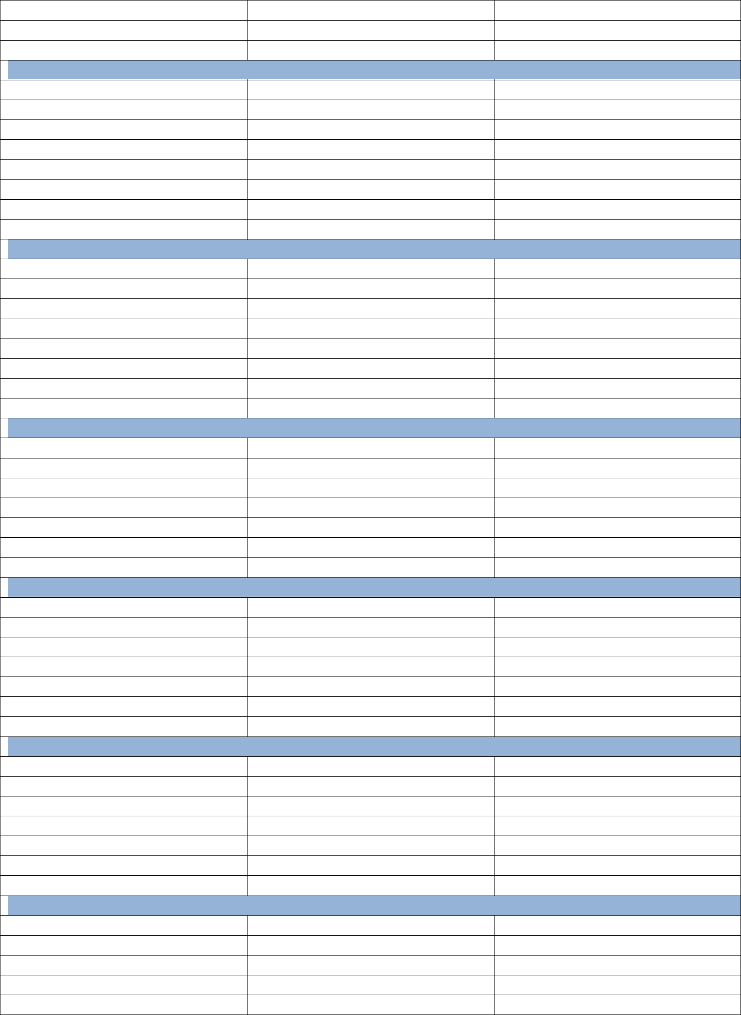
Laundry washer

Laundry dryer

Other appliances
LIVING ROOM

Floors / floor covering

Walls & Ceiling

Windows / locks / screens

Window coverings

Door / locks

Light fixtures / bulbs

Closet / shelves

Fireplace
FAMILY ROOM

Floors / floor covering

Walls & Ceiling

Windows / locks / screens

Window coverings

Door / locks

Light fixtures / bulbs

Closet / shelves

Fireplace
DINING ROOM

Floors / floor covering

Walls & Ceiling

Windows / locks / screens

Window coverings

Door / locks

Light fixtures / bulbs

Closet / shelves
OTHER ROOM

Floors / floor covering

Walls & Ceiling

Windows / locks / screens

Window coverings

Door / locks

Light fixtures / bulbs

Closet / shelves
ENTRY / HALL / STAIRS

Floors / floor covering

Walls & Ceiling

Windows / locks / screens

Window coverings

Door / locks

Light fixtures / bulbs

Closet / shelves
FRONT ENTRY / PORCH

Light fixtures / bulbs

Door bell

Front door

Siding

Porch

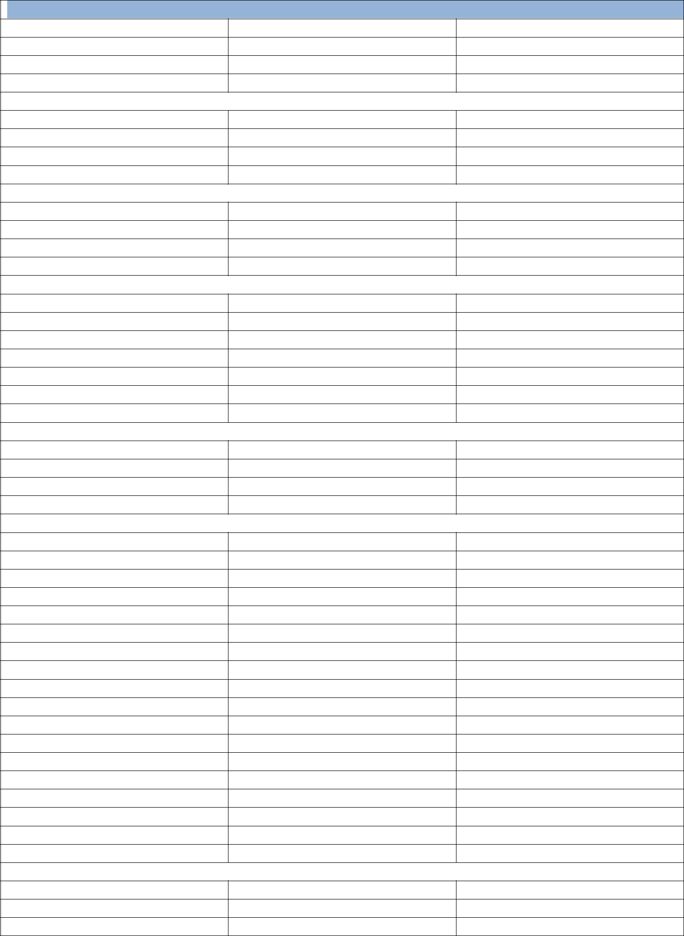
BACK / SIDE ENTRY
Light fixtures / bulbs

Back / side door

Siding

Deck
GARAGE / CARPORT

Floor type / condition

Doors / locks

Light fixtures / bulbs

Cabinets / shelving
STORAGE

Exterior

Interior

Attic

Basement
GROUNDS

Lawn / trees

Flower beds / gardens

Sprinkler / hose bibs

Walkways

Driveway

Parking area

Patio / deck
EXTERIOR

Light fixtures / bulbs

Mailbox

Siding

Roof
MASTER BATHROOM

Floor / floor covering

Walls / tile / grout / ceiling

Windows / locks / screens

Window coverings

Doors / knobs / locks

Light fixtures / bulbs

Exhaust fan / heater

Counter / shelves

Mirror / cabinets

Sinks / faucet / basin

Drain / plumbing

Tub / shower caulking

Shower head / tub faucet

Shower door / curtain

Shower tracks

Towel racks

Toilet bowl / seat

Toilet paper holder
BATHROOM #2

Floor / floor covering

Walls / tile / grout / ceiling

Windows / locks / screens

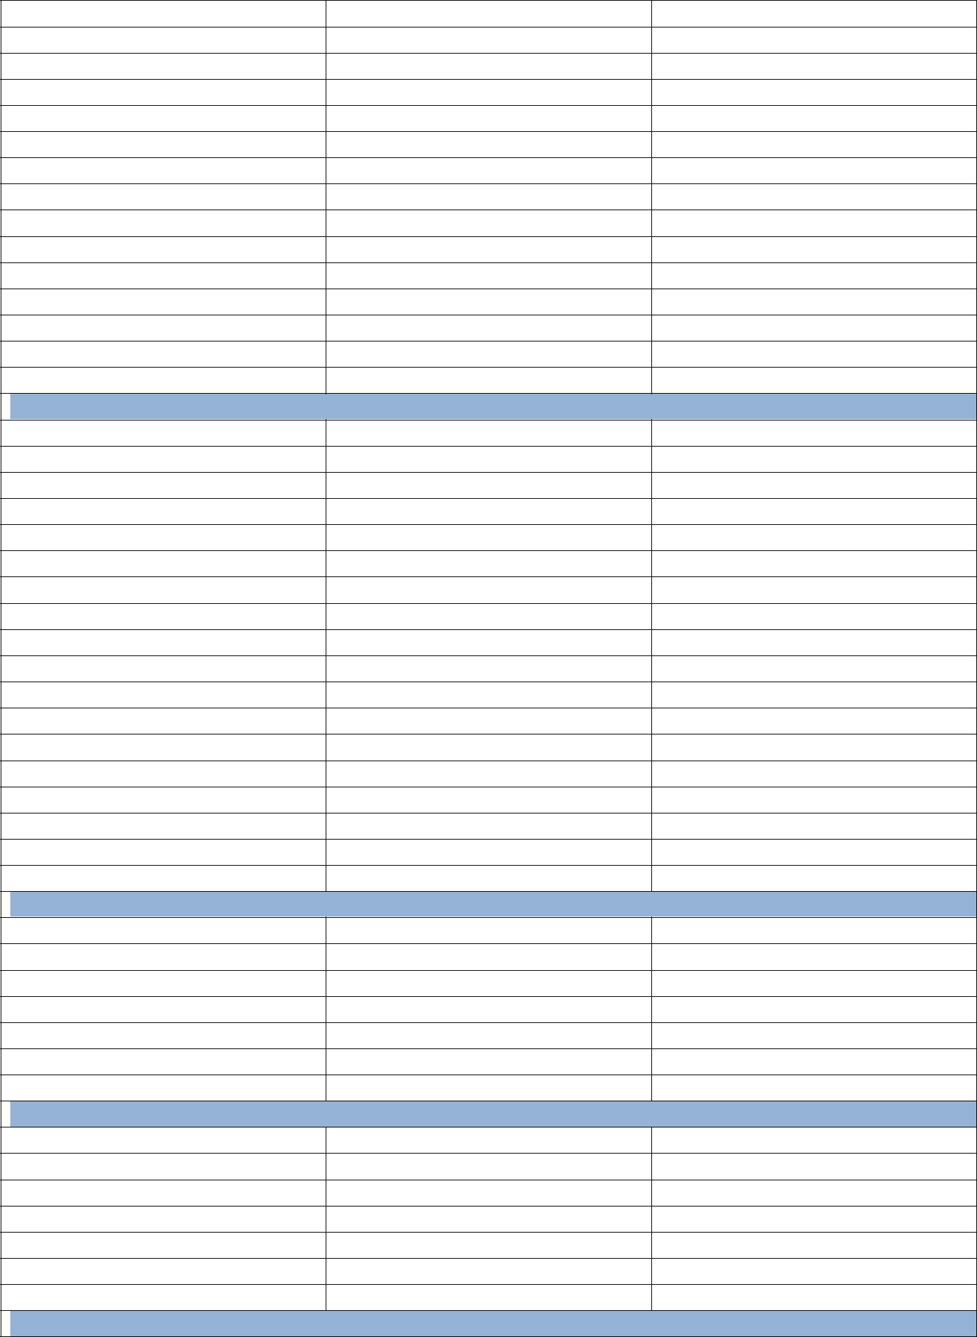
Window coverings

Doors / knobs / locks

Light fixtures / bulbs

Exhaust fan / heater

Counter / shelves

Mirror / cabinets

Sinks / faucet / basin

Drain / plumbing

Tub / shower caulking

Shower head / tub faucet

Shower door / curtain

Shower tracks

Towel racks

Toilet bowl / seat

Toilet paper holder
BATHROOM #3

Floor / floor covering

Walls / tile / grout / ceiling

Windows / locks / screens

Window coverings

Doors / knobs / locks

Light fixtures / bulbs

Exhaust fan / heater

Counter / shelves

Mirror / cabinets

Sinks / faucet / basin

Drain / plumbing

Tub / shower caulking

Shower head / tub faucet

Shower door / curtain

Shower tracks

Towel racks

Toilet bowl / seat

Toilet paper holder
MASTER BEDROOM

Floor / covering

Walls / ceiling

Windows / locks / screens

Window coverings

Doors / knobs / locks

Closets / shelves

Light fixtures / bulbs
BEDROOM #2

Floor / covering

Walls / ceiling

Windows / locks / screens

Window coverings

Doors / knobs / locks

Closets / shelves

Light fixtures / bulbs
BEDROOM #3

Floor / covering

Walls / ceiling

Windows / locks / screens

Window coverings

Doors / knobs / locks

Closets / shelves

Light fixtures / bulbs
BEDROOM #4

Floor / covering

Walls / ceiling

Windows / locks / screens

Window coverings

Doors / knobs / locks

Closets / shelves

Light fixtures / bulbs
BEDROOM #5

Floor / covering

Walls / ceiling

Windows / locks / screens

Window coverings

Doors / knobs / locks

Closets / shelves

Light fixtures / bulbs

Signatures

Inspection checklist completed on (date) _______________ at (time) _______________ and approved by:

Owner / Manager _______________________________________________________________

Tenants _______________________________________________________________________

