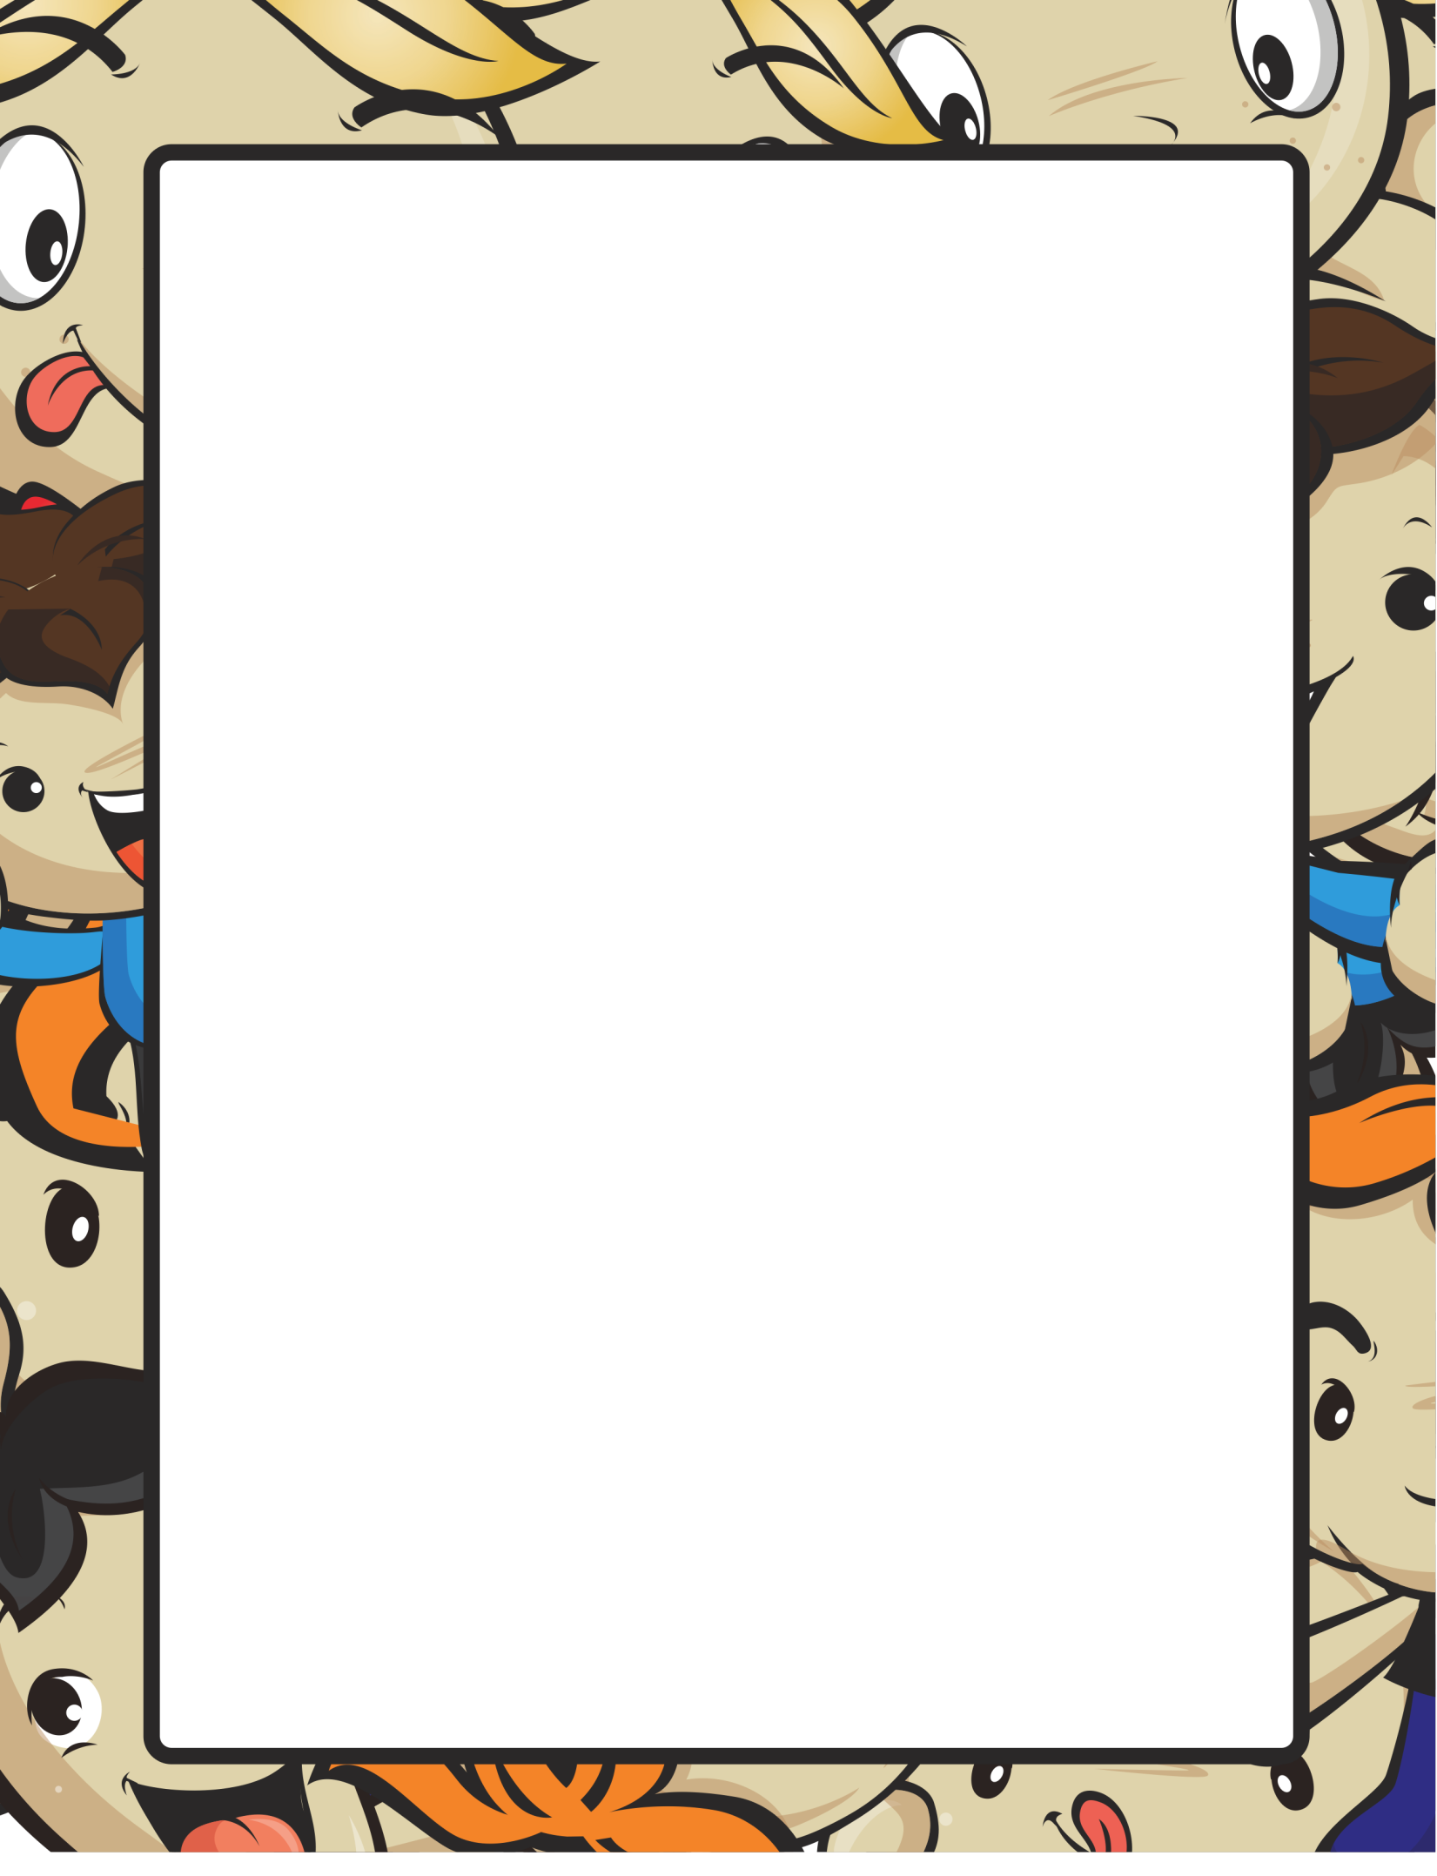

Name__________________________ Date________________________

My Book Report

Title of the Book

____________________________________

Author’s Name

___________________________________

My Favorite character was _____________________________________________________________________________________________________________________________________________________________________________________________________________________________________________________________________________________________________________________________________

The most appealing event in the story is _____________________________________________________________________________________________________________________________________________________________________________________________________________________________________________________________________________________________________________________________________

Write 2 sentences describing the book and how you wish the story ended

____________________________________________________________________________________________________________________________________________________________________________________________________________________________________________________________________
_______________________________________________________________

