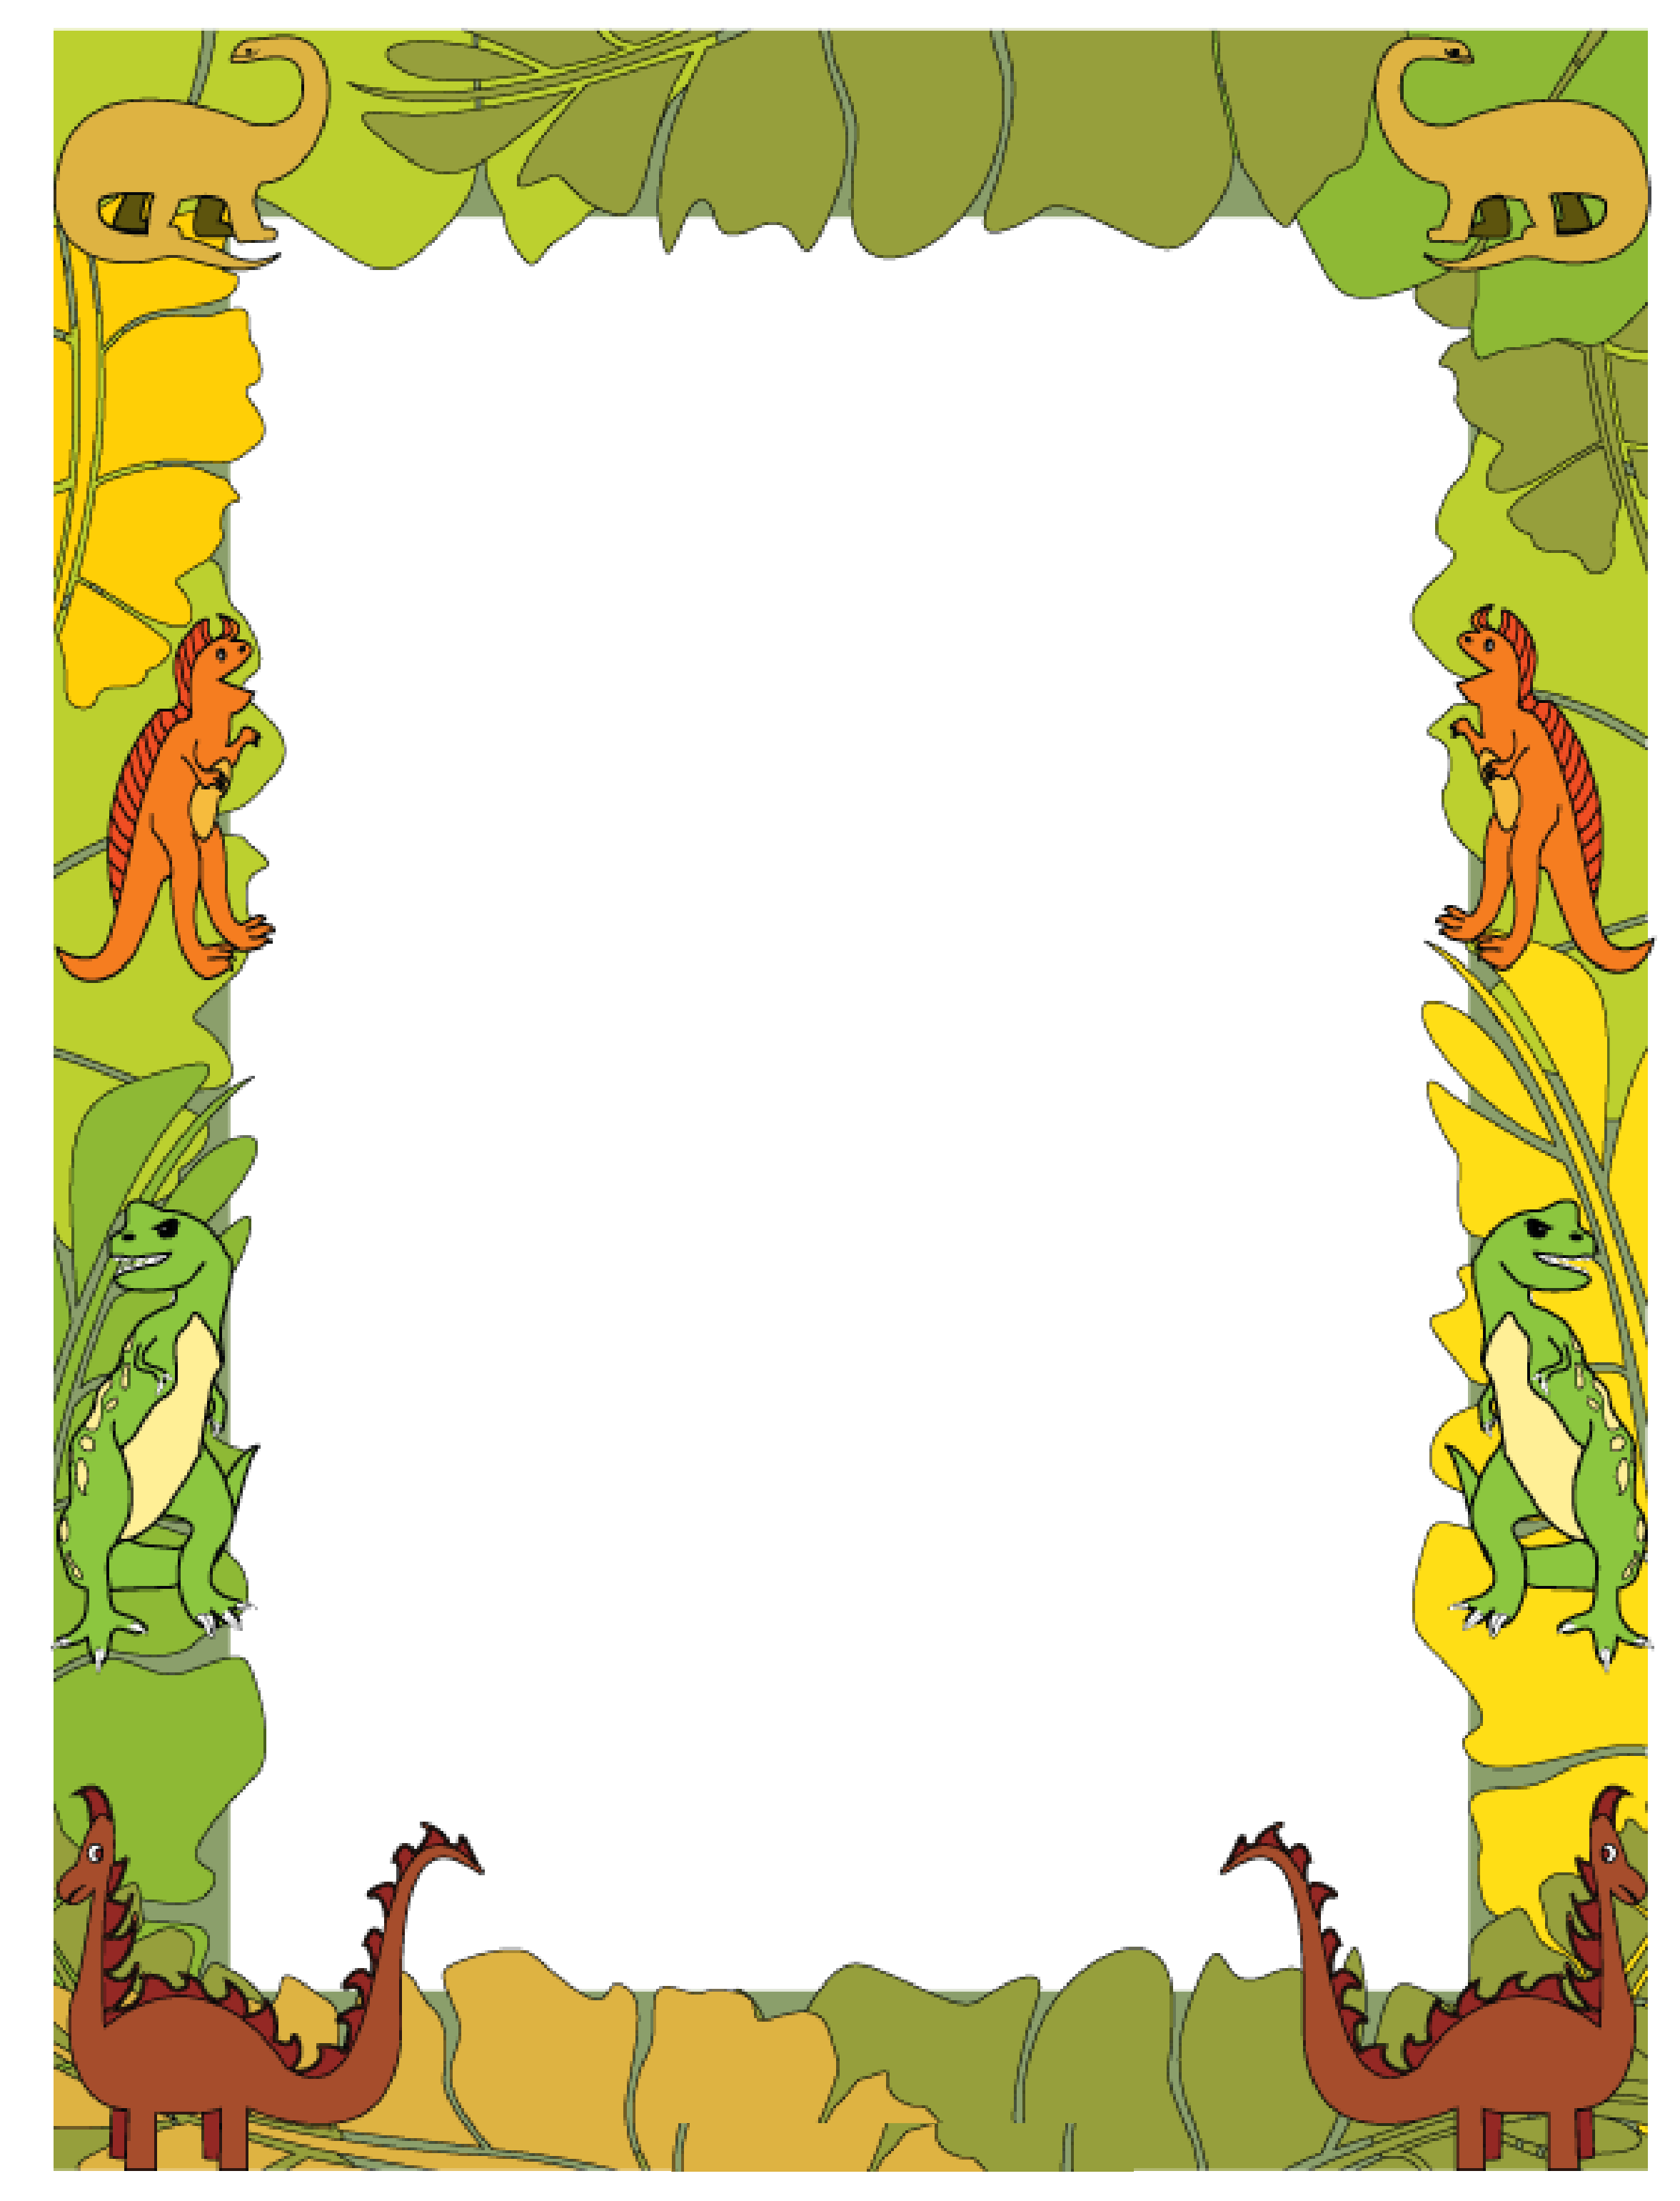
How did the story started?___________________________________________________________________________
How did the story ended?___________________________________________________________________________
Draw Setting then use details to explain

__________________________________________________________________________________________
My Book Report

