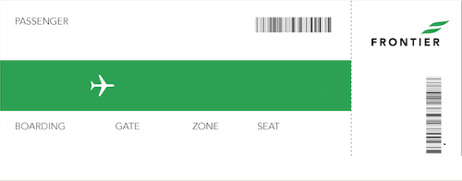

Name of Passenger
To Destination
From

