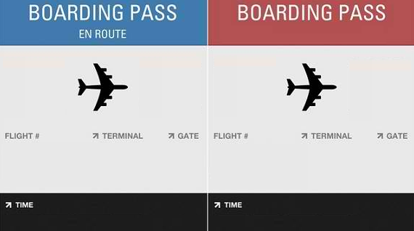

FROM
TO
TO
FROM

