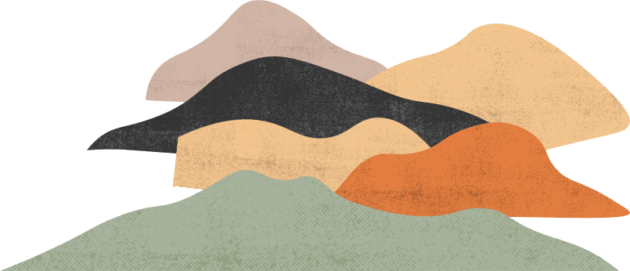

A book is a dream that you hold in your hand
love isn't like it
is in the books

