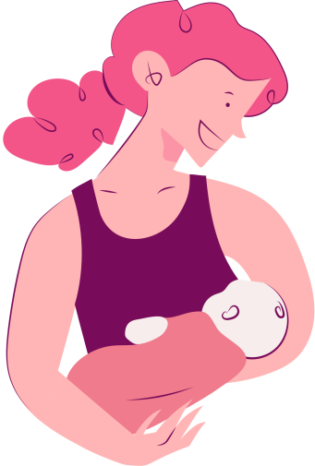
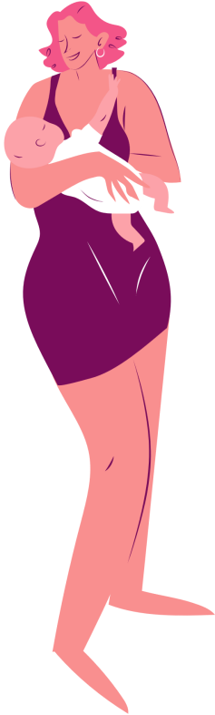
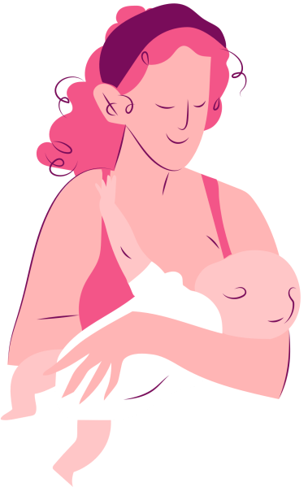
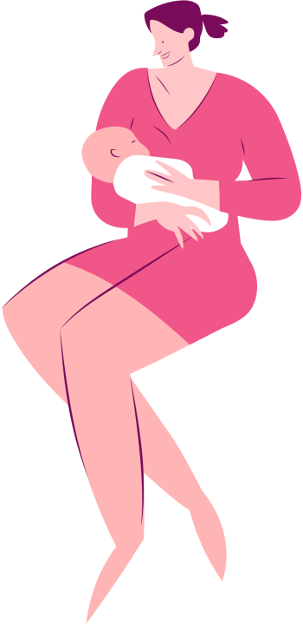
MOTHER'S DAY BOOKMARK
Happy
I love you,
Mom!
Thank you
for everything,
Mom!
mother's day!
You're
the best,
Mom!

