



TRAVEL BROCHURE
+123-456-7890
123 Anywhere St., Any City, ST 12345

Booklets are printed materials with four or more pages, containing details about a business, event, product, promotion, etc.
Let us
do the planning.
Just sit back and enjoy the wild ride.
WE TAKE YOU AT THE LOWEST RATES
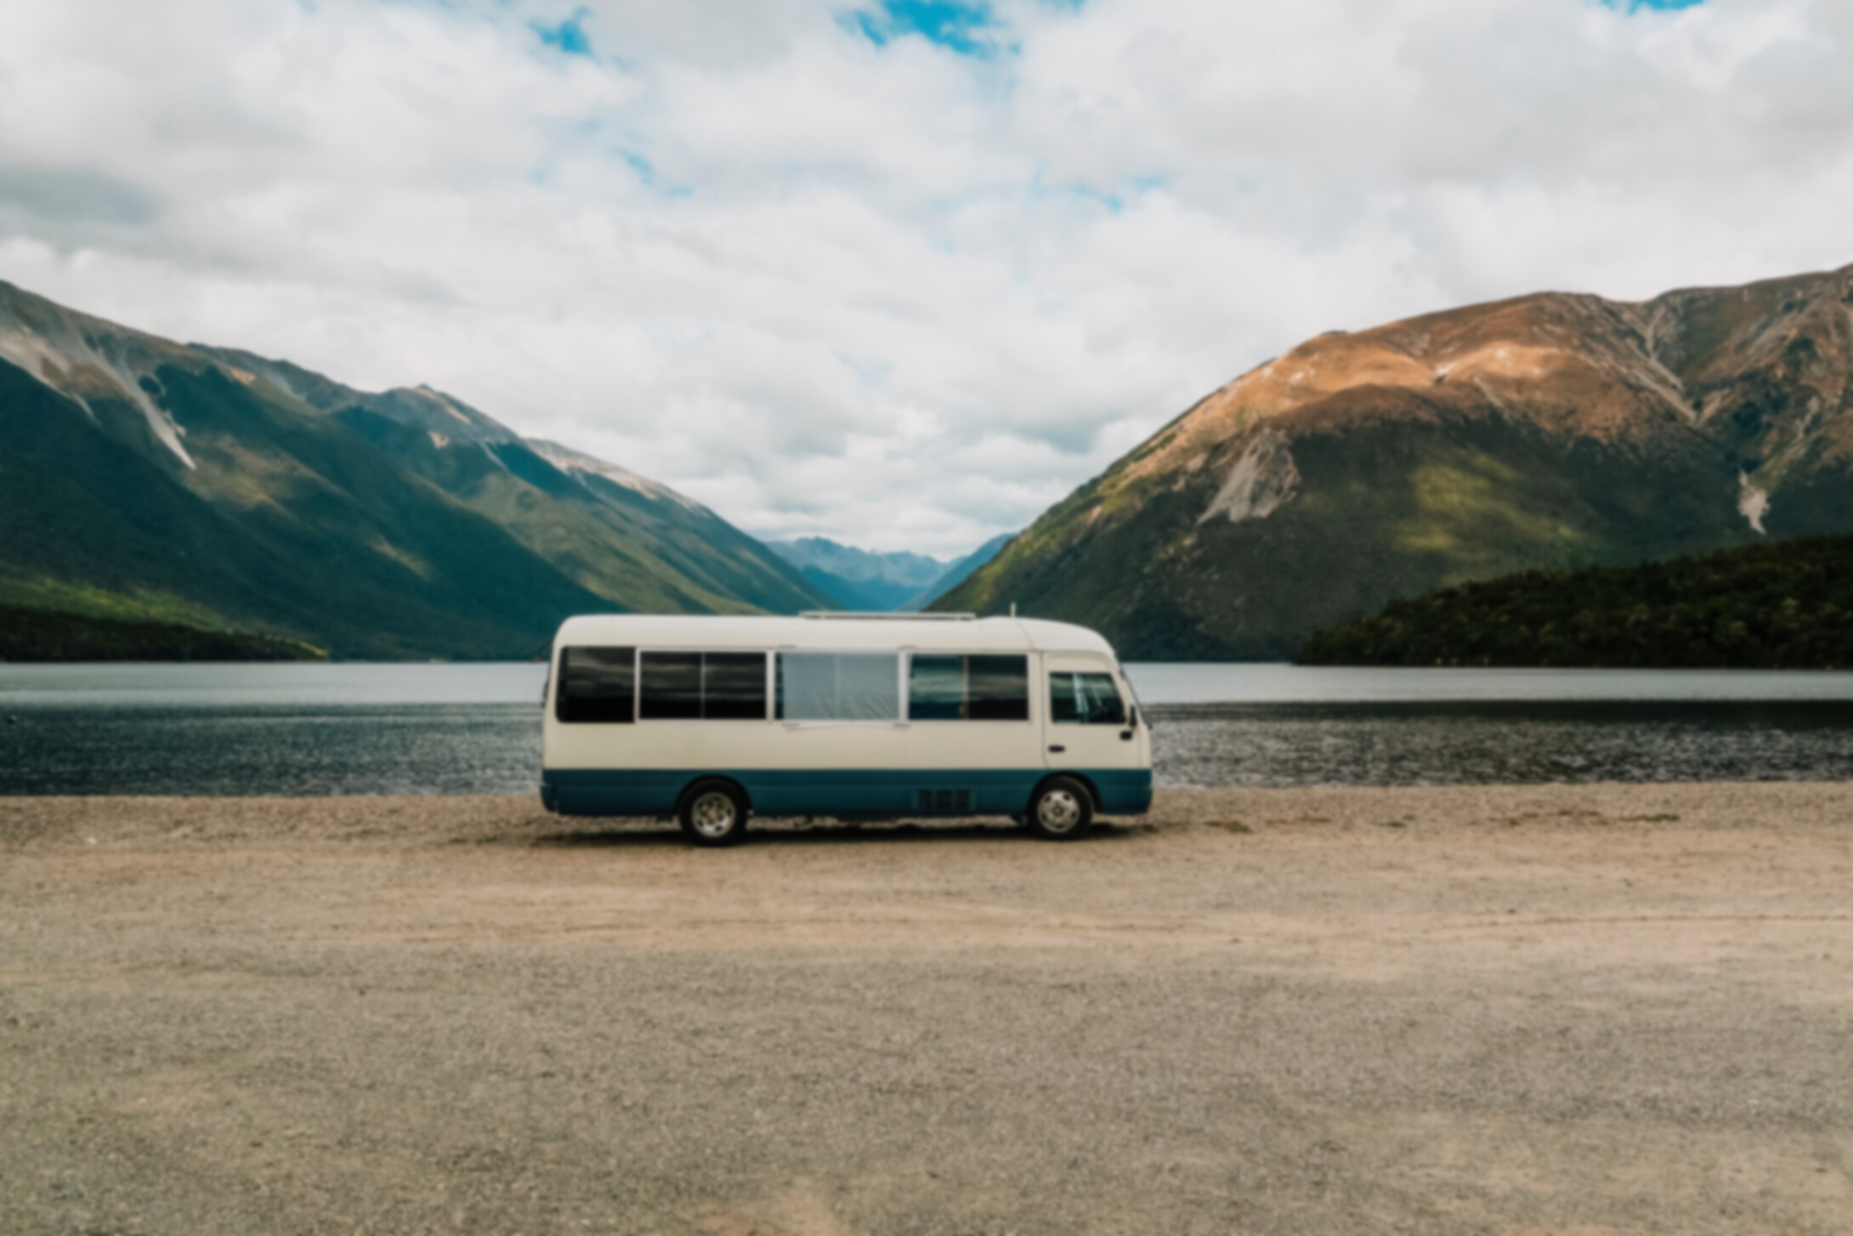


Booklets are printed materials with four or more pages, containing details about a business, event, product, promotion, etc. They are also known as catalogs or pamphlets and are usually created to communicate a message to audiences.
OUR SERVICES
PLAN YOUR NEXT
JOURNEY WITH US
Booklets are printed materials with four or more pages, containing details about a business, product, promotion, etc.
EXPLORE
the world
Booklets are printed materials with four or more pages, containing details about a business, event, product, promotion, etc.
They are also known as catalogs or pamphlets and are usually created to communicate a message to a wide
variety of audiences.
Seaside Tour
Make sure to feature your bestsellers or signature products or pieces.
Desert Trip
Make sure to feature your bestsellers or signature products or pieces.
CITY Trip
Make sure to feature your bestsellers or signature products or pieces.
Mountain TrIP
Make sure to feature your bestsellers or signature products or pieces.

