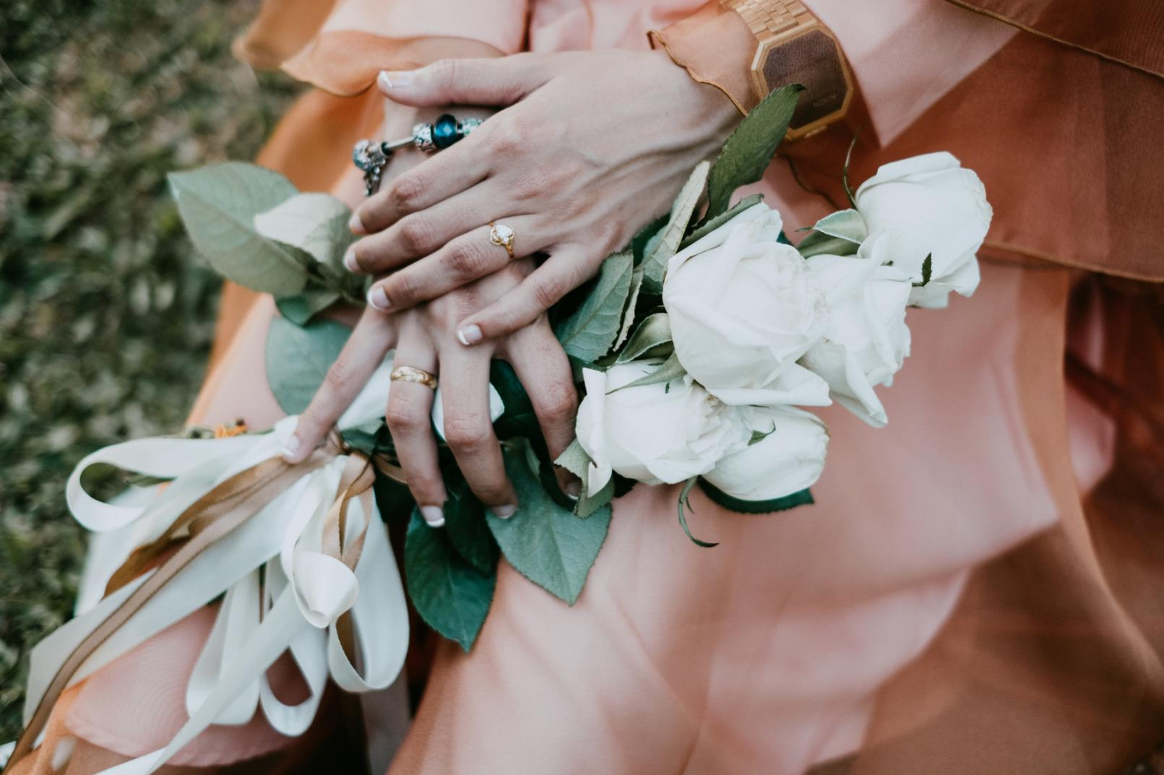

CONTACT US
123 Anywhere St., Any City, ST 12345
+123-456-7890

TELL ME ABOUT YOUR DREAM WEDDING, AND I'LL MAKE IT COME TRUE!
WEDDING PLANNING SERVICES
WEDDING BROCHURE
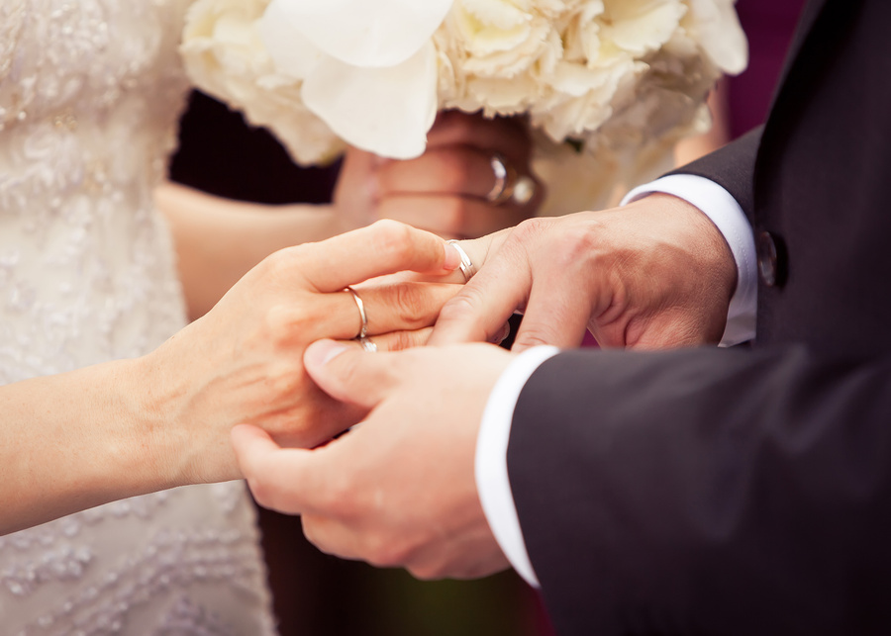

Trifold brochures have long been a type of material used to advertise brands, products, and services.
The best way to maximize its use is to introduce what the brand has to offer with a brief or about section like this. Make sure to keep your introduction short but interesting enough to readers.
ABOUT US
We create personalized weddings for every couple's unique style.
SERVICES
Make sure to feature your bestsellers or signature products or pieces. Keep it simple and to the point by listing the name, price and brief description.
DECORATIONS
Make sure to feature your bestsellers or signature products or pieces. Keep it simple and to the point by listing the name, price and brief description.
CATERING
Make sure to feature your bestsellers or signature products or pieces. Keep it simple and to the point by listing the name, price and brief description.
OPERATIONS
Make sure to feature your bestsellers or signature products or pieces. Keep it simple and to the point by listing the name, price and brief description.
PHOTOGRAPHY

