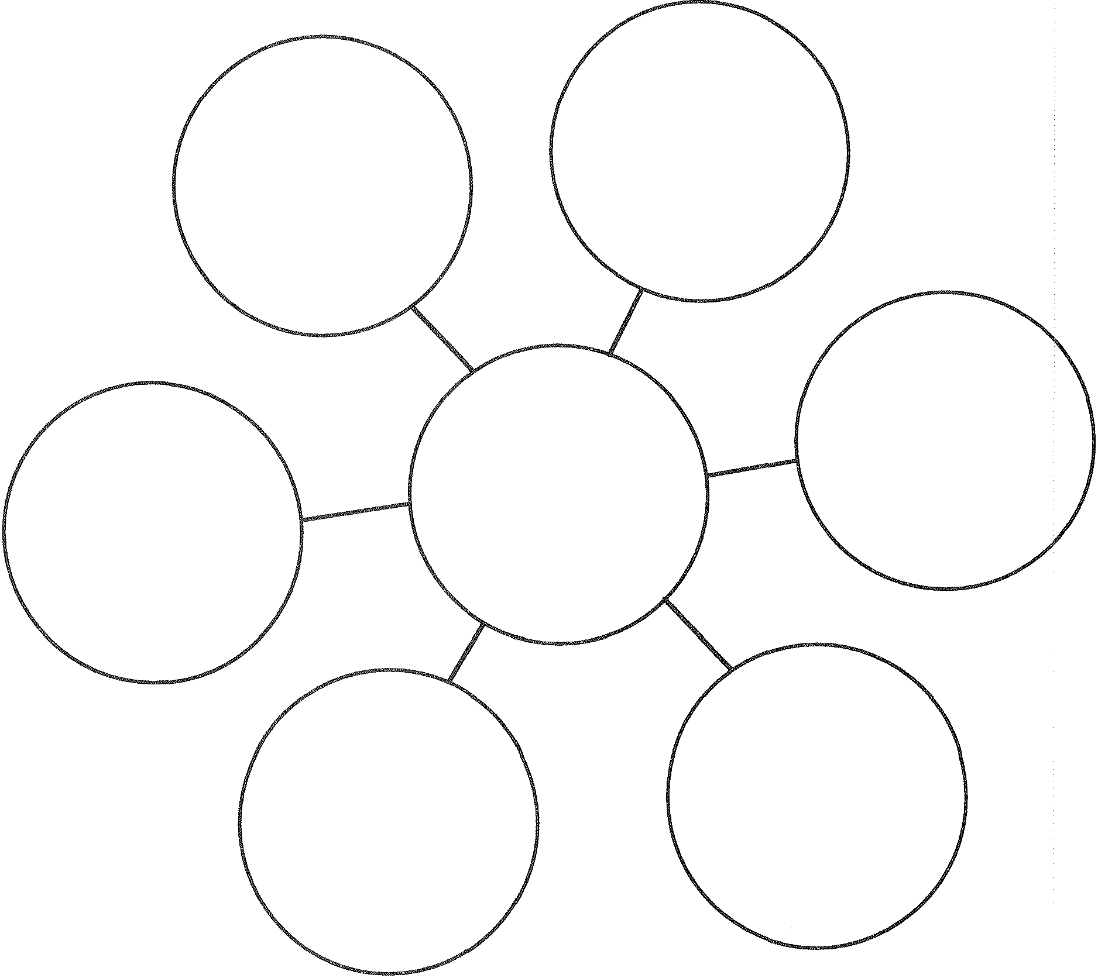
Bubble Map
Bubble Map for Describing Using Adjectives and Adjective Phrases

